financial analysis system (FAS) security

purpose

This purpose of this topic is to familiar you with the functionality of FAS Security.

objectives

By the end of this topic you we know how to:

- Create a User Security Profile

- Find a User’s Profile

- Delete a User’s Profile

Accessing the Financial Analysis System (FAS)
Step 1 Open your web browser (i.e. Internet Explorer, Netscape)

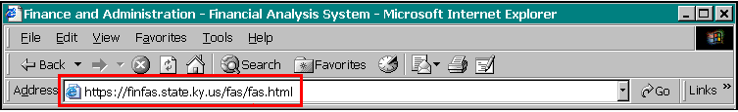Address box

Step 2 In the WEB ADDRESS box. Type https://finfas.state.ky.us/fas/fas.html .

Step 3 Press the <ENTER> key on your keyboard. The Security Warning box is displayed.

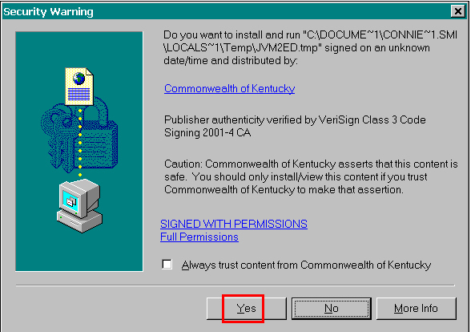Security Warning

Step 4 On the Security Warning box. Click the <Yes> button. The Financial Analysis System (FAS) screen is displayed.

Logon Window
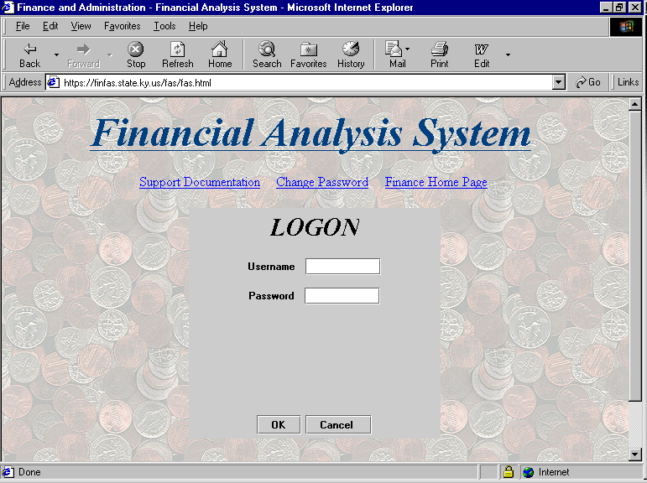

Logging into the Financial Analysis System (FAS)
Step 5 On the Logon window. Enter Your FAS Username and Password

Step 6 Click the <OK> button.

What is Fas Security Maintenance?
The FAS Security Maintenance feature is used to define a user’s security access, as well as, establish or edit a user’s security profile. Only FAS Security Administrators will have access to this feature. Security Administrators are set up by the Finance and Administration Cabinet based on information provided to the Agency Implementation Leads (AIL’s) by agency office heads or their designee.

Security maintenance window
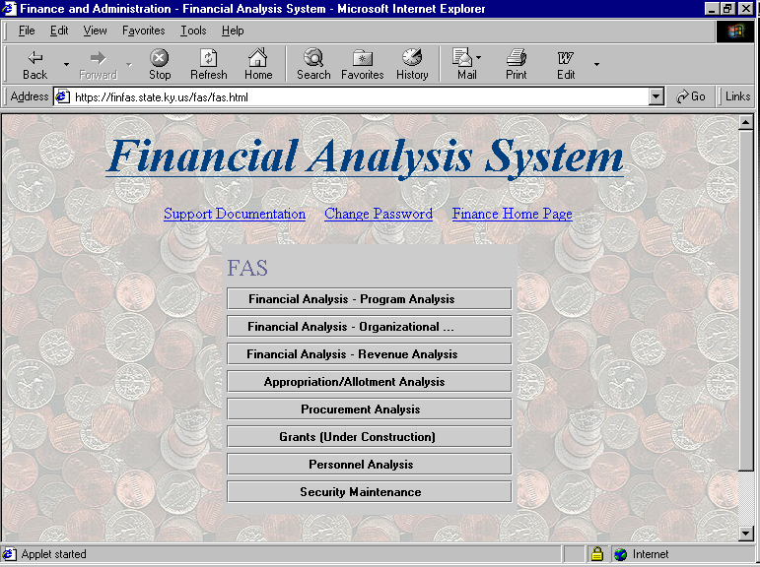

Creating User Security Profiles
Step 7 On the Main FAS Menu. Click Security Maintenance.

NOTE: The Security Maintenance option will appear on the main FAS menu if your FAS Administrator security has been established.

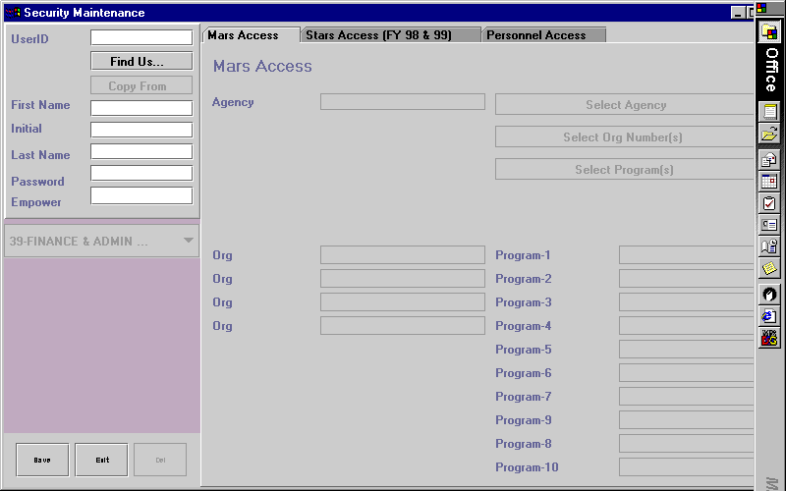
SECURITY MAINTENANCE

The Security Maintenance screen will appear. Notice there are three tabs located at the top of the screen.

- The MARS Access tab establishes the user’s security to the MARS data.

- The Stars Access (FY98 & 99) tab establishes a user’s security to the historical STARS data for FY98 or FY99 only.

- The Personnel Access tab establishes a user’s security to personnel data.

NOTE: Personnel data is highly sensitive containing personnel profile information such as; salary, leave balances, etc. Security requests for this portion of FAS must be received in writing or via e-mail from an office head or their designee.

Security maintenance window

Step 8 On the Security Maintenance window. Enter the USER ID.

NOTE: You many elect to use the MARS USER ID or the first name initial combined with the last name as the FAS USER ID. FAS will automatically convert lower case to upper case in the USER ID field.

Step 9 Press the <ENTER> button. The following box will appear.

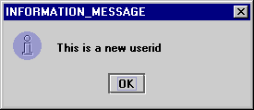
Information Message

Step 10 On the Information Message box. Click the <OK> button.

Step 11 Enter User information for the following fields:

FIRST NAME. Required
INITIAL. (OPTIONAL)
LAST NAME. Required
PASSWORD. Required. THIS FIELD IS CASE SENSITIVE.

NOTE: User should be directed to change password upon first access of FAS.

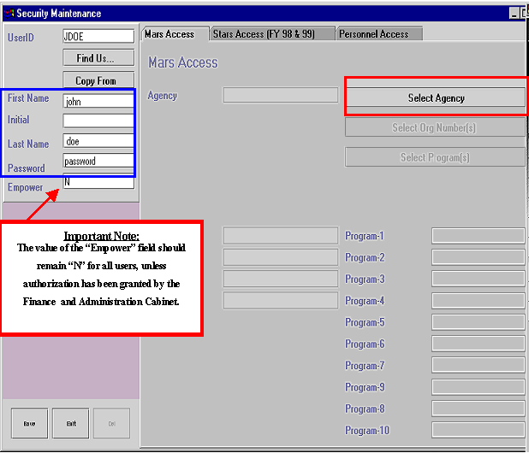

Security maintenance window

Mars Access Tab
Step 12 On the MARS Access tab. Click Select Agency.

Step 13 On the Agency Selection window. Select (left mouse click) the agency in which the user should have access.

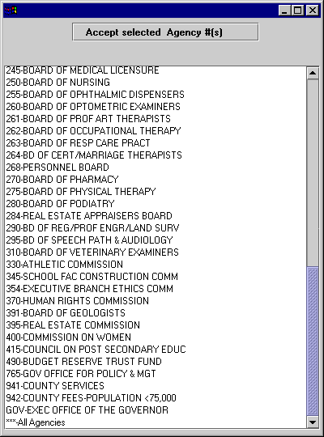
Agency selection window

Step 14 On the Agency Selection window. Click Accept Selected Agency #(s) to activate selection.

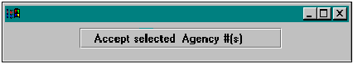

Agency Selection

NOTE: If a user needs security to all agencies within your cabinet, select ***-All Agencies. When a user has all agency access you will not need to establish security for the Organization or PBU. FAS will default the security level for these areas to ***-All orgs and **-All PBUs. The Organization and PBU buttons will appear greyed out and the default values will appear.

NOTE: If a user needs access to more than one agency, but not all agencies, then a separate user profile will need to be established for each agency. FAS will only permit access to one or all agencies per user profile.

Step 15 Click Select Orgn #[s]

Step 16 Select (left mouse click) the organization(s) to which the user should haveaccess. Up to four (4) organizations may be selected per user profile. To select more than one organization hold down the [CTRL] key and left click mouse on each selection.

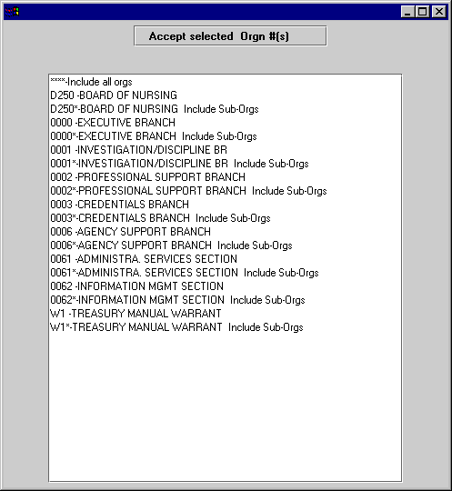
Agency Selection

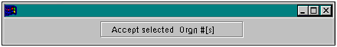Organization Selection

Step 17 On the Organization Selection window. Click Accept selected Orgn #(s) to activate selection.

NOTE: If a user needs security to all organizations within the available list, then select ***-Include all orgs.

Step 18 Click Select Program[s]

Step 19 Select (left mouse click) the program(s) to which the user should have access. Up to ten (10) programs may be selected per user profile. To select more than one organization hold down the [CTRL] key and left click mouse on each selection.

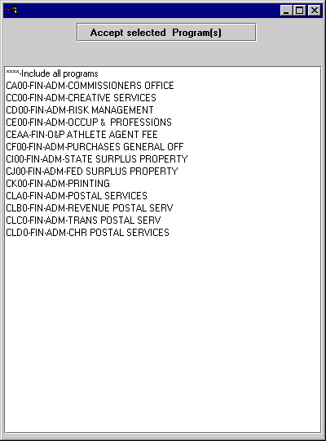

Program Selection

Program Selection
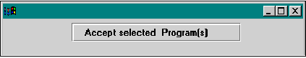

Step 20 On the Program Selection window. Click Accept selected Program[s] to activate selection.

NOTE: If a user needs security to all programs within the available list, then select ***-Include all programs.

Stars Access [Fy 98 & 99] Tab
Step 21 On the Security Maintenance window. Click on the Stars Access [FY 98 & 99] tab.

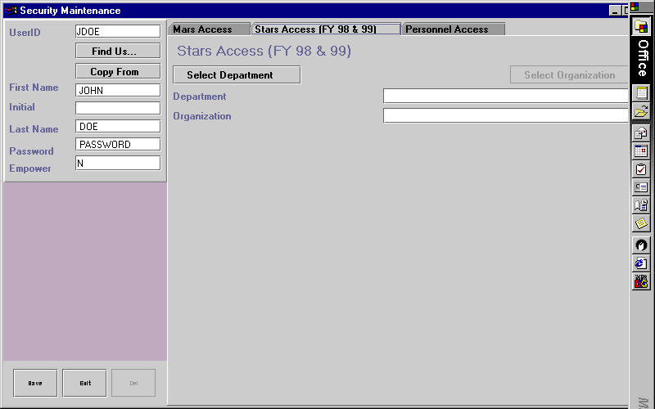
Stars access tab

Step 22 On the Stars Access tab. Click Select Department.

Step 23 On the Department Selection window. Select (left mouse click) the department in which the user should have access.

Department selection
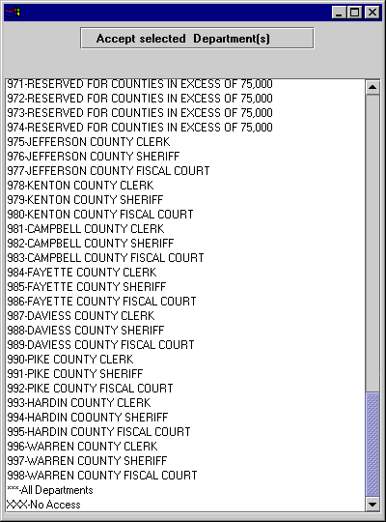

NOTE: If a user needs security to all departments within your cabinet, select ***-All Departments. When all department access is establish FAS will default the security level for Organization to ***-All orgs. The organization button will appear greyed out and the default values will appear.

NOTE: If a user needs access to more than one department, but not all departments, then a separate user profile will need to be established for each department. FAS will only permit access to one or all departments per user profile.

NOTE: If no access to STARS data is needed then select XXX-No Access.

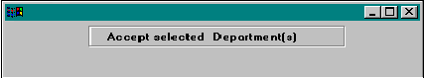Department Selection

Step 24 On the Department Selection window. Click Accept selected Department[s].

Step 25 On the Security Maintenance window. Click Select Organization. A list of available Organizations will appear.

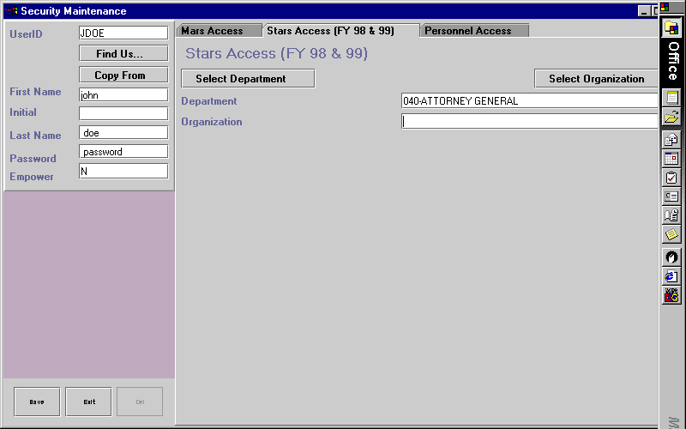
Security maintenance

Step 26 On the Security Maintenance window. Select (left mouse click) the Organization to which the user should have access.

NOTE: Only one (1) organization number is permitted for the STARS Access tab. However, organizational roll-ups are offered.

Personnel Access Tab
The personnel security is set up by position number. The position number is thirteen (13) characters in length. The break down of the number is as follows:

Position Name | Position | Position
Cabinet Number | First two (2) digits | 1, 2
Agency Number | Next three (3) digits | 3, 4, 5
Division Number | Next two (2) digits | 6, 7
Branch Number | Next two (2) digits | 8, 9
Section Number | Next two (2) digits | 10, 11
Unit Number | Next two (2) digits | 12, 13

A limit of two (2) Personnel Organizations is permitted per User Profile. Security may be established at any level of the position number, providing it is available within the listing.

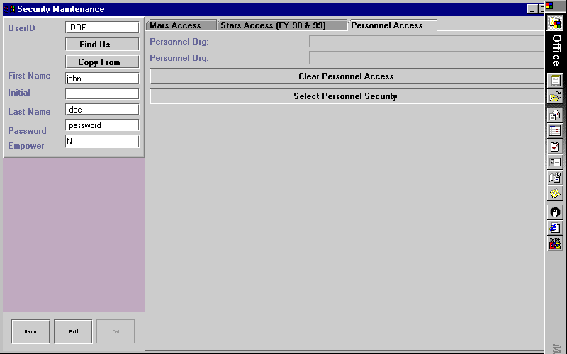
Personnel Access Tab

This feature will clear the users access.

Step 27 On the Personnel Access tab. Click on the Personnel Access tab to establish access.

NOTE: Personnel data is highly sensitive containing personnel profile information such as; salary, leave balances, etc. Security requests for this portion of FAS must be received in writing or via e-mail from an office head and/or their designee.

Saving Security Profiles
Step 28 Click Save after all information has been entered for the user. This will establish the user’s security record. Users will be able to access FAS immediately. FAS security is not dependant upon a nightly process.

Step 29 Test the new USER ID prior to notifying the user.

Step 30 Notify security has been established, providing ID and Password. You may want to include the link to FAS in your communication and instruct the user to add FAS to their list of favorites for convenience.

Listing of Required Fields
The following fields require a value for every user security profile.

LAST NAME
FIRST NAME
PASSWORD
MARS AGENCY CODE
MARS ORGANIZATION CODE
MARS PROGRAM CODE
STARS DEPARTMENT NUMBER
STARS ORGANIZATION CODE

Editing User Security Profiles
To edit a user’s security you will need to retrieve the user’s security profile.

Step 31 Enter the USER ID and press the <ENTER> key on your keyboard.

Step 32 Edit profile as needed then click the <Save> button to activate changes.

NOTE: Reference previous Steps for Creating User Security Profiles in FAS.

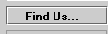
How to Find a User Profile

Step 33 Click on the Find Us… button.

A spreadsheet containing a list of the user profiles you have access to change will appear.

Step 34 Double Click on the USER ID to retrieve the user security profile for editing.

NOTE: Screenshot of this feature not shown for security reasons.

You can sort the spreadsheet in any order by clicking on the column heading.

Deleting a User Security Profile
Step 35 Retrieve the user’s security record.

Step 36 Click the <Delete> button. You will receive the following message box.

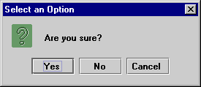
Dialog box

Step 37 Click the <Yes> button. You will receive the following message box.

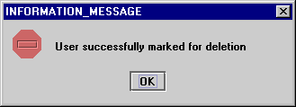
Dialog box

Step 38 Click the <OK> button.

NOTE: The user security record will be marked as deleted. It will continue to appear in the list of users until the list is purged. However, the user ID will be prefixed with an asterisk “ * ” character.

FOR ASSISTANCE OR QUESTIONS

Contact the Customer Resource Center Help Desk by phone (502) 564-9641 or Toll Free (877) 973-HELP, by email Finance.CRCgroup@mail.state.ky.us, or on the web at http://resource.state.ky.us for assistance.

In this topic we have learned how to:

- Create a User Security Profile

- Find a User’s Profile

- Delete a User’s Profile



Is there any questions concerning the information covered in this topic?

