Roadmap –
Inventory

December 30, 1998

NOTE: This document is formatted for duplex reproduction, which is the Commonwealth of Kentucky standard. Blank pages are intentionally inserted throughout the document so that the document will reproduce correctly.

Table of Contents
Page
1 About This Document 1
2 Inventory Functional Area Processes 2
Pick and Issue, or Over-the-Counter Item in a Storage Facility 3
2.2 Stock Transfer between Storage Facilities 6
2.3 Inventory Adjustments 8
Physical Inventory Counts/Costs in Storage Facility 10
2.5 Returns in Storage Facility 13
2.6 Reorder Points in Storage Facility 15
3 Agency Setup Requirements 18
3.1 Setup of Inventory Tables 18
3.1.1 ABC Classification Parameter (ABCP) table 18
3.1.2 Warehouse Management table (WHS2) 19
3.1.3 Inventory Inquiry table (INVN) 19
3.1.4 Inventory Inquiry table (INV2) 20
3.1.5 Inventory Inquiry table (INV3) 21
3.1.6 Adjustment Code table (ADJC) 22
3.1.7 Return Code table (RETC) 22
3.1.8 Warehouse Group table (WHSG) 23
3.1.9 Item Group table (ITMG) 24
3.2 Inventory Setup ‘Task Plan’ 24

List of Tables and Figures
Page
Figure 1. Pick & Issue or Over-the-Counter Item in a Storage Facility 3
Figure 2. Stock Transfer between Storage Facilities 6
Figure 3. Inventory Adjustments 8
Figure 4. Physical Inventory Counts/Costs in Storage Facility 10
Figure 5. Returns in Storage Facility 13
Figure 6. Reorder Points in Storage Facility 15

This page intentionally left blank.

About This Document

These Roadmaps provide a summarized document that can serve as a guiding document for Agency System Usage Analysis tasks, with the System Usage Analysis and Implementation Strategy documents serving as backup documentation when needed. Ten Roadmap documents are available, one for each business area outlined in a System Usage Analysis document.

The MARS Project Business Analysis and Design team produced numerous documents available to agencies during their implementation efforts. These documents consist of two basic types: System Usage Analysis documents and Setup and Usage documents. The Business Analysis and Design team produced ten System Usage Analysis documents (available on the Internet), one for each business area:

- Revenue and Receivables
- Internal Orders and Billings
- Purchasing and Payables
- Grants and Cost Allocation
- Project Billing and Job Costing
- General Accounting
- Inventory
- Fixed Assets
- Budget Preparation
- Disbursements

Six Setup and Usage documents (also available on the Internet) were produced:

- Materials Management Setup and Usage Strategy
- Accounts Payable/Accounts Receivable Redesigned Process Implementation Strategy
- Budget Setup and Implementation Analysis
- Chart of Accounts Plan
- Cost Classification and Reporting Plan
- Source Document & Transaction Mapping Analysis

Generally, these documents contain detailed information about the key business processes and system component setup, and most are fairly large documents. Recognizing that these materials can be overwhelming for agencies to digest, the MARS Implementation Team has taken these materials and condensed both the System Usage Analysis business process information and the Setup and Usage information into Roadmap documents.

Each Roadmap consists of two major sections:

- Functional Area Processes. This section provides an introduction, and information regarding key business process. An overview is given for each process, and diagram is provided where applicable.

- Agency Setup Requirements. Where applicable, this section summarizes key agency setup requirements and data elements. In addition, some Roadmaps provide data structure diagram for applicable components of the system. These setup requirements work in conjunction with the Data Prep and Setup section (section 6.8) of the Agency Implementation Notebook.

Inventory Functional Area Processes

The Commonwealth of Kentucky seeks to automate the processing of Inventory in ADVANTAGE and Procurement Desktop (PD). ADVANTAGE houses the inventory subsystem, however all purchasing documents and receiver documents for that inventory will be performed in Procurement Desktop. The implementation of the Inventory Control Subsystem together with Procurement Desktop will offer agencies a mechanism to track inventory items in facilities ranging from a small supply cabinet to a physical storage facility. It also will allow the flexibility for an agency’s “storage facility (large or small)” to recognize revenue or simply expense the item as it is issued. To use the inventory system, every item must have a stock item number associated with it. The stock item number will be the commodity code for that item with 3 digits on the end of it that differentiates it.

Six processes were identified within the Inventory function:

- Pick and Issue, or Over-the-Counter Item in a Storage Facility
- Stock Transfer between Storage Facilities
- Inventory Adjustments
- Physical Inventory Counts/Costs in Storage Facility
- Returns in Storage Facility
- Reorder Points in Storage Facility

Pick and Issue, or Over-the-Counter Item in a Storage Facility

Figure 1. Pick & Issue or Over-the-Counter Item in a Storage Facility

This process refers to a request for a pick and issue or over the counter item in a storage facility, as determined by the Inventory Officer.

Internal Orders/ Stock Requisition (SRP)
- To order an item from inventory, the end-user initiates an internal order document in PD or through PD-Web. A PD/PD Web internal order from a storage facility cannot be mixed with commodities from another catalog or another storage facility.
- Items ordered for a storage facility to increase stock levels, will be issued out of the same fund that the items were purchased from.
- An internal order for inventory generates a Stock Requisition transaction (SRP) in ADVANTAGE to reserve stock items. The SRP allows the Inventory Officer or end user to reserve quantities of requested stock items from a particular storage facility. The Inventory Officer will not be able to enter a SRP directly into Advantage, he must go through PD.
- The SRP allows storage facility personnel to review stock requests online as opposed to a paper document.
- The SRP pre-encumbers funds from the end-user requesting the item.
- The baseline ADVANTAGE SR document processor will be modified to store up to 10 accounting distribution lines in the document header.
- The following tables are updated when a SRP is processed: Inventory Inquiry (1 of 3) table (INVN), Open Stock Requisition Header Inquiry (OSRH), Open Stock Requisition Account Line Inquiry (OSRL), Open SR Line Inquiry table (OSRC), and the Issue Queue table (ISSQ).

Back Order Servicing

Backorder servicing attempts to fill backordered quantities of open stock requisitions. It reads through the Open SR Header Inquiry (OSRH) and selects all records that have a Backordered Status. Stock Requisitions (SRP) are then sorted in ascending delivery date order. Partially filled requisitions are serviced before fully backordered requisitions. If records were serviced by the program, these requisitions are now ready for the Pick and Issue process (PI).

Pick and Issue (PI)
- The Pick and Issue (PI) document schedules items reserved through the Internal Order in PD (SR in Advantage) to be picked from the shelves and issued to the requesting user department. Next, the Pick and Issue (PI) document submits the offline program Inventory Pick and Issue Order that prints pick tickets for selected SRP’s for the specified storage facility. The stock clerk to finds and removes the proper quantities of stock items from the shelves using the pick ticket report.
- Processing the PI transaction automatically creates a Stock Issue Confirmation (CI).
- There are no accounting consequences associated with the pick and issue process.
- The following tables are updated when a PI is processed: Open SR Line Inquiry table (OSRC), Open Stock Requisition Issues table (OSRI), Inventory Inquiry (1 of 3) table (INVN) and the Issue Queue table (ISSQ).

Stock Issue Confirmation (CI)
- The Stock Issue Confirmation (CI) document issues requested and released amounts from the on-hand quantity of a stock item.
- The CI is used in conjunction with the Internal Order from PD/PD Web with the stock requisition (SRP) and the pick and issue documents.
- The CI reverses the pre-encumbrance produced by the stock requisition, charges the user department for the item issued, and reduces the inventory quantity.
- The CI document is automatically generated by the Pick and Issue document.
- The following tables are updated by the Stock Issue Confirmation (CI) document: Open Stock Requisition Header Inquiry (OSRH), Open Stock Requisition Account Line Inquiry (OSRL), Open Stock Requisition Line Inquiry (OSRC), Open Stock Requisition Issues Inquiry (OSRI), Inventory Inquiry (1 of 3) (INVN), and Issue Queue Inquiry (ISSQ).

Over the Counter (OC)

The Over the Counter (OC) process does the following:
- Another alternative to the preceding SRP, PI, CI processes is to use the Over the Counter document (OC) , which allows the Inventory Officer to issue requested quantity directly by-passing the PI and CI documents. Eliminating these two steps is possible because it is assumed that when using the OC, the user is placing the order and picking up the goods at the same time.
- As the items are issued immediately upon request, in effect, “over-the-counter”, backordering is not allowed.
- Once the OC is processed, the on-hand quantity is reduced by the amount issued.
- The OC document produces a receipt that details the requestor and the stock items that were issued. This functionality is similar to the Pick Ticket Report (refer to Mod # INV-002).
- In addition, Over the Counter Generation (OCGN) provides capability of generating OC documents with a minimal number of keystrokes. Documents can be added, changed, or deleted using this table.
- In summary, the OC does not have a reserve for pre-encumbrance and encumbrance.
- The following tables are updated when an OC is processed: Inventory Inquiries (INVN) and (INV2), Open SR Header Inquiry (OSRH), Open Stock Requisition Account Line Inquiry (OSRL), Open SR Line Inquiry (OSRC), and the Open SR Item Issues Inquiry (OSRI).

Additional functionality was added to the baseline functionality during the analysis, design, and modification process:
- The ability to infer the Commodity Description from the Commodity Table (COMT) into the Stock Item Description on the Inventory Table will reduce data entry. Furthermore, this will allow the Inventory Manager the ability to see a description of the Commodity and then to further describe it in the 30-character description field (Refer to Modification #INV-004).
- Inventory users may view stock items by Parent Facility. The user must first establish their facility to a Parent Facility on the Warehouse Table. They must then update the Warehouse Group Table by adding the satellite warehouse to a Parent Facility. This will allow the Inventory Manager the flexibility to check the availability of the same stock item within the Parent as well as the satellite facilities. This is needed to check availability so some stock items may be transferred from one facility to another rather than purchased (Refer to Modification #INV-024).

Stock Transfer between Storage Facilities
Figure 2. Stock Transfer between Storage Facilities

Transfer Documents (TI and TR)
- The Stock Transfer Issue (TI) document is the first step in transferring stock items from one storage facility to another.
- The TI is used to initiate the transfer of stock from one storage facility to another.
- The TI marks a certain quantity of the stock item as being in transfer.
- The storage facility that has the items to transfer would initiate this document.
- A Transfer Issue (TI) document can be modified, as long as the Stock Transfer Receipt (TR) has not been accepted.
- The second step is the Stock Transfer Receipt (TR). The TR completes the transfer process by recognizing the receipt of stock being transferred.
- The TR is input by the storage facility requesting the stock item to be transferred.
- If the quantity received on the TR document does not match the quantity issued on the TI document, the transfer is rejected (Refer to Mod # INV-013).
- The TR document reduces the on-hand quantity of the stock item in the issuing storage facility and increases the on-hand quantity in the requesting storage facility.
- The TR reduces inventory costs for the issuing storage facility and increases inventory costs for the requesting storage facility.
- If the transfer is between two related storage facilities the change in location and the related inventory quantity adjustment is updated on the Inventory tables.
- The Stock Movement Report (IN51) provides information about each document that affects the on-hand balance of the stock item.
- The following tables are updated when TI and TR documents are processed: Open Stock Transfer Receipt Header Inquiry table (OTRH), Inventory Inquiry table (INVN), Open Transfer Header Inquiry table (OTRH), and Open Transfer Line Inquiry table (OTRL).

Inventory Adjustments
Figure 3. Inventory Adjustments

This process refers to an inventory adjustment and an alternate method to stock transfers from a storage facility. Items that have been transferred, lost, stolen, or have become obsolete can be written off the books to update the inventory count.

Inventory Adjustments (IA)
- The Inventory Adjustment (IA) document allows storage facility management to adjust on-hand quantities or the per unit value of an item in inventory (storage facility management must indicate which change is being made).
- The IA document may be used whenever a discrepancy is found between what is on the shelf and what is recorded in the inventory system.
- These adjustments alter inventory quantities, cost of goods expense balances and total inventory value.
- Since adjustments are classified by an adjustment code, the appropriate codes must be defined in the Adjustment Code (ADJC) table prior to IA processing. Warehouse and Inventory codes must also be defined in Warehouse Table (WHS2) and Inventory Inquiry (1 of 3) (INVN).
- The Inventory Inquiry (1 of 3) (INVN) is updated when an IA document is processed.

Transfers using an Inventory Adjustment (IA)

The IA document not only facilitates adjustment of on-hand quantities, but may also be used for storage facility to storage facility transfers. For a transfer that is handled by an IA, the receiving and the issuing storage facilities both must process an IA document. Transfers not involving IA documents should be handled by processing a TI document followed by a TR document (refer to stock transfer process).

Physical Inventory Counts/Costs in Storage Facility

Figure 4. Physical Inventory Counts/Costs in Storage Facility

This process involves the physical counting of inventory items and subsequently their costs and the posting of the proper accounting entries to the current General Ledger. This involves two batch programs working together, the Physical Inventory Freeze and the Physical Inventory Reconciliation and Posting Offline programs.

Physical Inventory Freeze Batch Program
- Selects the inventory stock items which will be counted in the physical inventory count. Three selection options exist for the physical inventory freeze:
- User may select all items in a storage facility.
- System Administrator can freeze up to three groups at a time (one storage facility, 5 stock groups, or a beginning and end bin number).
- User may freeze items within certain bin ranges (assuming bins are being used).
- Records selected for the count by the System Administrator are copied from the Inventory Inquiry (1 of 3) (INVN) to the Inventory Freeze table (INVF).
- Frozen stock items cannot be issued from the storage facility. They can be reserved for future issue or released for transfer.
- Physical inventory cards are printed by the system depending upon freeze parameters. They are used by the stock clerk to record the actual count.

Report Reconciliation
- The Inventory Freeze report (INIF) provides the following information: the date of the physical count, the storage facility, the stock item number, the Issue Unit, and the bin location for a person to fill in the quantity counted. The actual quantity fields are blank. The individual performing the actual physical counts enters these fields. This same individual also signs the completed report.
- After the actual counts of stock items under physical freeze are recorded and entered into the system, and before the Inventory Reconciliation Posting program is run, the Physical Inventory Discrepancy Report (IN70) should be run. This report shows the difference between on-hand quantities and the actual counts of the stock items involved in the physical count. The IN70 report includes the stock item, the stock description, the unit cost, the unit of issue, and the dollar overage or shortage adjustment. The dollar overage or shortage is computed according to the unit price in (1 of 3) (INVN). If the actual quantity field is blank on INVF, the report assumes that actual quantity is zero, and computes the shortage as the full on-hand quantity. The Replenishment Posting Program is used to adjust inventory.
- If items located in the storage facility are not recorded in the inventory, the Insurance Coordinator is notified. For items missing from the storage facility an attempt is made to locate them. A declaration of surplus is prepared for the missing items. Items that are in the wrong location are put back to their correct location.

The Physical Inventory Reconciliation and Posting Batch Program
- The second phase of the Physical Inventory Count Procedure involves the Physical Inventory Reconciliation and Posting Program.
- The program reads the Inventory Freeze (INVF) and updates the On-Hand Quantity and Last Count fields in Inventory Inquiry (1 of 3) (INVN).
- This program cannot be run until the actual quantities are updated to Inventory Freeze (INVF).
- It also posts entries to the general ledger adjusting for stock overages and shortages.
- Finally, all processed records of Physical Inventory Freeze (INVF) are deleted.

Returns in Storage Facility
Figure 5. Returns in Storage Facility

Stock Return is the process of returning previously issued items to the inventory of the issuing storage facility regardless of how the original issuance took place.

Stock Returns (SN)
- The process begins when the customer decides to return the product. The Stock Return (SN) document records the return of previously issued items to the storage facility.
- The stock storage facility manager identifies and evaluates the product to determine if it is eligible for return to inventory, and its condition upon return, for example, item is damaged, etc.
- If the item in question is eligible for a return, the inventory return (SN) document is processed to correct inventories at one or more locations including accounting charges to cost centers. The item is then returned to inventory.
- A SN document may reference the original Stock Requisition (SRP) document or Over the Counter (OC) document.
- The Stock Return (SN) document will cause a reversal of the original transaction. The SN document increases on-hand quantity for the item in inventory.
- Depending on the hazardous nature of the product, the item is set aside for disposal or put back on the shelf.
- If the item is not eligible for a return then the customer is required to keep the item.
- The following tables are updated by the Stock Return (SN) document: Inventory Inquiry (INVN, INV2), Open Stock Requisition Header Inquiry (OSRH), Open Stock Requisition Account Line Inquiry (OSRL), Open Stock Requisition Line Inquiry (OSRC), Open Stock Requisition Item Issues Inquiry (OSRI), and Open Requisition Issue / Return ID Inquiry (OSRR).

Reorder Points in Storage Facility
Figure 6. Reorder Points in Storage Facility

The Reorder process determines which items need to be ordered and how many are required.

Reorder Point Calculation Batch Program
- The Reorder Point Calculation Program is run at the end of each month and performs the following functions:
- Calculates the safety stock for each stock item
- Calculates the reorder level for each stock item
- Calculates the reorder quantity for each stock item
- Uses the safety stock factor, average lead time, and the forecasted demand quantity for the specified stock item
- The lead time calculation and forecast demand calculation batch programs must be run prior to calculating the reorder point
- The safety stock factor must be set in the ABC Classification Parameter table (ABCP) before the reorder point can be calculated
- Three methods for calculating reorder points:

- Economic Order Quantity Method
- Used to balance inventory carrying costs against order costs
- Aims to minimize carrying costs and order costs by ordering the proper quantity
- Most effective for costly items which need close control and have short review periods
- Based on annual usage, order cost per order, annual carrying cost, and average cost per unit

- Order Up to Quantity Method
- Used to place maximums on inventory amounts held in a storage facility
- Aims to minimize carrying costs while maintaining effective service levels
- Based on the order up to quantity specified in the Inventory table for each stock item
- Computes the order amount by subtracting the reserved quantity, the in-transfer quantity, and the on order quantity from the on-hand quantity

- Manual
- Used when inventory managers want to perform their own analysis
- Manual calculation of reorder quantities can be done using data downloaded from the Inventory Control Subsystem to a PC database.
- This allows the buyer to exercise expertise in a given area in combination with data obtained from the system (sales, bulk discounts).

Replenishment Review Reports

The Replenishment Review Report (IN90) reports on each stock item. It details the reorder quantity, how it was derived, on-hand quantity, on-order quantity, reorder level etc. The Inventory Management Report (IN40) and Inventory Replenishment Review (IN90) both identify the items to reorder. The selected items are flagged on the IREP table. This table can be revisited later if any changes or modifications need to be made. The Inventory Officer approves if item has to be reordered or not.

PD Integration
- Prior to the nightly re-creation of the Inventory Replenishment table (IREP), the INRE program creates a flat file of replenishment transactions of the selected items from the current IREP table. This flat file is passed to PD.
- The flat file is imported into PD through its requisition data loader utility. This loader utility will produce requisitions in PD. PD will route the created requisitions to a specified buyer’s desktop (possibly the Inventory Officer’s PD inbox).
- The requisitions created in PD then result in an award document (PO, contract, etc.) in PD.
- The PC document is generated in Advantage from the award document in PD. The PC updates on order quantity, next delivery date and reduces current required quantity field.
- The receiving document is then generated in PD which in turn generates the RC document in Advantage. The RC document increases the on hand and available quantity fields on the Inventory Inquiry (1 of 3) (INVN). Also, the on order field is reduced by the quantity received.
- The invoice is then generated from the receiving document in PD. The PD invoice triggers a Payment Voucher (PV) document in ADVANTAGE. The Payment Voucher (PV) that is generated authorizes the spending of money and initiates automated check-writing procedures. The unit cost and extended cost fields on Inventory Inquiry (1 of 3) (INVN) is affected based on payment amount.
- Once the Reorder Point program is processed and all calculations are complete, the Reorder Level, Reorder Quantity, and Safety Stock Quantity fields are updated in the Inventory (2 of 3) (INV2) table.

Agency Setup Requirements

The Inventory Control Subsystem is designed to support the requisition processing, inventory management, purchasing, and physical inventory reconciliation functions of inventory management through a set of highly interactive capabilities. The Inventory Control subsystem is fully integrated with the base financial system.

Setup of Inventory Tables

The Inventory Control subsystem requires that users setup following user-maintained tables. All data entered into the system is edited and validated by the Inventory Control subsystem.

- ABC Classification Parameter table (ABCP)
- Warehouse Management table (WHS2)
- Inventory Inquiry tables (INV2, INV3)
- Adjustment Code table (ADJC)
- Return Code table (RETC)
- Warehouse Group table (WHSG)
- Item Group table (ITMG)

The fields that are required/optional and their descriptions for each of these tables are explained in detail in the Inventory Control User’s Reference Guide.

ABC Classification Parameter (ABCP) table

The ABCP table is used to set management parameters (for example, forecast methods, order quantity methods) for stock items with similar management needs. ABC classifications are used to group these items together. For example, expensive items may be in one ABC classification while inexpensive items are in another.
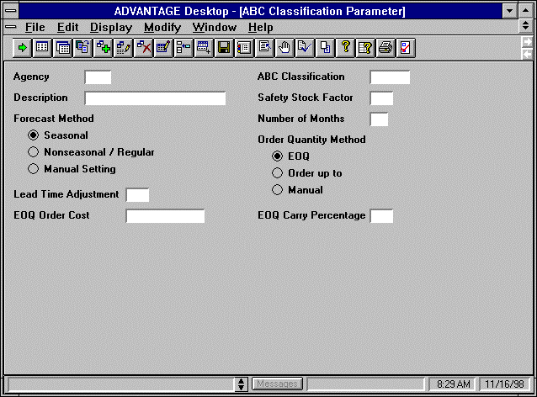

Warehouse Management table (WHS2)

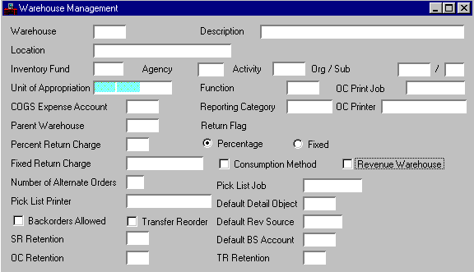
The WHS2 table consists of related information for each storage facility. It displays general information as well as specific operation conditions.

Inventory Inquiry table (INVN)

The INVN table is the most essential screen used and maintained by the Inventory Control subsystem. It stores information about each stock item stored at each storage facility. This window maintains descriptive, purchasing, historical use, reorder and cost information. It also maintains backordered, reserved, released, and in-transfer stock balances. A record is added to this window each time a new stock item is accepted by ADVANTAGE. It is updated when document processors and other off-line processes are accepted.
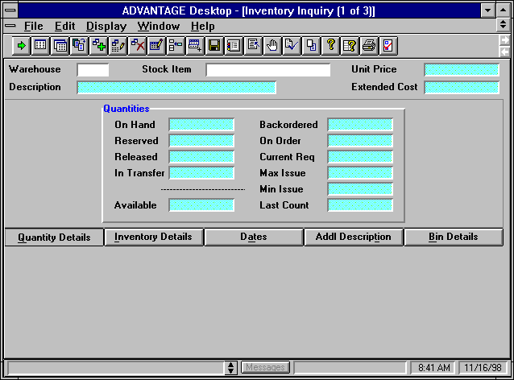

Inventory Inquiry table (INV2)

The INV2 table is an inquiry screen that displays all system-maintained item information. If Transfer Reorder is selected [Y] (for the issuing warehouse) on Warehouse Management (WHS2), the system updates the Issue Plus Transfer Quantity fields (for the issuing warehouse) to reflect the quantities transferred-out using Stock Transfer receipt (TR) documents.
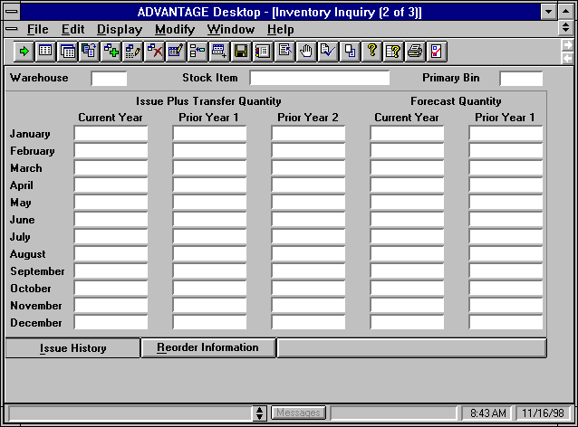

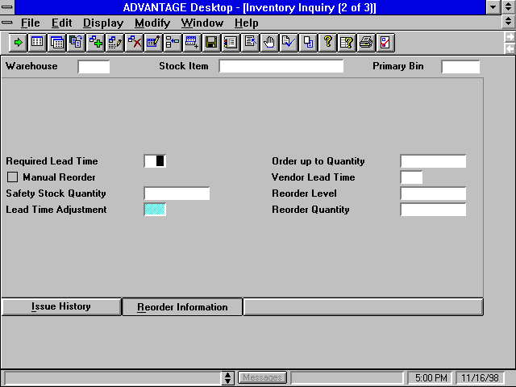
The reorder information tab on the INV2 table is updated to reflect the reorder quantity, reorder level, safety stock quantity fields etc.

Inventory Inquiry table (INV3)

The INV3 table is used to maintain non-system-generated information about stock items. Item account codes, price method options, and inventory control management parameters are set and /or modified using this screen. For the stock items, a technique called ‘smart numbering’ is used wherein all like items are displayed together to make the subsystem easier to use when ordering items.
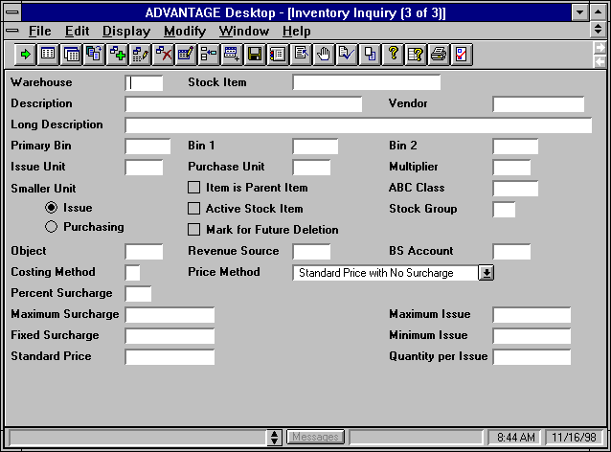

Adjustment Code table (ADJC)

The ADJC table provides a list of valid adjustment codes with descriptions to define the reason for the adjustments to inventory. For each adjustment code, there is an object code to which the accounting entries are posted. The default adjustment code used by the inventory freeze program must have an entry in this table.
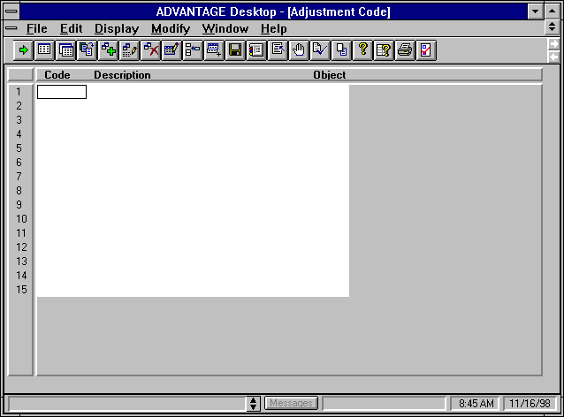

Return Code table (RETC)

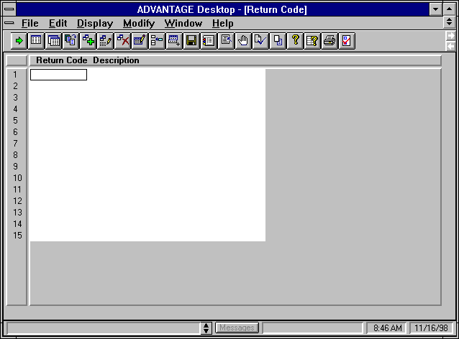
The RETC table is used to interpret valid return codes using the description defining why the stock item is returned to inventory.

Warehouse Group table (WHSG)

The WHSG table specifies the relationship between each central storage facility and its satellite storage facilities.

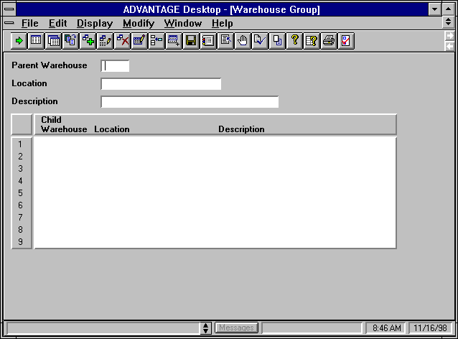

Item Group table (ITMG)

The ITMG table specifies relationships between inventory items. The relationship of parent/child allows the user to request one item (the parent) which consists of two or more stock items (the children).
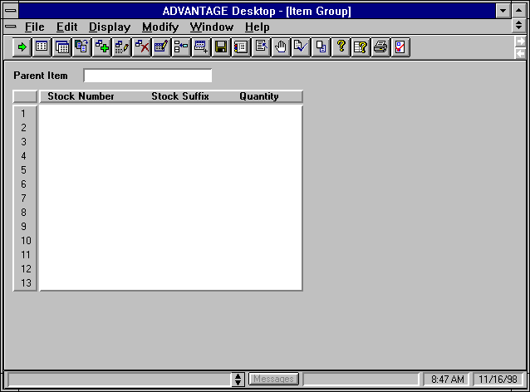

Inventory Setup ‘Task Plan’

This Inventory setup ‘task plan’ describes the step-by-step procedure required to get started using the Inventory Control subsystem:

Task # | Task Description
T-1 | Finalize additional computer equipment installations including communication lines or circuits, terminals or PCs, and laser printers.
T-2 | Identify all consumable inventory system users including appropriate fiscal staff, warehouse managers and warehouse clerks.
T-3 | Identify number of agency storage facilities.
T-4 | Identify and classify a standardized inventory list.
T-5 | Update warehouse management master table (WHSE).
T-6 | Update master table (ABCP) ABC classification parameter table.
T-7 | Update reorder information on INV2.

Once the user maintained tables have been setup, users enter Inventory Adjustment (IA) documents. The Inventory Adjustment (IA) document allows the user to adjust the quantity or unit cost of an item. Since adjustments are classified by an Adjustment Code, the appropriate codes must be defined in Adjustment Code (ADJC) prior to Inventory Adjustment (IA) processing. Storage facilities and Inventory codes must also be defined in Warehouse Management (WHS2) and Inventory Inquiry (1 of 3) (INVN).

Inventory Adjustment
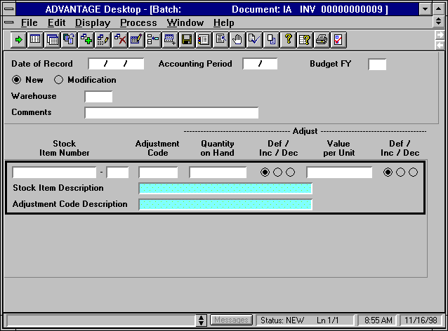

System Maintained Tables

The online mechanism for reviewing inventory reference data consists of the following tables:

- Open Stock Requisition Header Table- OSRH
- Open Stock Requisition Account Line Table- OSRL
- Open Stock Requisition Line Table- OSRC
- Open Stock Requisition Item Issues Table- OSRI
- Open Stock Transfer Receipt Header Table- OTRH
- Open Stock Transfer Receipt Line Table- OTRL
- Inventory Replenishment Table- IREP

Key Off-line Processes

Inventory control provides a series of offline programs to aid in the functionality of the system. These programs use data from the commodity ledger and master tables to perform the following functions:

- Calculate lead time. Calculates projected lead time required to requisition, order, and receive a stock item from a vendor and is also used to calculate safety stock.

- Calculate reorder levels. Calculates the safety stock for each stock item, the reorder level and reorder quantity for each stock item.

- Forecast demand calculation. Calculates demand forecasts for each stock item.

Key Inventory Reports

The Inventory Control subsystem includes various management and planning reports. These reports are identified by a report ID consisting of the letters IN followed by a two-digit number. The reports are normally run monthly or semi-monthly, although they may also be run on request.

Key reports include:

- ABC Analysis Report- IN10
- ABC Classification Report- IN20
- Forecasted Demand and Actual Item Usage History Report- IN30
- Inventory Management Report- IN40
- Inventory Price List by Stock Item Number Report- IN 50

