Manually Routing a PD Document for Approval

- Click the document once to highlight it.
- Choose “Approvals” from the File menu OR click on the red “checkmark” from the toolbar.

- The Approval Creation window opens as shown in Figure 1.
- Select the appropriate template from the list of approval templates on the left. The approval types for the selected template will appear. Manual routing templates have been created to assist in choosing the correct approvals that the document must receive for processing. Select the template that matches the type of document you are routing for approval, i.e. MA/MA Mod - PSC or Invoice. The template includes the approvals that will be required for the document. The listing of newly added templates is included in Table 1.
Table 1 Manual Approval Templates
Catalog Delivery Order/CDO Mod | MA/MA Mod - Program Adm. Contract
CMA/CMA Mod - Internal | MA/MA Mod - Provider Agreements
CMA/CMA Mod - Standard | MA/MA Mod - PSC
CMA/CMA Mod Blanket Agreement | MA/MA Mod - PSC Legal Services
CMA/CMA Mod Fixed Price | MA/MA Mod Internal
CMA/CMA Mod Fluctuating Price | MA/MA Mod-Spec Auth Fin Purchases Approval
CMA/CMA Mod Professional Services Fixed Price | MA/MA Mod Revenue Generating
CMA/CMA Mod Professional Services Fluctuating Price | PO/PO Mod - Internal
CMA/CMA Mod Statewide Purchasing Agreement | PO/PO Mod Standard
Contract/Contract Mod - Construction | Invoice/Inv Mod
Contract/Contract Mod - MOA | Payment Authorization/Payment Auth Mod
Contract/Contract Mod - PSC | PR Insurance
Contract/Contract Mod - PSC Legal Services | PR/PR Mod Agency Small Purchase
Contract/Contract Mod - Property Rental | PR/PR Mod Agency Sm Purchase Commodity Approval
Contract/Contract Mod- Standard | PR/PR Mod Fin Purch Commodity Approval
Contract/Contract Mod-Spec Auth Fin Purchases Approval | PR/PR Mod Finance Purchases Approval
Delivery Order/Delivery Order Mod | PR/PR Mod Natural Resources Approval (Shredders>$1000)
MA/MA Mod Fluctuating Price | PR/PR Mod DIS Approval
MA/MA Mod Grant Agreement | PR/PR Mod Printing
MA/MA Mod - MOA - Internal | PR/PR Mod Construction
MA/MA Mod - MOA
MA/MA Mod - MOU
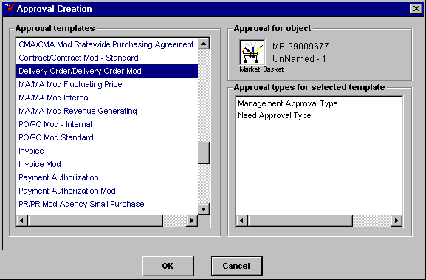
Figure 1

- Click OK.

- The Approval Sheet window opens as shown in Figure 2.
- If you have authority to take approval action, the drop-down box under Approval Types is shown in blue. If it is greyed-out, then you do not have authority to apply the particular approval type. Contact the CRC at (502) 564-9641 if you should have authorization for a certain approval level and do not.
- If you have authority, select an approval action (Approved, Conditionally Approved or Disapproved) from the drop-down table. The default is Unapproved.
- The Approval Authority Confirmation window appears. Enter your Procurement Desktop password.

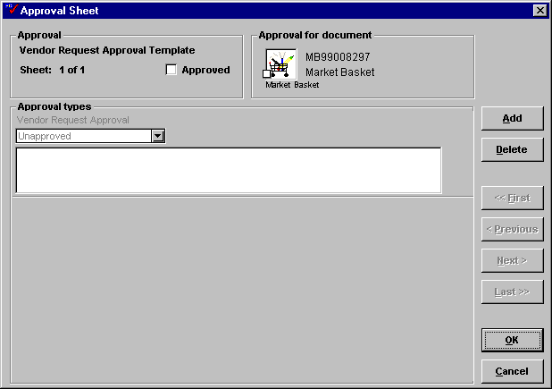
Figure 2

- Click OK.

- When you have completed the approval action, click OK to close.
- Click the document once to highlight it.
- Choose “Route” from the File menu OR drag the document to be routed to your outbox OR click on the envelope from the toolbar.

- The Routing Sheet window opens as shown in Figure 3.
- The list box on the left will default to a list of MARS users. Please select the users within your agency who will apply the required approvals for this document. You can select the user from the user list on the left OR type in the user’s last name in the field above the user list and click on the right arrow (>>).
- You may also select a routing template. A routing template is a pre-defined list of users for routing. For documents that require central approval such as Division of Purchases or LRC, several routing templates have been created to assist you in deciding where to route the document. Choose Route from the drop-down box at the top left of the window and a list of routing templates will replace the list of users. Selecting the appropriate routing template will select all of the users included in this template to be on the routing path. The listing of newly created routing templates is included in Table 2.
Table 2
DIS Approval Route
Div of Printing Approval Route
Finance Prop Rental Approval Route
Finance Purch/LRC Approval Route
Special Authority Approval Route

- Select yourself as the last route stop so that the final approver will route the document back to you.
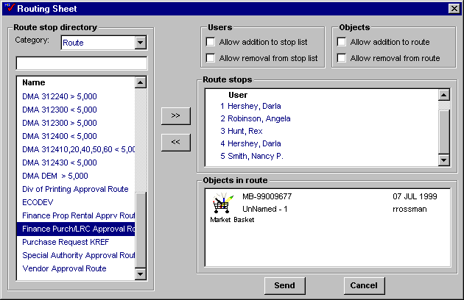
Figure 3

- Click on the send button.

- The document is now routed for approval.
- It will come back to you when it is approved and released.
- On its final approval, the transaction will be initiated in ADVANTAGE.

