TOPIC 1 INTRODUCTION TO SYSTEM ADMINISTRATION

PURPOSE

The purpose of this topic is to ensure you understand that System Administration for PD allows authorized personnel from each agency to maintain the agency’s own preferences for some features associated with the operation of PD. However, many features in PD will be maintained centrally by the Finance and Administration Cabinet. It is important to note that the System Administration features:

- Are global configurations, except where noted,

- Will impact users throughout state government,

- Should be completely thought through before updates are made and,

- Will be controlled via security access.

Objectives

This topic will also cover these basic navigation skills of System Administration:

- Working in a Maintenance Task Window,

- Working in an Information Window, and

- Exiting from a Maintenance Task.

Procurement Desktop Utilties Menu
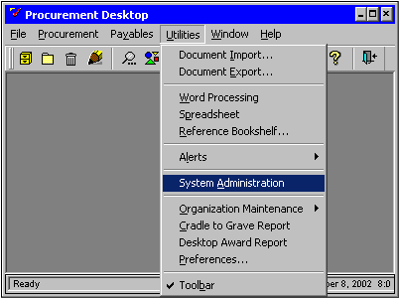

Getting Started
To access the System Administration tasks, perform the following step:

Step 1 On the Menu Bar, select Utilities: System Administration. The System Administration window will be displayed.

Step 2 In the TASK List. Select the desired task. The tasks to which you have access will be listed on the left-hand side.

System Administration
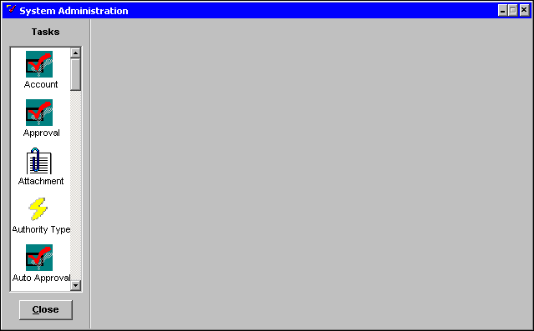

Understanding the Role of System Administration
The System Administration of PD consists of a series of maintenance tasks. Each task is designed to initiate, maintain, monitor, or manage data in the database.

Not all system administrators will have access to all tasks within System Administration. This allows secondary tasks to be managed by agency personnel, while Finance and Administration Cabinet system administrators will control security-related tasks.

System Administration is the backbone of PD and provides the means to customize access for each PD user. Through Finance System Administration, users are given the authority to create, update and/or approve documents. The Finance System Administrators also grant access to the Agency System Administration tasks.

In the Procurement Tasks section of this training, we will discuss the procurement-specific features of the desktop (e.g., maintenance of clause templates) that will be controlled by agency system administrators.

In the Accounting Tasks section of this training, we will discuss the financial features of the desktop (e.g., accounting templates and fixed asset exceptions) that will be controlled by agency system administrators.

Finally, in the Approval Tasks section of this training, we will discuss Team Cabinet and Routing Templates that will be controlled by agency system administrators.

Let’s look at the difference components of a Maintenance Task window.

Maintenance Task window
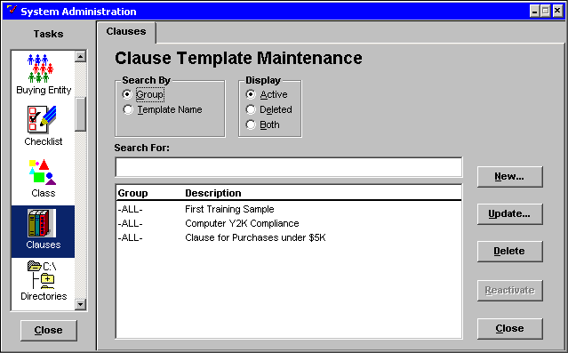

Working in a Maintenance Task Window
Using the Clause Template Maintenance window as an example, the following section introduces you to the various fields that are commonly found on a Maintenance window. We will now discuss the following fields:

SEARCH BY box
DISPLAY box
SEARCH FOR:
<NEW> button
<UPDATE> button
<DELETE> button
<REACTIVATE> button
<CLOSE> buttons

Search By Box
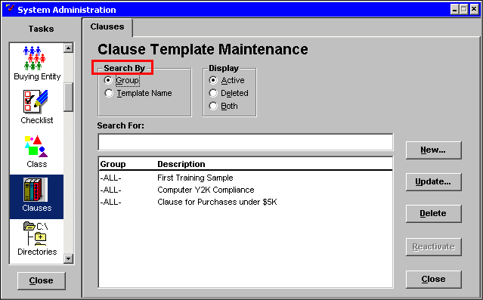

Search By Box
A SEARCH BY box consists of radio buttons that offer a choice as to how a value is searched and sorted in a list of values. The default is the top selection whenever a maintenance window is opened. For example, in the Clause Template Maintenance window, the SEARCH BY box has two radio buttons: Group and Template Name.

The <GROUP> radio button is to view the list of clause templates alpha-numerically by group.

The <TEMPLATE NAME> radio button is to view the list of clause templates alpha-numerically by description.

Display Box
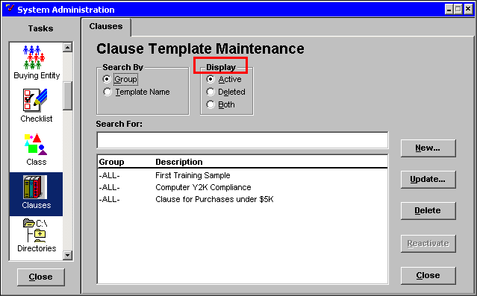

Display Box
Another common field in a Maintenance window is the DISPLAY box. This box also contains radio buttons that can be selected to display different information on the list. The default is the top selection (Active) whenever a maintenance window is opened. The <ACTIVE>, <DELETED>, and <BOTH> radio buttons are described below:

The <ACTIVE> radio button displays values, such as a group or class, which are available for use in the system.

The <DELETED> radio button displays values that are not available for use in the system. However, any existing references will continue to use the deleted information. In addition, if needed, some deleted values may be reactivated.

The <BOTH> radio button displays both active and deleted values.

Search For
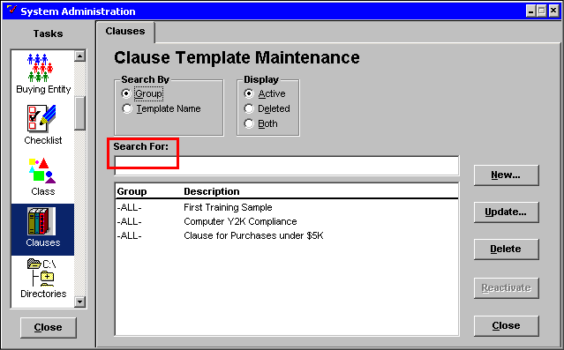

Search For
The SEARCH FOR field is used to help find a particular value from the list. Partial information can be entered in this field. The cursor will highlight the closest match as you enter the information. You can search for a clause template by either Group or Template Name. To search by Group, click on the <GROUP> radio button and enter a Group in the SEARCH FOR field. To search by Template Name, click on the <TEMPLATE NAME> radio button and enter the name of the template in the SEARCH FOR field.

Information Window
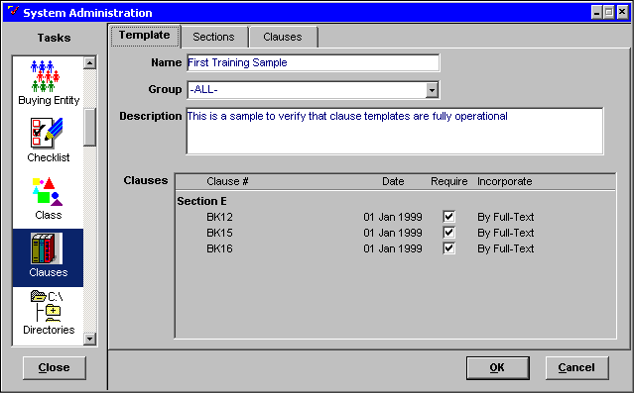

Information Window
Most of the Maintenance Task windows have Information windows where you can add or update information for a particular task. The above screen shot shows an Information window. Information windows open when the <NEW> or <UPDATE> button is clicked on a Maintenance window.

The <NEW> button opens an Information window that allows you to enter new information into the database.

The <UPDATE> button opens an Information window that allows you to modify information that was originally entered.

clauses Tab
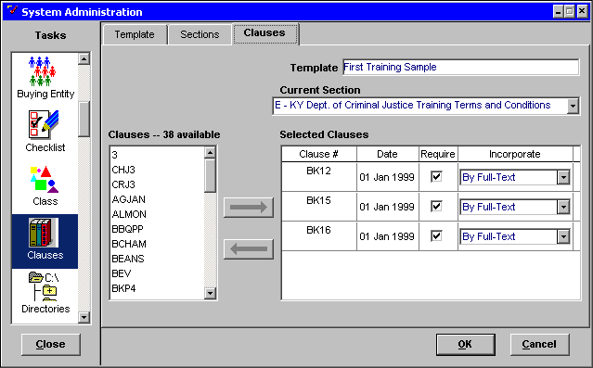

Tabs
When you click on a tab name, a different window will be displayed for new information to be entered. For example, when you click on the Clauses tab, the Available Clauses window will be displayed.

AVAILABLE BOX: The left-hand box lists all the items available that can be selected to add to the selected box.

SELECTED BOX: The right-hand box contains the information that has been selected for the task.

ARROWS: The arrows transfer information back and forth between the AVAILABLE BOX and the SELECTED BOX.

<OK>: When you click on the <OK> button, any information entered in the task is saved to the database and the window closes.

<CANCEL>: When you click on the <CANCEL> button, the window closes and no information is saved to the database.

DELETE button
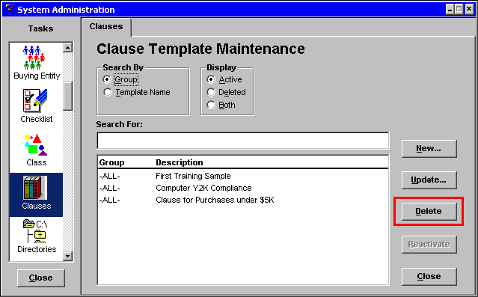

Delete Button
Clicking on the <DELETE> button box opens a confirmation dialog box that allows you to verify the deletion of an item. In some cases, there are several dialog boxes opened depending on the circumstances associated with the item that is being deleted. If a <REACTIVATE> button is displayed, a deleted item will appear in the Deleted Maintenance window. If no <REACTIVATE> button is displayed, the data is completely deleted from the system.

REACTIVATE and close buttons
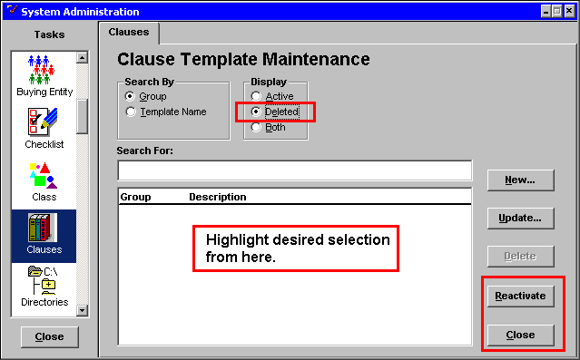

Reactivate and Close Buttons
Clicking on the <REACTIVATE> button opens a confirmation dialog box that allows you to verify the reactivation of an item. When an item is reactivated, it will appear in the Active Maintenance window.

Clicking on the right <CLOSE> button closes the Maintenance window, whereas clicking on the left <CLOSE> button closes the System Administration window.



In this topic we have learned:

- How to work with a Maintenance Task window,

- How to work with an Information window,

- The role of Systems Administration within PD.

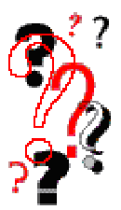

Are there any questions concerning the information covered in this topic?

