TOPIC 2 PROCUREMENT TASKS

PURPOSE

The purpose of this topic is to ensure that you have an understanding of the basic procurement tasks for maintaining the desktop.

OBJECTIVES

By the completion of this topic, you should be able to:

- Create Attachments Templates,

- Create Checklist Templates,

- Create Clause Templates and,

- Create Evaluation Criteria and Evaluation Criteria Templates.

System Administration Task
Only the tasks that the user has access to will appear on the left-hand side of the screen. To open a task, simply click once on the icon. Once inside a task, you can perform any of the actions available for that task.

First, let’s talk about Attachments.

Attachment Template
In System Administration, you are able to set up pre-defined template documents for attachments. The template documents are word processing or spreadsheet files that are created outside of the system and are imported into PD.

PD users will generally employ this functionality when a standardized spreadsheet is a required element of a contract or when a form or questionnaire needs to be attached to a purchase request, contract, or delivery order.

In the System Administration Attachment task you:

- Define an attachment template.

For example, your agency may require each division to complete a Request Form when the division wishes to purchase equipment. The Request Form can be imported into PD as an attachment template and the division can electronically attach the form to their purchase document.

- Associate the template with the All Documents module type.

There are nine module types listed in the drop down list, however, some of the associations do not work. To play it safe, always associate your template to the All Documents module.

Let’s access the Attachment task.

Attachment maintenance
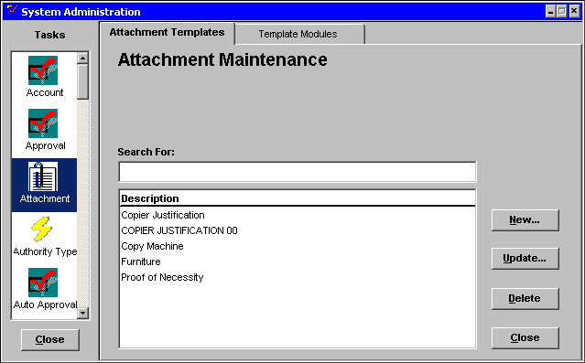

Creating Attachment Templates
Step 1 In System Administration window. Scroll down the in the selection scroll bar and click once on the Attachment icon. The Attachment Maintenance window will be displayed.

You will notice that there are two tabs in the Attachment Maintenance window. Through these tabs, you can create, maintain and delete attachment templates, as well as associate them with a desktop module.

To establish a new attachment, you must:

- Create a template document by generating a word processing (e.g., Word) or spreadsheet (e.g., Excel) document,

- Import the template document into the Procurement Desktop Attachment Maintenance task, and

- Associate the template document with the All Documents module.
From the Attachments Template tab, you can:

- Define a <NEW> attachment template for use in PD,

- <UPDATE> the attachment template contents, and

- <DELETE> the association of the attachment template.

Any existing templates appear in the DESCRIPTION list box. When you create a new template, it will be added to this list.

Now we will use an existing word processing document to create an Attachment Template. Let’s continue with creating an attachment template.

Step 2 Click on the <NEW> button. The Attachment Template Maintenance window will be displayed.

Attachment Template maintenance
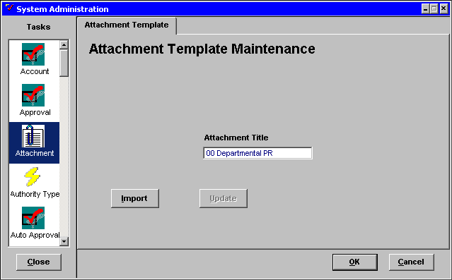

Step 3 In the ATTACHMENT TITLE field. Type ☺☺ Departmental PR.

Step 4 Click on the <IMPORT> button. A File Directory window will be displayed.

File Directory
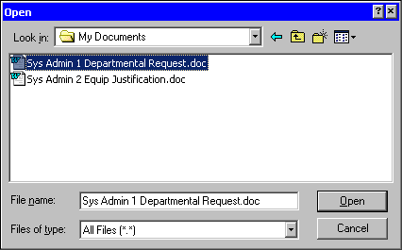

Step 5 On the Open window in the Look In drop down list. Select the F: drive

Step 6 Highlight the file Sys Admin 1 Departmental Request.

Step 7 Click on the <OPEN> button. The file is imported into your PD template and you are returned to the Attachment Template Maintenance window.

Notice that the <UPDATE> button is now active. The <UPDATE> button enables you to edit the imported document within PD.

Step 8 Click on the <OK> button. You are returned to the Attachment Template tab.

Attachment Templates
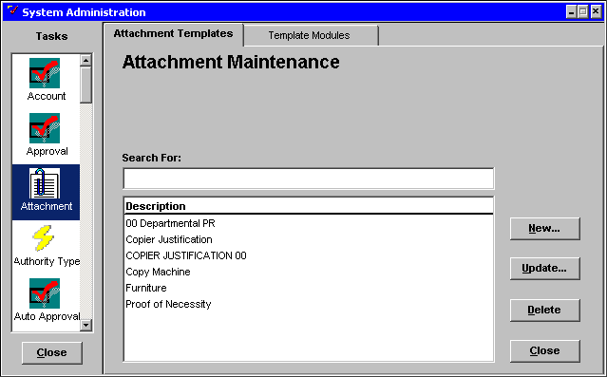

The document is now associated with the Attachment Template ☺☺ Departmental PR, and this new title will appear in the DESCRIPTION list.

Next we will associate the Attachment Template with the All Documents Desktop Template module.

Template Module Maintenance
PD requires that all template information be associated to a PD module. Selecting a module is supposed to be used to associate your template to specific PD documents (i.e. Pre-Award and Post-Award). However, we have discovered that some of the associations to do work. To insure that your template can be used with the appropriate document, it is recommended that you always select the All Documents module.
Caution: If changes to your attachment document are necessary, you can update your original file and re-import to PD. However, before you can re-import the updated file into the existing template, you must delete the Template Module association. If you attempt to re-import the updated file to the existing template without first deleting the module association, you will receive the following Data Window Error.

DATA WINDOW ERROR
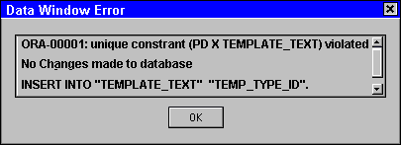

Template Module Maintenance
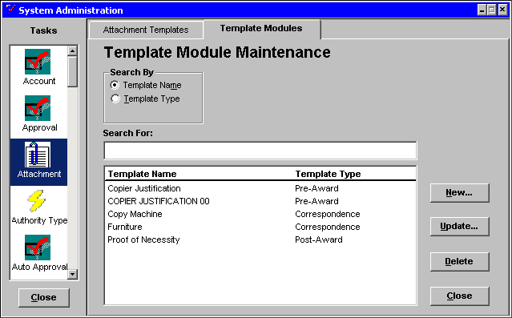

Associating an Attachment Template with a Module
From the Template Module Maintenance window you can:

- Associate a template with a Procurement Desktop module, or

- Delete the association between the word processing or spreadsheet template document and the Desktop Module.

Let’s now associate the Attachment Template with the All Documents Module.

Step 1 Click on the Template Modules tab. The Template Module Maintenance window will be displayed. The window displays the Template Name and Template Type for any existing templates.

Step 2 Click on the <NEW> button. The Attachment Module Maintenance window will be displayed.

Attachment Module Maintenance
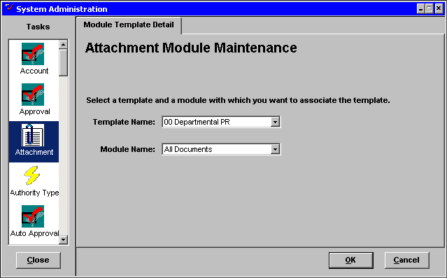

Step 3 In the TEMPLATE NAME drop down list box. Highlight the ☺☺ Deparmental PR to assign the template to a module name.

NOTE: The TEMPLATE NAME drop down list box contains the names of templates that were previously created in the Attachment Template tab.

Step 4 In the MODULE NAME drop down list box. Highlight the pre-defined desktop module All Documents to correspond with your selected template name

Step 5 Click the <OK> button to save the association.

You have now created a template for PD users to attach to PD documents.

Template Module maintenance
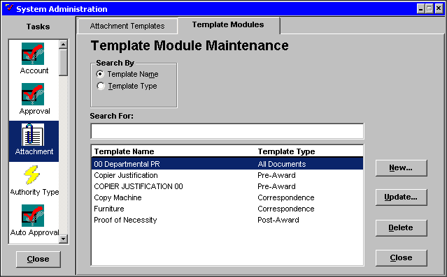

Deleting a Template Module
Step 1 In the Template Module Maintenance window. Highlight or SEARCH FOR the template name ☺☺ Departmental PR.

NOTE: The SEARCH FOR field is used to help find a particular value from the list. Partial information can be entered in the SEARCH FOR field. The cursor will highlight the closest match.

Step 2 Click on the <DELETE> button on the Template Module Maintenance window. A Procurement Desktop Confirmation window will be displayed.

Confirmation window
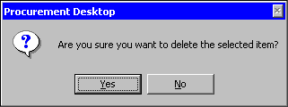

Step 3 Click on the <YES> button.

NOTE: Clicking the <NO> button would exit the window without deleting the Template Module.

We will now look at how Attachment Templates can be updated.

Updating an Attachment Template
Once you have an existing template in place for your organization, you may want to periodically maintain or update the template. You may change the template by using one of the following methods:

A. Within PD: Select the template name from the Template Maintenance tab in System Administration,

OR
B. Outside PD: Modify the template document in the appropriate word processing or spreadsheet application.

NOTE: If you update a template document outside of PD, you will need to delete the module association and re-import the information into the Attachment task.

Each of these update methods will be discussed in the next few pages.

Attachment maintenance
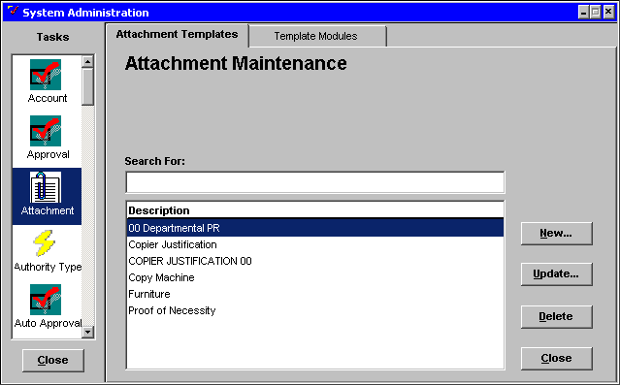

Updating a Template Attachment Within PD
Step 1 Click on the Attachment Templates tab. The Attachment Maintenance window will be displayed.

Step 2 In the DESCRIPTION list. Highlight the ☺☺ Departmental PR template name.

Step 3 Click on the <UPDATE> button. The Attachment Template Maintenance window will be displayed.

Attachment Template maintenance
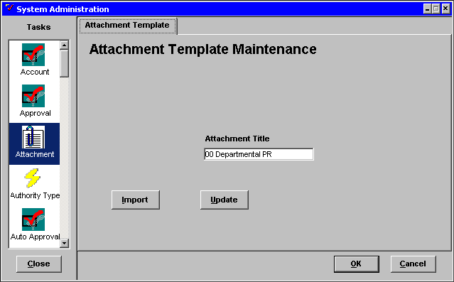

Step 4 Click on the <UPDATE> button to launch the third party tool (e.g. word processing or spreadsheet). The imported MSWord document will be displayed.

MS WORD DOCUMENT
Department Purchase Request | Date:
Department Purchase Request | Phone::
Department Purchase Request | Ship to attn.:
Division/Branch: | Ship by (date):
Description/Suggested Vendor | Estimated Price
Total Request Amount: | $

Step 5 Make your changes on the MSWord document. Replace Department with your agency’s name.

MS WORD
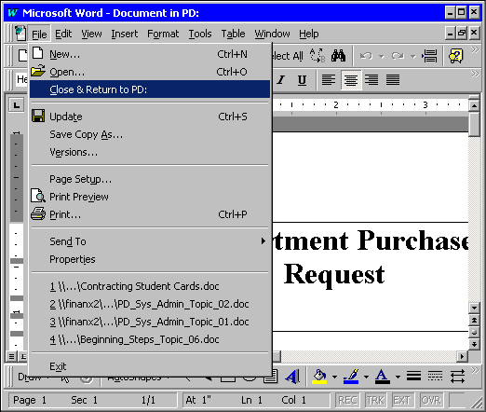

Step 6 On the MS Word Menu Bar, Select File: Close & Return to PD. The document closes, but MSWord is still open.

Step 7 In MS Word on the Menu Bar, select File: Exit to close the application. A warning message window is displayed.

Warning Message
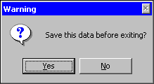

Step 8 Click on the <YES> button. You are returned to the Attachment Template Maintenance window.

NOTE: Clicking the <NO> button would exit the application without saving the changes.

Attachment Template
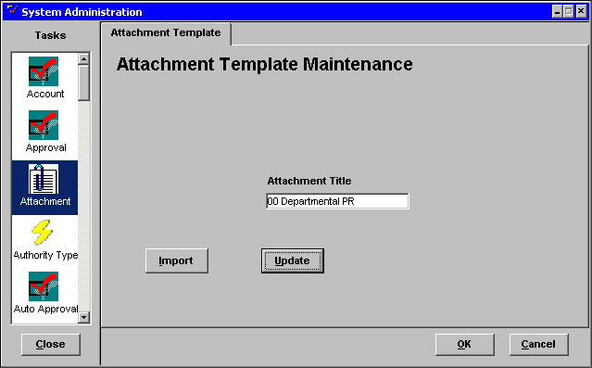

Step 9 Click on the <OK> button to save the modified template.

NOTE: Clicking the <CANCEL> button would close the window without saving any changes.

Attachment Templates
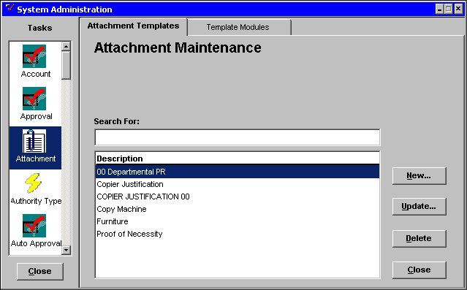

Updating a Template Attachment Outside of PD
Since we previously deleted the module association for the ☺☺ Departmental PR template, you can follow the steps below to modify the template outside of PD:

Step 1 Click on the Attachment Templates tab. The Attachment Maintenance window will be displayed.

Step 2 In the DESCRIPTION list. Highlight the ☺☺ Departmental PR template name.

Step 3 Click on the <UPDATE> button. The Attachment Template Maintenance window will be displayed.

Attachment Template maintenance
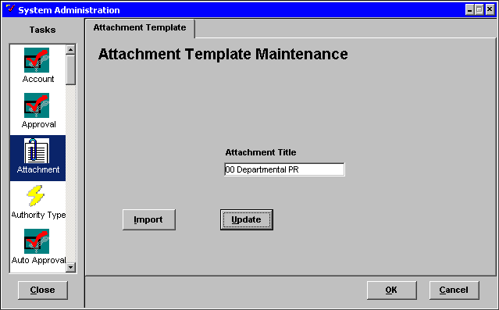

Step 4 Click the <IMPORT> button to import an updated file to replace the old file in this template. A Warning dialog window will be displayed.

Warning dialog window
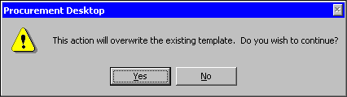

Step 5 Click the <YES> button to continue. The desktop Open window will open.

Open
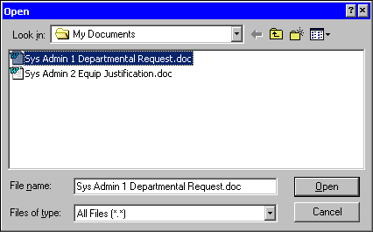

Step 6 In the Open window. Highlight the file Sys Admin 1 Departmental Request and click on the <OPEN> button. You are returned to the Attachment Template Maintenance window

Step 7 Click on <OK> to save the modified template.

Before the updated template can be used, you would need to click on the Template Modules tab and re-associate with the All Documents module.

NOTE: Click the <CANCEL> button to exit the window without saving the changes.

NOTE: Only future attachments using this template will be affected by these updates. Existing attachments that used the prior, non-updated template will not change.

Attachment templates
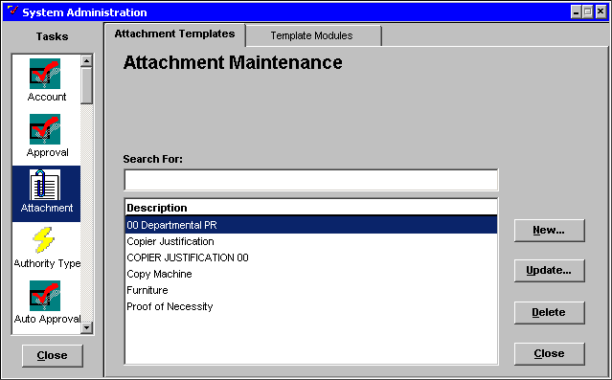

Deleting an Existing Attachment Template
Step 1 In the Attachment Maintenance window. Highlight ☺☺ Departmental PR

Step 2 Click on the <DELETE> button. A Procurement Desktop Confirmation window will be displayed, asking if you are sure you want to delete the item.

Confirmation window

Step 3 Click on the <YES> button to confirm the deletion.

NOTE: Clicking the <NO> button would exit the window without deleting the template.

Let’s do an Attachment Template exercise.

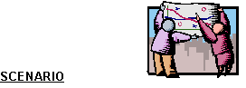
When someone in your agency wishes to purchase equipment, your cabinet requires an Equipment Justification form be electronically attached to the Purchase Request. The Equipment Justification form is on your F:\ drive in Word format.

Using the information above, prepare an Equipment Justification attachment template and associate the template with the All Documents PD module.

Attachment maintenance
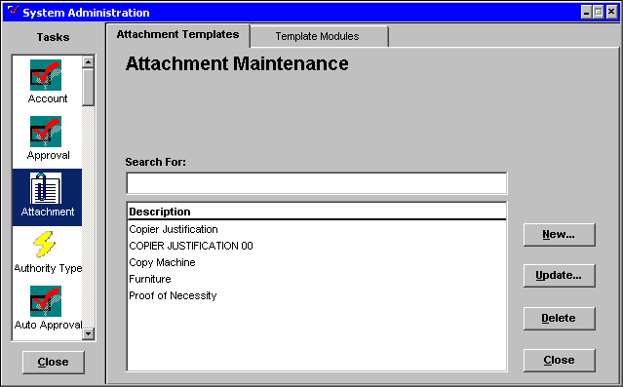

Step 1 In System Administration window. Scroll down the Tasks list and click once on the Attachment task icon.

Step 2 On the Template Maintenance tab. Click the <NEW> button.

Attachment template maintenance
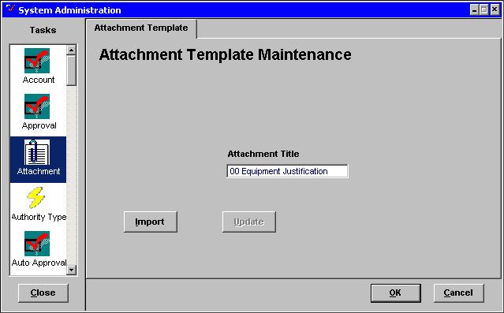

Step 3 In the ATTACHMENT TITLE field. Enter ☺☺ Equipment Justification.

Step 4 Click on the <IMPORT> button. A File Directory window is displayed.

open
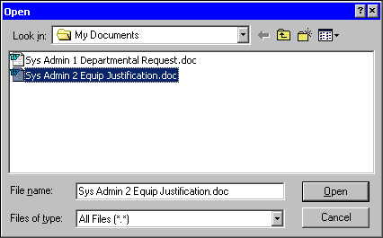

Step 5 In the Open window. Highlight the Sys Admin 2 Equip Justification.

Step 6 Click on the <OPEN> button. The file is imported to PD. You are returned to the Attachment Template Maintenance window.

Step 7 Click on the <OK> button to save your work.

Now let’s associate the Attachment Template with a PD Module.

Template Module maintenance
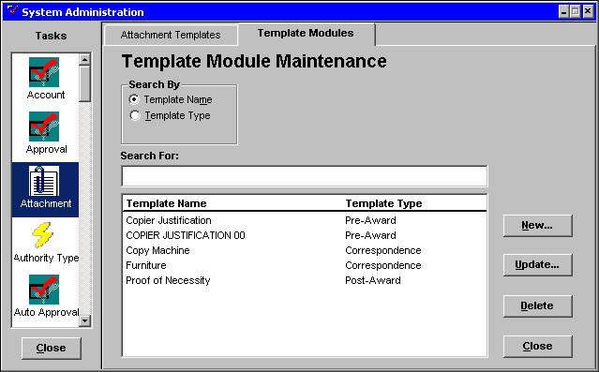

Associating the Attachment Template with a PD Module
Step 1 Click on the Template Module Maintenance tab.

Step 2 Click on the <NEW> button. The Attachment Module Maintenance window will be displayed, allowing you to associate a template with a module.

Attachment module maintenance window
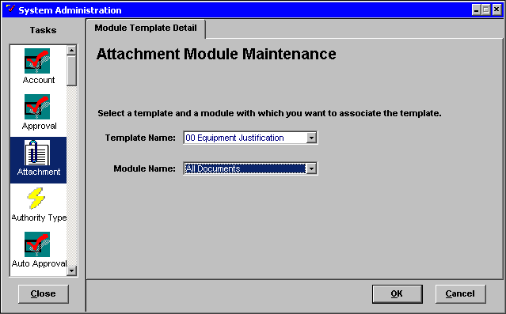

Step 3 In the TEMPLATE NAME drop down list box. Highlight ☺☺ Equipment Justification.

Step 4 In the MODULE NAME drop down list box. Highlight All Documents to correspond with your selected template name.

Step 5 Click on the <OK> button. Your Equipment Justification attachment Template is now associated with the module All Documents desktop module.

We will now go through the steps of how a Checklist Template can be created.

Checklist template maintenance
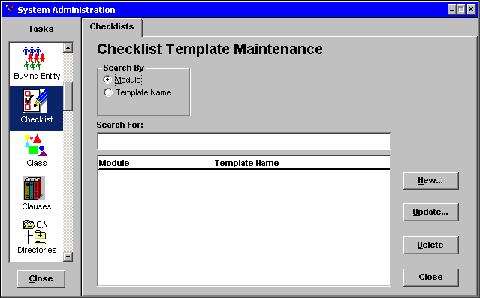

Creating a Checklist Template
Step 1 In the TASK list. Scroll down and click on the Checklist task icon. The Checklist Maintenance window will be displayed.

Step 2 Click on the <NEW> button. The Checklist Maintenance information window will be displayed.

Checklist Maintenance
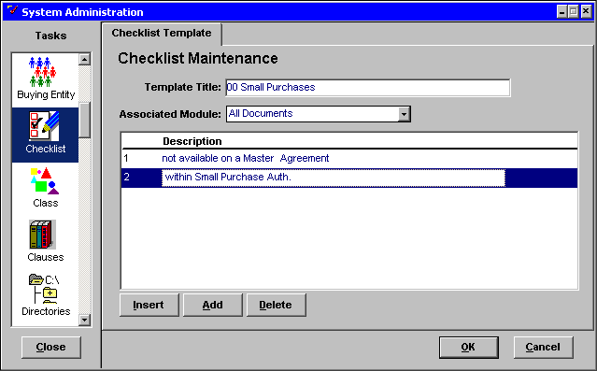

Step 3 In the TEMPLATE TITLE field. Enter ☺☺ Small Purchases.

Step 4 In the ASSOCIATED MODULE drop down list. Highlight the All Documents Module.

Step 5 Click on the <ADD> button to add the first checklist item. A description of the activity or procurement action performed must be entered.

NOTE: You may add as many steps as you need, however only seven can be viewed in the window and at the present time, there is no scroll bar. Use your <TAB> key or mouse wheel to scroll to steps greater than seven.

Step 6 In the DESCRIPTION field. Enter not available on a Master Agreement.

Step 7 Click on the <ADD> button.

Step 8 Click in the blank area next to the number 2.

Step 9 In the new DESCRIPTION field. Enter within Small Purchase Auth.

Step 10 Click on the <OK> button to save the new checklist template.

NOTE: Clicking on the <CANCEL> button would exit the window without saving the data.

Checklist Template maintenance
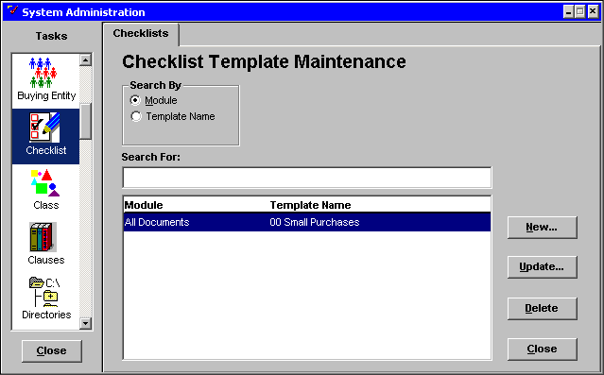

Updating a Checklist Template
Let’s insert an item into the Checklist Template we just created.

Step 1 In the MODULE/TEMPLATE NAME display list. Highlight ☺☺ Small Purchase.

Step 2 Click on the <Update> button. The Checklist Maintenance Information window will be displayed.

Checklist maintenance
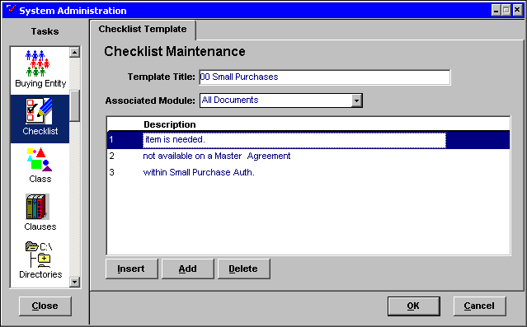

Step 3 In the DESCRIPTION list. Highlight not available on a Master Agreement. You want the new inserted item to precede the highlighted Checklist Item.

Step 4 Click on the <INSERT> button. A new line is inserted above the highlighted Checklist Item and is now Checklist Item number one.

Step 5 In the new checklist item DESCRIPTION field. Enter item is needed.

Step 6 Click on the <OK> button to save the changes.

NOTE: Clicking on the <CANCEL> button would exit the window without saving the changes.

NOTE: You can delete any of the Checklist steps by highlighting the Checklist Item and clicking on the <DELETE> button.

Checklist Template Maintenance

Deleting a Checklist Template
Step 1 In the Checklist Template Maintenance window. Highlight the ☺☺ Small Purchase.

Step 2 Click on the <DELETE> Button. A Procurement Desktop Confirmation window will be displayed.

Step 3 Click on the <YES> button to confirm the deletion.

NOTE: Clicking on the <NO> button would exit the window without deleting the Checklist Template.

NOTE: Since there is no <REACTIVE> button, the information is permanently deleted from PD.

Establishing Clause Templates
Clauses are loaded into the system by GOT through DMPS.

Each of the following PD forms contains access to information related to clauses and their assembly.

- Solicitation and Solicitation Modification,

- Contract and Contract Modification,

- Purchase Order and Purchase Order Modification,

- Delivery Order and Delivery Order Modification, and

- Catalog Deliver Order and Catalog Delivery Order Modification.

Each individual clause will be stored in Rich Text Format (RTF) and can be edited in a Microsoft Word document once assembled. Clauses can be added by section, ID, or by Template.

System Administrators can create, update, delete and reactivate clause templates through the Clauses task.

Creating a new clause template consists of three parts. You must enter information on the following tabs.

- Template tab
- Sections tab
- Clauses tab

Let’s create a Clause Template.

Clause Template maintenance
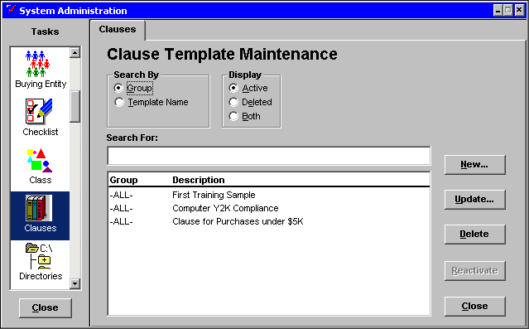

Creating a Clause Template
Step 1 In System Administration window. Scroll down the TASK List and click once on the Clauses icon. The Clause Template Maintenance window will be displayed.

Step 2 Click on the <NEW> button. The Clause Template Maintenance information window will be displayed.

Template tab
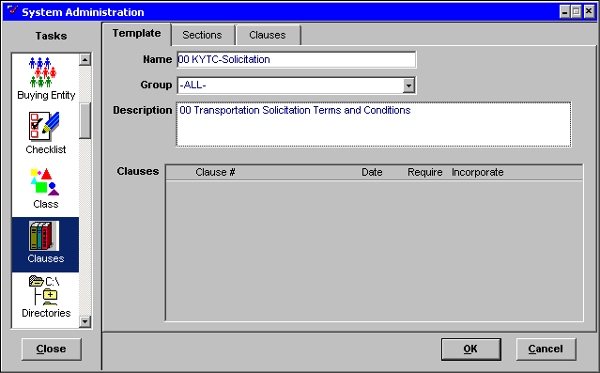

The Template tab allows you to enter descriptive information about the template. The top of the window contains fields for you to enter information. The bottom of the window will list all clauses you associate with this template.

Step 3 In the NAME field. Enter ☺☺ KYTC-Solicitation for the name of the clause template you are creating

The GROUP field defaults to All groups. Selection of a specific group (i.e. 775BUY, or C35PUR) is optional, but should be used to filter groups of clause templates because multiple workgroups share the server. For example, if the Buyers in the Transportation Cabinet are the only ones that should use this template, you would select the group C35PUR.

Step 4 In GROUP drop down list box. Leave As Is.

Step 5 In the DESCRIPTION field. Enter ☺☺ Transportation Solicitation Terms and Conditions as the description of the template.

Sections tab
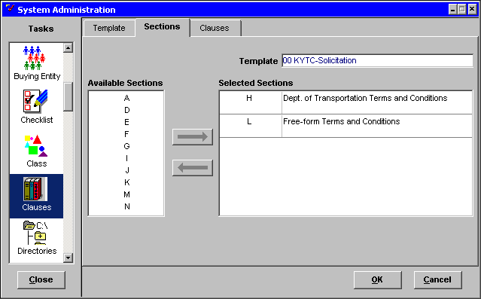

Step 6 Click on the Sections tab. The Sections Template Selection window will be displayed.

Clauses are grouped into sections, with each section containing clauses from a single agency. For instance, clauses for the Department for Material and Procurement Services are included in section M, while clauses for the Transportation cabinet reside in section H.

Step 7 In the Available Sections list on the left. Highlight Sections H and L.

Step 8 Click on the <RIGHT ARROW> button. The Available Sections you highlighted are moved to the Selected Sections list on the right.

The Selected Sections list contains all the sections selected for this template.

Clauses tab
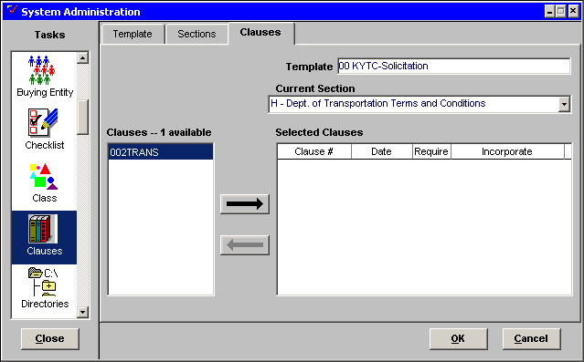

Step 9 Click on the Clauses tab. The Available Clauses window will be displayed.

The TEMPLATE field contains the template name from the Template tab.

All clauses that are associated with the CURRENT SECTION (i.e. H- Dept of Transportation Terms and Conditions)for the selected group are listed in the Clauses list.

Step 10 In the CLAUSES list. Highlight the clause 002Trans.

Step 11 Click on the <RIGHT ARROW> button.

Step 12 In the CURRENT SECTION field. Select L from the drop down box.

Step 13 In the Clauses list. Highlight Free.

Step 14 Click on the <RIGHT ARROW> button.

NOTE: You may select multiple clauses at once by holding down your <CTRL> button and clicking on each clause that you wish to move to the Selected Clauses list.

Check the Require box only when a clause cannot be used as a standalone clause. If the box is marked, and a user adds the template to their document, the user cannot delete the clause from the template. If the Require box is left blank, the user has the option of removing any clauses that do not pertain to their document.

Step 15 The REQUIRE checkbox defaults as blank. Leave Blank. The clause will not be required in the template.

Options for the INCORPORATE field are:

- By Full Text,
- By Full Text Only,
- By Reference, and
- By Reference Only.

The Incorporate field determines whether or not the text of the clause appears as part of the document or if there is only a reference to the clause. The Full-Text options will allow the user to view and/or print the actual MSWord document. The By Reference options do not generate a MSWord document for either viewing or printing.

When a clause is marked as By Full Text Only or By Reference Only, the template user may not change the default selection. If a clause is marked as By Reference, then template users can upgrade the clause in their document to By Full-Text.

Step 16 In the INCORPORATE drop down list box. Highlight By Full Text Only to determine how the clause will be incorporated when it is assembled.

Step 17 Click on the <OK> button to save the Clause Template.

Establishing Evaluation Criteria
PD provides users the ability to assign Best Value Criteria, such as Price, Personnel Experience, or Number of Employees, to a solicitation document and score the criteria in the resulting bid evaluation document. When creating a solicitation document, users have the option to create free-form criteria or select System Administration defined criteria. The master list containing pre-defined Best Value criteria, as well as the templates that utilize this list, are created and maintained by agency system administrators.

The Evaluation Criteria task consists of the following tabs:

- Template Maintenance: From this tab, you can create, update, delete, or reactivate Best Value Criteria templates.

- Detailed Best Value Criteria: From this tab, you can create, update or delete Best Value Criteria.

Let’s create a Best Value Criteria Template.

Evaluation Criteria Maintenance – Templates

Template maintenance tab
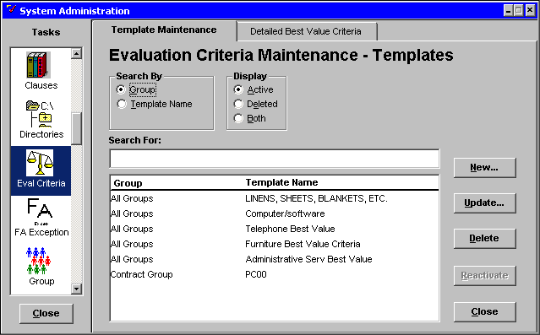

Creating an Evaluation Criteria Template
Step 1 In the System Administration window. Scroll down the Task list and click once on the Eval Criteria icon. The Evaluation Criteria Maintenance – Templates window will be displayed.

Step 2 Click on the <NEW> button. The Evaluation Criteria Maintenance – Template information window will be displayed.

Template tab
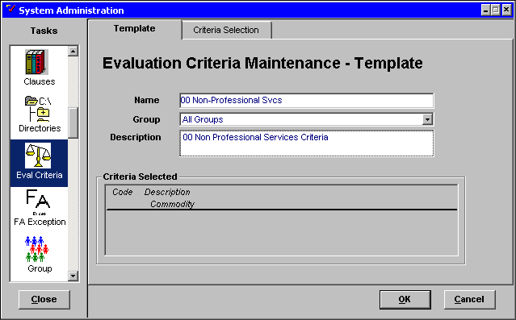

Step 3 In the NAME field. Enter ☺☺ Non-Professional Svcs as the template name

Step 4 In the GROUP drop down list box. Leave As Is.

NOTE: You could also select one specific group to give authorization to use this template, but All Groups is a safer selection since most agencies consist of more than one group.

Step 5 In the DESCRIPTION field. Enter ☺☺ Non-Professional Services Criteria as the description.

Step 6 Click on the Criteria Selection tab. The Evaluation Criteria Maintenance – Template Criteria Selection Information window will be displayed.

Criteria Selection tab
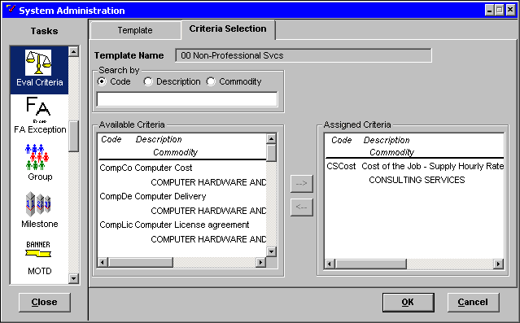

Step 7 In the AVAILABLE CRITERIA list box. Highlight the code CSCost (Cost of the Job).

NOTE: You can use Ctrl + Click and randomly highlight criteria.

Step 8 Click the <RIGHT ARROW> to move the stops to the ASSIGNED CRITERIA list box.

Step 9 Click on the <OK> button to save the data.

NOTE: Clicking on the <CANCEL> button would exit the window without saving the data.

Let’s update the Evaluation Criteria Template you just created.

Template Maintenance tab
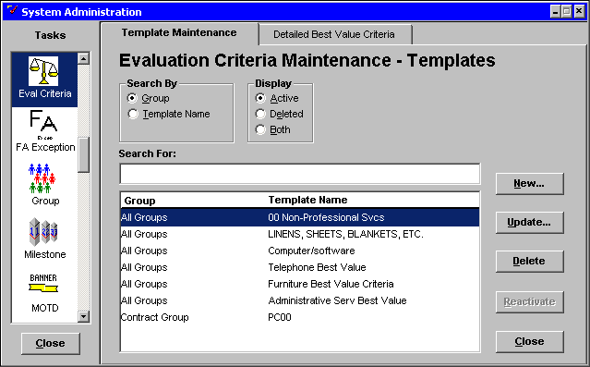

Updating an Evaluation Criteria Template
Step 1 In the GROUP/TEMPLATE NAME list. Highlight the template ☺☺ Non-Professional Svcs.

Step 2 Click on the <UPDATE> button. The Evaluation Criteria Maintenance – Template Information window will be displayed.

Template tab
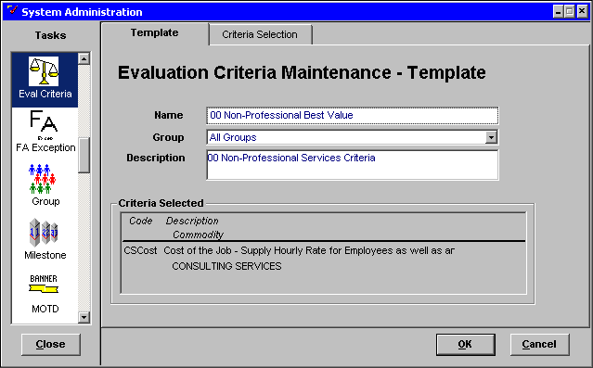

From this window, you can change the name or description of the template, and/or select a new user group.

Step 3 In the NAME field. Change the template name to ☺☺ Non-Professional Best Value.

Step 4 Click on the Criteria Selection tab. The Evaluation Criteria Maintenance – Template Criteria Selection Information window will be displayed.

Criteria Selection tab
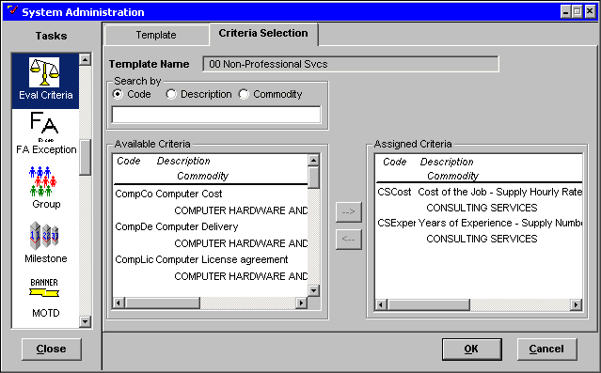

From this window, you can add or subtract evaluation criteria to or from the template.

Step 5 In the AVAILABLE CRITERIA display list. Highlight the code CSExper (Years of Experience).

Step 6 Click the <RIGHT ARROW> button to add the criteria to the template.

Step 7 Click the <OK> button to save the changes.

NOTE: Clicking on the <CANCEL> button would exit the window without saving the changes.

Let’s delete the Evaluation Criteria Template we just updated.

Evaluation Criteria maintenance - Templates
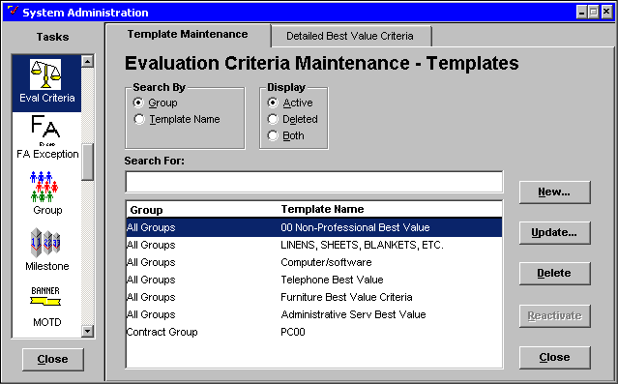

Deleting a Evaluation Criteria Template
Step 1 In the GROUP/TEMPLATE NAME field. Highlight the template ☺☺ Non-Professional Best Value.

Step 2 Click on the <DELETE> button. A Procurement Desktop Confirmation window will be displayed.

PD Confirmation window

Step 3 Click the <YES> button to confirm the deletion.

NOTE: Clicking on the <NO> button would exit the window without deleting the Evaluation Criteria Template.

Reactivating an Evaluation Criteria Template
Step 1 In the Display box. Click the <DELETED> radio option button

Step 2 In the GROUP/TEMPLATE NAME field. Highlight the template name ☺☺ Non-Professional Best Value.

Step 3 Click on the <REACTIVATE> button. A Procurement Desktop Confirmation window will be displayed.

Step 4 Click on the <YES> button to reactivate the template.

NOTE: Clicking on the <NO> button would exit the window without reactivating the Evaluation Criteria Template.

Evaluation Criteria Maintenance – detailed Best Value
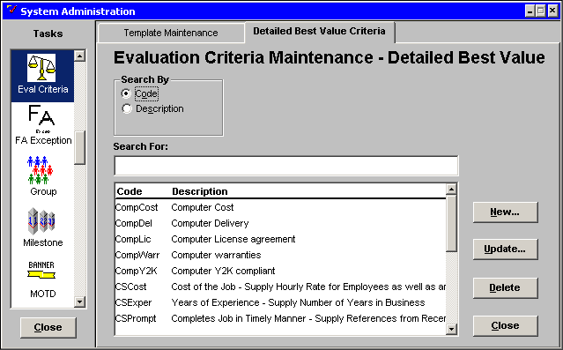

Creating a Detailed Best Value Criterion
Step 1 Click on the Detailed Best Value Criteria tab. The Evaluation Criteria Maintenance – Detailed Best Value window will be displayed.

Step 2 Click on the <NEW> button. The Evaluation Criteria Maintenance – Best Value information window will be displayed.

Best Value Criteria tab
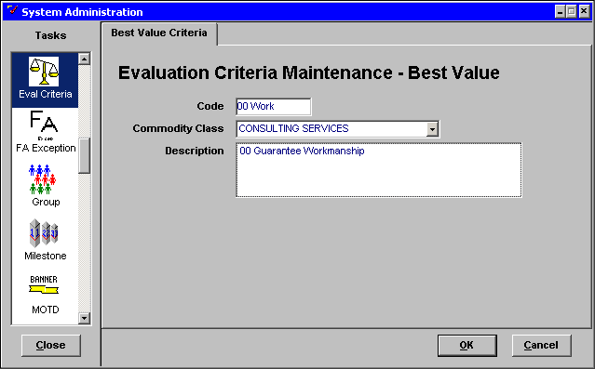

Step 3 In the CODE field. Enter ☺☺ Work.

Step 4 In the COMMODITY CLASS drop down list. Highlight CONSULTING SERVICES to associate the criteria.

Step 5 In the DESCRIPTION field. Enter ☺☺ Guarantee Workmanship.

Step 6 Click on the <OK> button to save the data.

NOTE: Clicking on the <CANCEL> button would exit the window without saving the data.


In this topic we have:

- Learned how to create templates that can be utilized by Procurement Desktop users for Attachments, Checklists, Clauses and,

- Established Vendor Best Value Evaluation Criteria to facilitate contract awards.



Are there any questions concerning the information covered in this topic?

