TOPIC 3 ACCOUNTING TASKS

PURPOSE

The purpose of this topic is to ensure that you have an overall understanding about the creation of account templates and fixed asset exceptions

OBJECTIVES

By the conclusion of this topic, you will be able to:

- Understand how common coding strings in Advantage are used to build account templates in PD,

- Input information that schedules Invoice and Payment Authorization payments, and

- Create agency specific exceptions to the defaulted fixed asset criteria.

System Administration Accounting Tasks
This topic will cover the following System Administration tasks:

 Account Templates

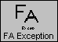 Fixed Asset Exception

First, let’s look at how Accounting Information is established in System Administration.

Funding tab
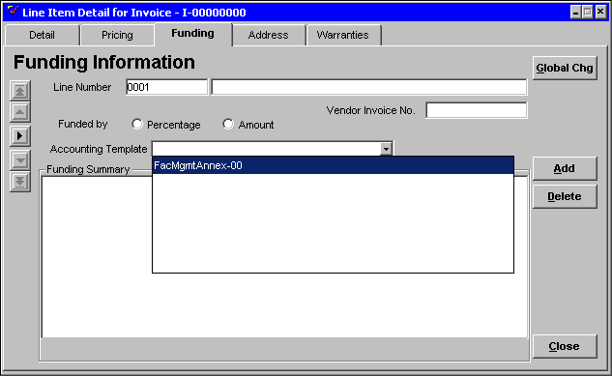

Establishing Accounting Information
Some agencies repeatedly use the same multi-accounting distribution on PD documents. The Account task allows the System Administrator in each agency to build account templates to represent these multi-accounting distributions. These templates allow users the ability to populate their PD document with multi-account coding string information simply by selecting the appropriate Accounting Template on the Funding tab.

Desktop common codes (DKCC)
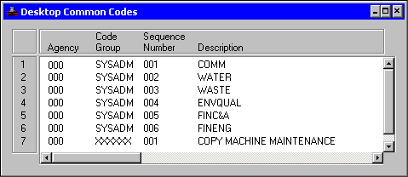

A common coding string is a code that represents a complete accounting string. It is a tool that was created in MARS to provide users with easy access to commonly used accounting strings. The common coding strings will be created and maintained in ADVANTAGE Financial (DKCG and DKCC tables), but will be transferred to a PD table several times a day. These common coding strings will appear in the Account Template Maintenance task AVAILABLE FUND DESC display list. The System Administrators will build their Account Template(s) using the common coding strings that appear in this list.
The Account task allows System Administrators to:

- Create an Account Template,

- Update an existing Account Template, or

- Delete an existing Account Template.

Let’s create a new Account Template.

Account Template Maintenance window
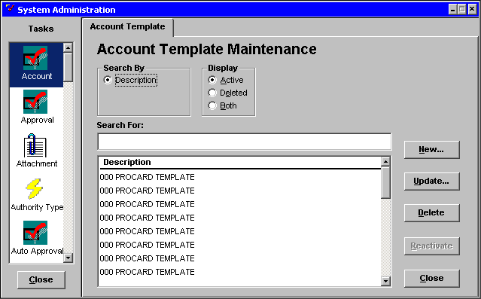

Creating an Account Template
Step 1 In the System Administration window. Scroll down the Tasks list and click once on the Account icon. The Account Template Maintenance window will be displayed.

Step 2 Click the <NEW> button. The Account Template Maintenance Information window will be displayed.

Account template Maintenance Information Window
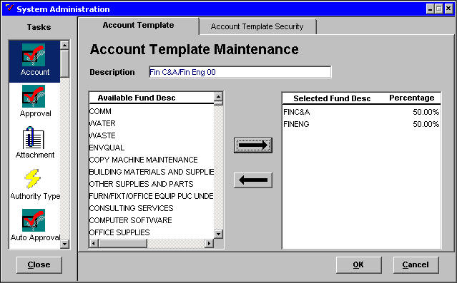

The Account Template Maintenance Information window has two tabs: Account Template and Account Template Security. The Account Template tab defines the common coding string codes that are available and that can be selected by each authorized System Administrator. Whereas, the Account Template Security tab allows the System Administrator to assign or remove template authority to or from selected users.

Assigning Common Coding Strings to a Template
Step 1 Click on the Account Template tab.

Step 2 In the DESCRIPTION field. Enter Fin C&A/Fin Eng ☺☺ for the title of the account template.

Step 3 In the AVAILABLE FUND DESC list. Highlight the two codes, FINC&A and FINENG.

NOTE: Hold down the <CTRL> key and click on each code to highlight both codes at one time.

Step 4 Click on the <RIGHT ARROW> button. The codes are transferred to the SELECTED FUND DESC list.

Step 5 In the PERCENTAGE field. Enter a 50 percent distribution to each fund code. The percentage distribution must total 100%.

NOTE: Clicking the <OK> button would save the data and return to the Account Template Maintenance window.

NOTE: Clicking on the <CANCEL> button would exit the window without saving the data.

Next, we will assign users to this Account Template.

assigning users to the Account Template
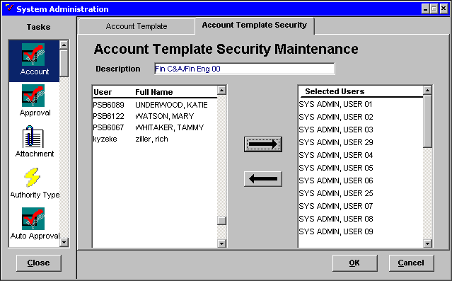

Assigning Users to Account Templates
Step 1 Click on the Account Template Security tab. The Account Template Security Maintenance window will be displayed.

The User/Full Name list contains all the users that have been defined in Procurement Desktop.

Step 2 In the USER/FULL NAME display list. Highlight all the SYS ADMIN users to assign to the template.

NOTE: You may highlight more than one user at a time by holding the <SHIFT> key and clicking your selections. Hold down the <CTRL> key instead of the <Shift> key to select users that are not directly in order.

Step 3 Click on the <RIGHT ARROW> button. The user names are transferred to the SELECTED USERS list.

Continue to select users until you have selected all the SYS ADMIN users.

Step 4 Click on the <OK> button to save the data.

NOTE: Clicking on the <CANCEL> button would exit the window without saving the data.

The Account Template Security Maintenance window will close and the Account Template Maintenance Information window will be displayed.

updating the Account Template
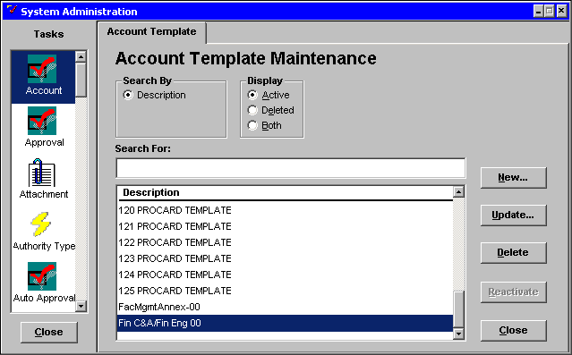

Updating an Existing Account Template
Step 1 In the DESCRIPTION list. Highlight the Account Template title FinC&A/FinEng☺☺.

Step 2 Click on the <UPDATE> button. The Account Template Maintenance information window will be displayed.

ACCOUNT TEMPLATE MAINTENANCE
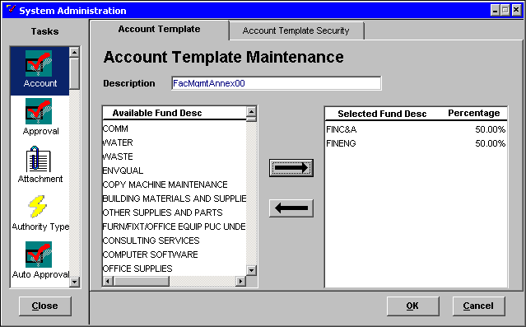

Step 4 In the DESCRIPTION field. Change the title to FacMgmtAnnex☺☺.

Step 5 Click on the <OK> button to save the changes.

NOTE: Clicking on the <CANCEL> button would exit the window without saving the changes.

deleting an Account Template
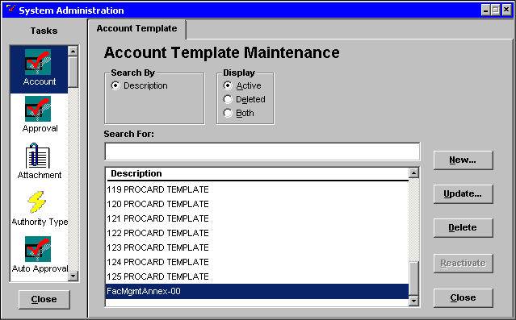

Deleting an Existing Account Template
Step 1 In the Description list. Highlight the template name FacMgmtAnnex☺☺.

Step 2 Click on the <DELETE> button. A Procurement Desktop Confirmation window will be displayed.

PD Confirmation window
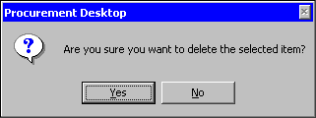

Step 3 Click on the <YES> button to confirm the deletion.

NOTE: Clicking the <NO> button would exit the window without deleting the Account Template.

ACCOUNT TEMPLATE MAINTENANCE
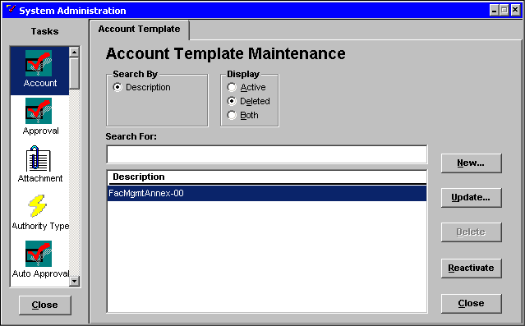

Reactivating an Account Template
Step 1 In the DISPLAY GROUP box. Click on the <DELETE> radio button.

Step 2 In the Description list. Highlight the template name FacMgmtAnnex☺☺.

Step 3 Click on the <REACTIVATE> button. A Procurement Desktop Confirmation window will be displayed.

Pd confirmation window
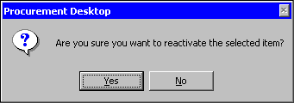

Step 4 Click the <YES> button to confirm the reactivation of the Account Template.

NOTE: Clicking on the <NO> button would exit the window without reactivating the Account Template.

We will now complete an exercise creating an Account Template.

Using the scenario below, create an Account Template.

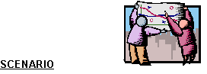
The Natural Resources and Environmental Protection Cabinet has four offices that are located in the Ash Complex. These offices share the expense of office supplies, janitorial services and copier rental. To facilitate payment processing for these shared expenses, an account template can be set up to represent the cost distribution among the offices’ four accounting strings. The only authorized users are in the SYS ADMIN group. The names, percentage distributions, and common coding string codes for these offices are:

Ofc of the Commissioner 10% COMM
Division of Water 40% WATER
Div of Waste Mgmt 40% WASTE
Environ Qual Comm 10% ENVQUAL

Account Template Maintenance

Step 1 In the System Administration window. Scroll down the TASKS list and click on the Account task icon.

Step 2 Click on the <NEW> button.

Account Template Maintenance Information Window
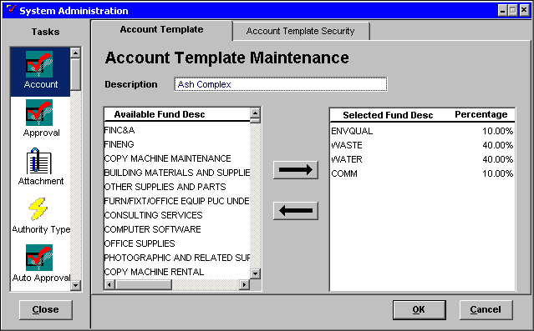

Step 3 In the DESCRIPTION field. Enter Ash Complex ☺☺ as the name of the template.

Step 4 In the AVAILABLE FUND DESC list. Move the fund codes, COMM, WATER, WASTE, and ENVQUAL to the SELECTED FUND DESC list.

Step 5 Assign the following percentage distribution to each fund code:

COMM 10%
WATER 40%
WASTE 40%
ENVQUAL 10%

NOTE: The percentage distribution must total 100%.

Account Template Security
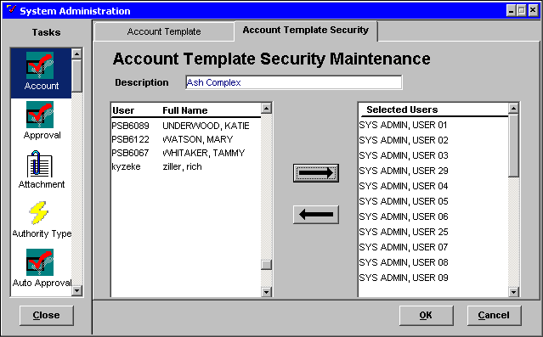

Step 6 Click on the Account Template Security tab.

Step 7 In the USER/FULL NAME list. Move all the Sys Admin users to the SELECTED USERS list.

Step 8 Click on the <OK> button to save the data.

Next we’ll learn how to establish fixed asset exceptions.

System Administration Prod/Svcs
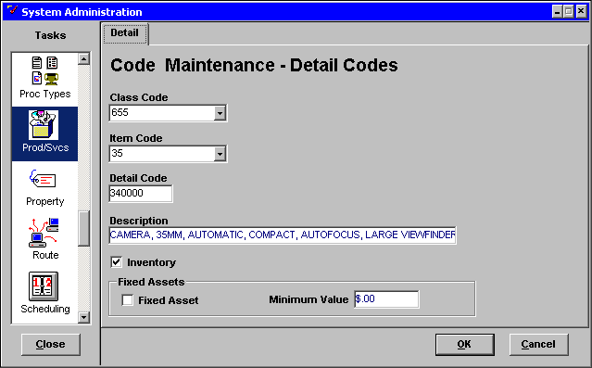

Establishing a Fixed Asset Exception
Central Agency System Administrators identify commodities as Fixed Assets by checking the FIXED ASSET box in the Detail tab of the Product Services Commodity Code (Prod/Svcs) task. If an agency decides that they would like to raise or lower the value of a fixed asset for their agency, the System Administrator for that agency can create a Fixed Asset Exception.

Fixed Asset exception Maintenance
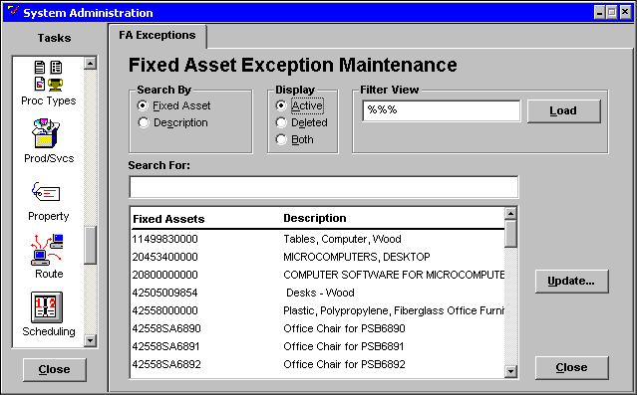

The Fixed Asset Exceptions task displays the list of all potential fixed assets, as defined by the checkbox on the Prod/Svcs System Administration task. From the FA Exceptions tab, agency System Administrators can select and update existing fixed assets with their agency rules. For example, snowplow blades are usually considered a fixed asset, but the Transportation Cabinet consumes a snow plow blade in less than a year. Therefore, the Transportation Cabinet System Administrator can increase the minimum dollar value for that commodity thus creating a Fixed Asset Exception for snow plow blades. Other agencies might want to lower the dollar limit of all their fixed assets, this can be accomplished by selecting the global commodity code 00000000000 and lowering the minimum dollar value. Agencies can even set a dollar value at the global level and set other dollar values for individual commodities.

Let’s update a Fixed Asset now.

Fixed Asset Exception Maintenance
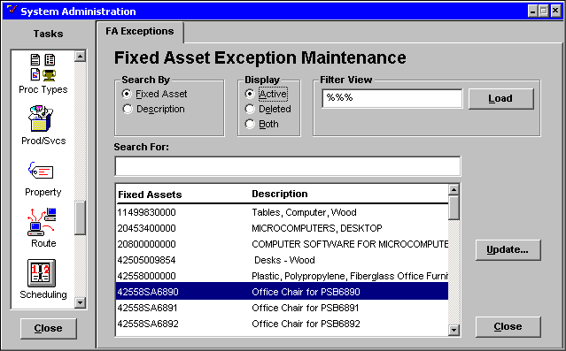

Updating Fixed Assets
Step 1 In the System Administration window. Scroll down the TASK list and click once on the FA Exception icon.

Step 2 In the FILTER VIEW field to view fixed asset commodities. Type %%% and click on the <LOAD> button. All fixed asset commodities are displayed.

Step 3 in the FIXED ASSETS/DESCRIPTION field. Highlight the commodity Office Chair for PSB☺☺☺☺.

Step 4 Click on the <UPDATE> button. The Fixed Asset Exception Maintenance Information window will be displayed.

Step 5 In the AGENCY drop-down list. Highlight the agency (buying entity) Payables.

Fixed Asset Exception Maintenance Information window
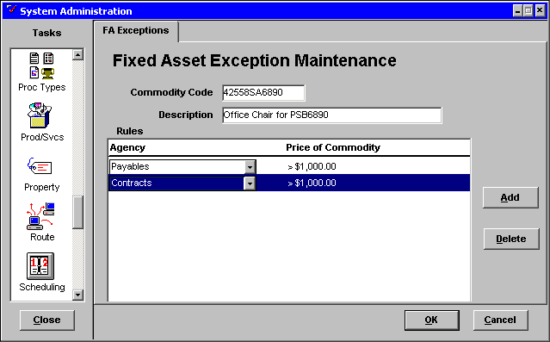

Step 6 In the PRICE OF COMMODITY field. Change the dollar amount to $1,000.

You are responsible for another agency buying entity and need to include them in the fixed asset exception.

Step 7 Click on the <ADD> button.

Step 8 In the AGENCY drop-down list. Highlight the buying entity Contracts.

Step 9 In the PRICE OF COMMODITY field. Enter $1,000.00.

NOTE: You may also delete a line by highlighting the line and clicking the <DELETE> button.

Step 10 Click on the <OK> button to save the changes.

NOTE: Clicking on the <CANCEL> button would exit the window without saving the changes.


In this topic we have:

- Created Accounting Templates using common coding strings and,

- Created agency - specific exceptions to defaulted Fixed Asset rules.



Are there any questions concerning the information covered in this topic?

