TOPIC 4 APPROVAL TASKS

PURPOSE

This topic provides an overview of the functionality of Teams, Team Cabinets and Routing Templates.

OBJECTIVES

By the completion of this topic, you will be able to:

- Create Teams and Team Cabinets and,

- Create Routing Templates

System Administration Approval Tasks
This topic will cover the following tasks:

Team

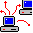 Route

Establishing Teams
A team is a group of users that have mutual purchasing responsibilities. The team shares a group cabinet that is placed on the desktop of all team members. A team cabinet contains documents relating to each of the team’s purchasing actions.

The following rules apply to teams:

- All team cabinets are gray (personal cabinets are yellow).

- If one user removes an item from the team cabinet, that item is removed from the cabinet on the desktop of every member of the team.

- If any member of the team puts an item into the cabinet, it appears in the cabinet on every member’s desktop.

- Items cannot be routed to or from a team cabinet.

- Each system user can be assigned to one or more teams. All attributes assigned to a team are given to each member of the team.

Documents assigned to a team are stored in the team cabinet instead of an individual’s cabinets. To update or approve a document, the user must drag the document out of the team cabinet into one of their personal cabinets. Any member of the team can drag an item into or out of the team cabinet.

The Team Maintenance window defines the teams that are available to each user. The Team task in System Administration allows an authorized user to:

- Create a new team,
- Update a team, or
- Delete a team.

Establishing a Team
When creating a team in Procurement desktop, you must:

- Enter a Team ID and description,

- Designate a Team Leader,

- Associate Users as member of the team, and

- Designate Team Cabinet Names.

NOTE: Users need to refresh (closed open) cabinet to see current contents.

Team Maintenance
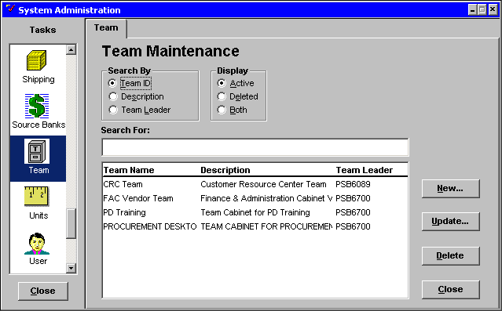

Creating a Team
Step 1 Scroll down the TASKS List and click once on the Team icon. The Team Maintenance window will be displayed.

Step 2 Click on the <NEW> button. The Team Detail: Team Maintenance information window will be displayed.

team maintenance

Team tab
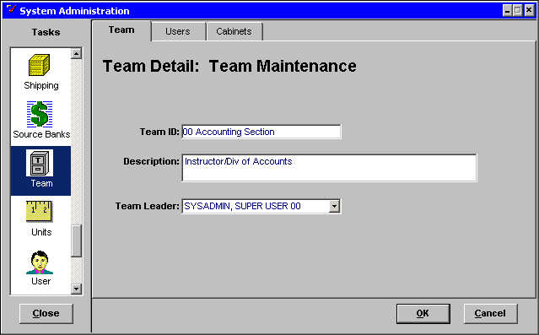

Step 3 In the TEAM ID field. Enter ☺☺Accounting Section for the team name.

NOTE: You are limited to 30 characters. Because the TEAM ID cannot be modified once the data has been saved, team names should be carefully considered.

Step 4 In the DESCRIPTION field. Enter Your Name/Div of Accounts for the description of the team name.

Step 5 In the TEAM LEADER drop down list. Highlight Your Name to designate a team leader.

Step 6 Click on the Users tab. The Team Detail: Member Maintenance window will open.

Team Maintenance

Users Tab
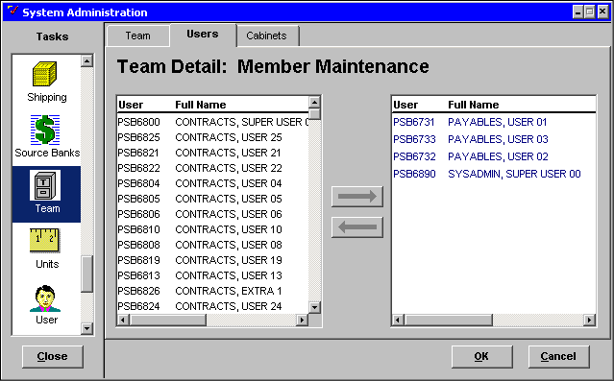

Assigning Users to a Team Cabinet
The list box on the left contains all current users. The list box on the right indicates which users have been assigned to the team.

Step 1 In the LEFT LIST box. Click on the Your Name and the First Three Payables Users to assign them to the team.

NOTE: Hold down the <CTRL> key and click on each User to select users that are not directly in order.

Step 2 Click on the <RIGHT ARROW> button.

The user names are transferred from the left User/Full Name box to the right User/Full Name box. If necessary, continue to select more users.

Step 3 Click on the Cabinets tab. The Cabinet window will be displayed.

Team Maintenance

cabinets Tab
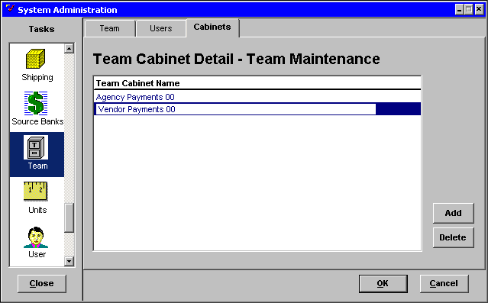

Naming Team Cabinets
You can have as many team cabinets assigned to a team as you like. In order to be easily identified, team cabinets should have unique names.

Step 1 In the TEAM CABINET NAME field. Enter Vendor Payments☺☺ for the first team cabinet name.

Step 2 Click on the <ADD> button. A new line appears.

Step 3 In the TEAM CABINET NAME field. Enter Agency Payments☺☺ for the second team cabinet name.

Step 4 Click on the <OK> button to save the data.

NOTE: Clicking on the <CANCEL> button would exit the window without saving the data.

Team Maintenance
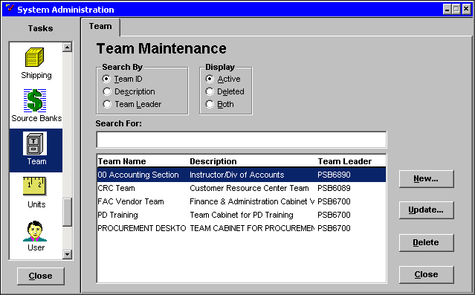

Updating a Team
In the Team Maintenance window, you can modify an existing team.

Step 1 In the DESCRIPTION list. Highlight the team Your Name/Div of Accounts.

Step 2 Click on the <UPDATE> button. The Team Detail: Team Maintenance window will be displayed.

Team Maintenance

Team Tab

NOTE: TEAM ID cannot be altered.

Step 3 Click on the Cabinets tab. The Team Cabinet Detail – Team Maintenance window will be displayed.

Team Maintenance

cabinets tab
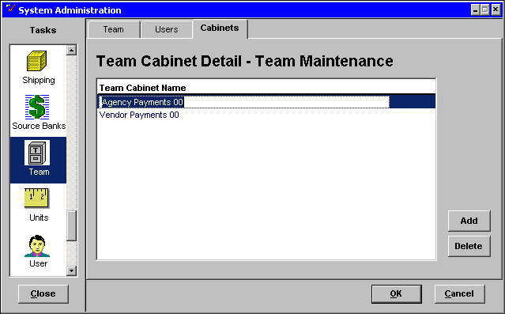

Step 4 In the TEAM CABINET NAME field. Highlight Agency Payments☺☺ as the team cabinet name.

Step 5 Click on the <DELETE> button to remove the Team Cabinet Name.

NOTE: Team Cabinets must be empty before you will be allowed to delete a Team Cabinet Name.

Step 6 Click the <OK> button to save the changes.

NOTE: Clicking on the <CANCEL> button would exit the window without saving the changes.

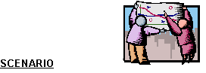
The buyers in the Division of Material and Procurement Services need to be grouped into teams. Users PSB6827, PSB6819, PSB6807, and PSB6815 will be assigned to Your Small Purchases team, User PSB6815 (Contracts User 15) is the Small Purchases team leader.

Create a team using the scenario above.

Team Maintenance
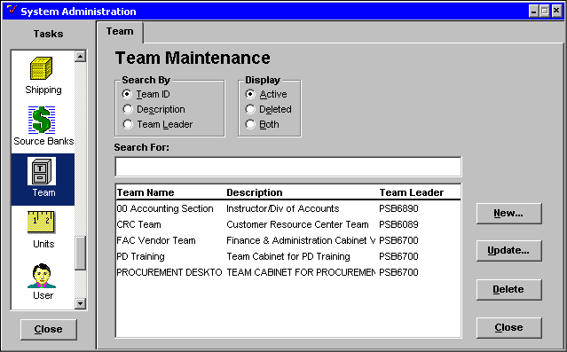

Step 1 In the System Administration window. Scroll down the TASKS list and click once on the Team icon.

Step 2 Click the <NEW> button.

team maintenance

Team tab
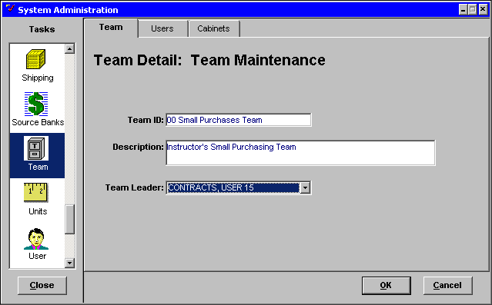

Step 3 In the TEAM ID field. Enter Team Name ☺☺ Small Purchases Team.

Step 4 in the DESCRIPTION field. Enter Your Name’s Small Purchasing Team.

Step 5 In the TEAM LEADER drop down list. Highlight the user Contracts User 15.

Team Maintenance

Users tab
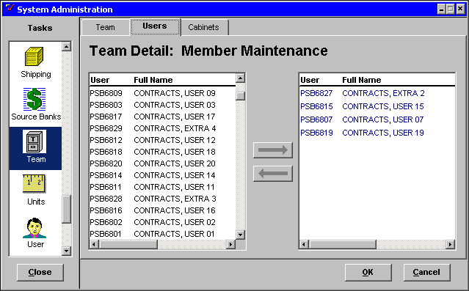

Step 6 Click on the Users tab.

Step 7 In the left USER/FULL NAME list box. Highlight the users PSB6827, PSB6819, PSB6807 and PSB6815 to be assigned to the team.

Step 8 Click on the <RIGHT ARROW> to move the users to the right USER/FULL NAME list box.

team maintenance

Cabinets tab
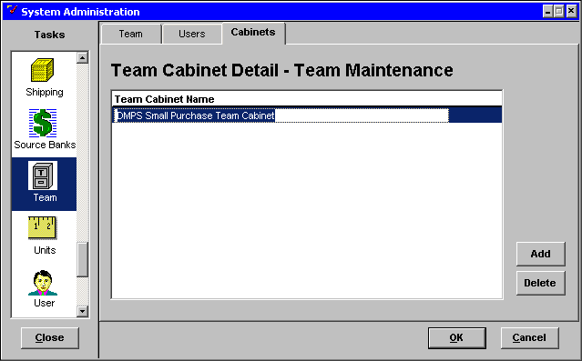

Step 9 Click the Cabinets tab.

Step 10 In the TEAM CABINET NAME field. Enter DMPS Small Purchase Team Cabinet.

Step 11 Click on the <OK> button.

Now let’s talk about the Route task.

Routing Maintenance
Routing templates provide the means of sending one or more documents or folders to users in a predefined order. Objects are routed or sent from one user to other users according to the route template chosen. Agencies defined routing templates that correspond to centrally defined Approval templates, help the PD user route their documents to the appropriate approvers.

A Route Template consists of:

- ROUTE NAME - The route name guides a user in choosing a route template and

- USER STOPS - These are the users, setup in a specific order, who will receive the routed object or objects.

This section describes how to create and manage route templates.

From the Route task, you can perform the following functions:

- Create a route template,
- Associate Groups to a template.
- Modify a route template and
- Delete a route template.

Route maintenance
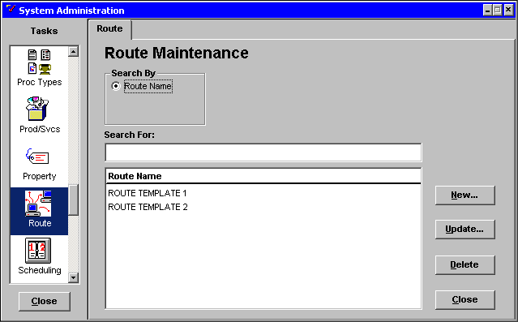

Creating a Route Template
Step 1 In the System Administration window. Scroll down the TASKS list and click once on the Route icon. The Route Maintenance window will be displayed.

Step 2 Click on the <NEW> button. The Route Detail: Route Maintenance window will be displayed.

Route detail: route maintenance
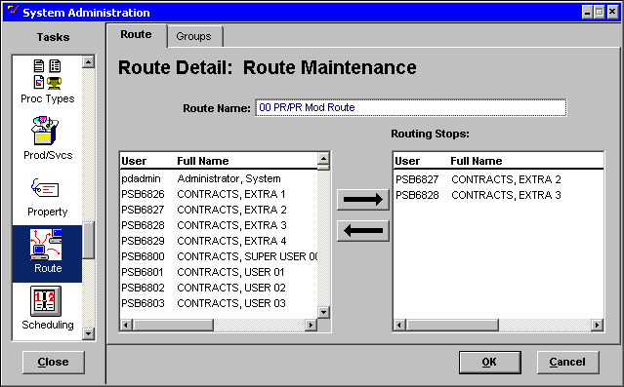

Step 3 In the ROUTE NAME field. Enter ☺☺ PR/PR MOD Route.

In order to make it easier for the user to select the appropriate route, the Route template name should correspond to a centrally defined Approval template. Begin the Route template name with your agency identifier, and then finish the template name with the specific document type or subtype that are defined in the name of the centrally defined Approval template.

For example, a Purchase Request route template for the Department of Administration in the Finance and Administration Cabinet might read: 775- PR/PR Mod Small Purchase

The Routing Stops sequence is the order in which the object will be routed. You can create the ROUTING STOPS list by adding or deleting Users.

NOTE: If new users must be inserted into the route, then delete the route template and start over.

Adding a User to the Route
Step 1 In the left USER list. Highlight the user PSB6826.

Step 2 Click on the <RIGHT ARROW> button.

The selected User ID and name appear in the ROUTING STOPS list box. You can continue to add as many users as the route requires. Each user is added to the end of the stop list.

Step 3 Repeat Steps 1 and 2 to add PSB6827 and PSB6828.

Deleting a User from the Route
Step 1 In the left hand USER list. Highlight the user PSB6826.

Step 2 Click on the <LEFT ARROW> button. The user is deleted from the stop.

Caution: Users may not appear in the correct order if one user is deleted and another user is inserted into an existing template. It is best to create a brand new routing template if you have one person replacing another.

Group tab
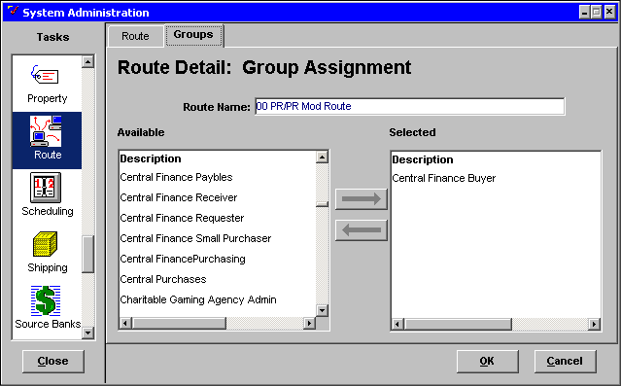

Assigning Groups to Routing Templates
Step 1 Click the Groups tab.

Step 2 Highlight the group (s) that will most likely use this routing template.

Step 3 Click the <RIGHT ARROW> button.

Step 4 Click the <OK> button.

Routing sheet
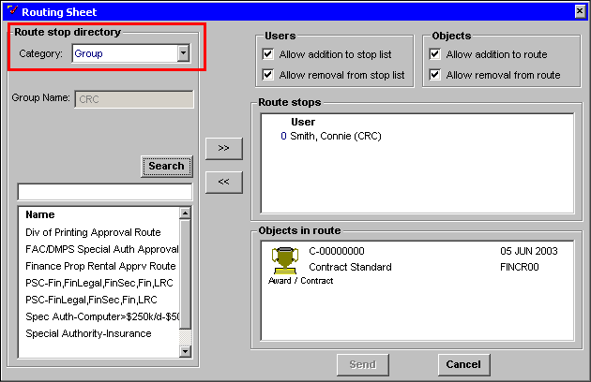

The User’s primary group can filter routing Templates. This Group Assignment is completed in the System Administration Route Task Group tab described above.

On the routing sheet the user will have to select Group under the CATEGORY field to utilize the group function.


In this topic we have learned:

- How to establish Team Cabinets and

- How to designate team members and team leaders



Are there any questions concerning the information covered in this topic?

