Chart of Accounts Plan

Version 2.0
December 7, 1998

Final

NOTE: This document is formatted for duplex reproduction, which is the Commonwealth of Kentucky standard. Blank pages are intentionally inserted throughout the document so that the document will reproduce correctly.

List of Authors:
Carl Ward (AMS)
Brett Antle (Commonwealth)

Table of Contents
Page
1 Introduction 3
2 Statewide Chart of Accounts 3
2.1 Overview 3
2.2 Element Descriptions: 3
2.2.1 Fund 3
2.2.2 Agency 5
2.2.3 Organization 6
2.2.4 Appropriation Unit 7
2.2.5 Object 8
2.2.6 Revenue Source 10
2.2.7 Balance Sheet Account 10
2.2.8 Bank Account Code 11
2.3 Statewide Crosswalk Matrix 13
3 Agency Chart of Accounts 14
3.1 Overview 14
3.2 Element Descriptions 14
3.2.1 Sub-Organization 14
3.2.2 Sub-Object 14
3.2.3 Sub-Revenue Source 15
3.2.4 Function 16
3.2.5 Activity 16
3.2.6 Project / Sub-project, Phase 17
3.2.7 Reporting Category 18
3.2.8 Termini 19
3.3 Agency Crosswalk Matrix 20
4 Appendix A – Agency Chart of Account Crosswalk 21

Introduction
The purpose of this document is to provide an approach for implementing the production MARS Chart of Accounts. The setup and usage of budgetary control elements will be addressed in the Budget Setup & Implementation Analysis document. Items covered in this document include:

MARS Statewide Chart of Accounts Data Elements.
MARS Agency Chart of Accounts Data Elements
Strategies for establishing the base Chart of Accounts data elements
Strategies for establishing the hierarchical Chart of Accounts elements

Statewide Chart of Accounts

Overview

Statewide chart of account elements are accounting elements that are common across all organizations. They support a standard fund structure and a common organization structure. They also provide for budgetary control and assist with high level reporting, including the Commonwealth’s Comprehensive Annual Financial Report (CAFR).

Element Descriptions:

Fund

The Fund (FUN2) table defines values for all funds in MARS. It also specifies, for each fund, how the financial system is to handle various control options. The control options determine the level of budget control, the optional use of appropriations and allotments, and specific subsystem options. Control options should not be changed for existing funds during the fiscal year. The Fund table will be maintained by the Controller’s Office.

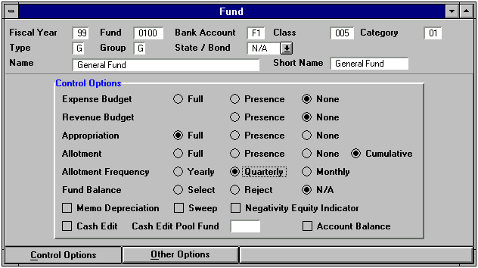

Before a fund can be used, a valid record must be defined on the Fund Agency table (FGY2). This table specifies various budget options for each fund/agency combination. Requirements for budget and accounting documents for each fund/agency combination are also defined on this table. Certain decisions on how to set the control options for fund/agency must be made by agencies. These options include whether or not to require activity or function on accounting transactions and how to interpret job/project precedence (See section 3.2.6). The Fund Agency table will be maintained by the Controller’s Office.

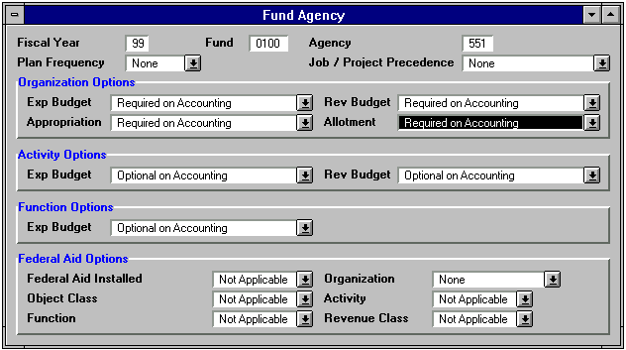
The MARS fund code is an alpha/numeric field 4 bytes in length. The fund code for the Commonwealth that is used in STARS is two bytes long. The current STARS fund number will be added into MARS by appending two zeros at the end of the code. For example, STARS fund 01 will become MARS fund 0100, STARS fund 35 will become MARS fund 3500, etc.
Fund code rollups are defined in the following table.

ADVANTAGE Element | Hierarchy | Length | STARS Element or Reserved Use
Fund | Code | 4 | Fund
 | Class | 3 | Budgetary Fund
 | Category | 2 | Undefined
 | Type | 1 | Reserved for Fund Types such as General, Special Revenue, Debt Service, and Capital Projects.
 | Group | 1 | Reserved for Fund Groups such as Governmental.

Agency

The Agency (AGC2) table defines valid agency codes and related information.

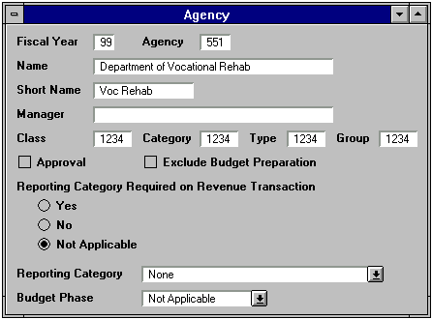
In ADVANTAGE, the Agency data element is used for a variety of purposes. For example, Agency is used in combination with the Fund data element to establish the highest level of budgetary control for appropriations and allotments. The Agency data element can also be used to restrict security to records on tables and it is used in combination with the Fund data element to establish parameters for document processing. For example, whether or not the Activity data element (discussed later in this document) will be used on expenditure transactions is established for each Fund and Agency combination on the Fund/Agency table. The Agency data element can also be used to provide for unique document numbering using the automatic document numbering functionality. The Agency value may be divided into progressively larger and / or smaller groups. The larger hierarchy elements are defined in the table below and the smaller hierarchy elements (Organization and Sub-Organization) are discussed later in this document. The Agency table will be maintained by the Controller’s Office.

The MARS Agency code is an alpha/numeric field 3 bytes in length. In most cases the MARS Agency will be defined as the STARS Department number. For example the Cabinet for Workforce Development (46) is comprised of several agencies, one of which is the Department of Vocational Rehabilitation (551). The Department of Vocational Rehabilitation may be established as a MARS Agency, with an Agency code of 551. An example of where a STARS Cabinet may become a MARS Agency is the Personnel Cabinet (47). The new MARS Agency code for the Personnel Cabinet may be defined as C47.

There are several factors to be taken into account when determining whether a MARS Agency should be defined as a STARS Cabinet or a STARS Department. Factors to be considered include:

- Is the current appropriation established at the Cabinet or Department level, or for multiple but not all departments within a Cabinet?
- Does security access need to be established at a Cabinet or Department level (or lower)?
- MARS document numbering includes the MARS Agency code (payment documents, cash receipt document, etc.).
- MARS workflow setup for certain documents will be dependent upon Agency codes to facilitate proper document routing.
- Most agency chart of account elements are defined within a MARS Agency code.
- Treasury issued checks to be mailed by agencies will be sorted and returned to agencies based on Agency codes.
- Treasury issued checks to be mailed will be sorted and returned to agencies based on Agency codes.

Regardless of whether the MARS Agency is defined as the STARS Cabinet or STARS Department number, a hierarchy of MARS Agency (Agency Class) will be defined as the STARS Cabinet number. This will allow for statewide Cabinet level reporting to be accomplished via the Agency Class. The MARS Agency Class is an alpha/numeric field 4 bytes in length. The STARS Cabinet code is 2 bytes in length. Current STARS Cabinet codes will be added into MARS by appending 2 zeros at the end of the code. For example, STARS Cabinet 46 will become MARS Agency Class 4600, etc.

Agency code rollups are defined in the following table.

ADVANTAGE Element | Hierarchy | Length | STARS Element or Reserved Use
Agency | Code | 3 | Cabinet, Department or Department Grouping
 | Class | 4 | Cabinet
 | Category | 4 | CAFR Function
 | Type | 4 | Government Branch
 | Group | 4 | Undefined

Organization

The Organization (ORG2) table defines valid organization values and creates Agency/Organization relationships.

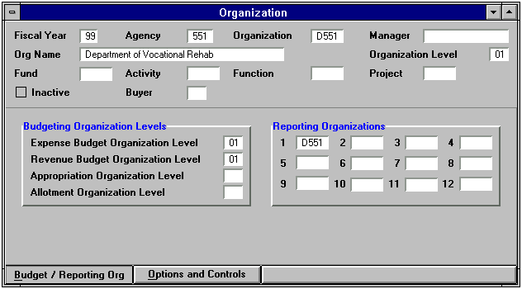
Agencies may be divided into any number of Organizations, and one Agency may divide into Organizations without requiring other Agencies. The Organization structure can be up to twelve levels.

In ADVANTAGE, the Organization data element is used for a variety of purposes. For example, the Agency and Organization data elements may be used to restrict security on certain types of transactions and inquiries. Organization may also be used in combination with other data elements to establish management budgets. In general, users code the lowest level of Organization that has been established in the hierarchical structure on accounting transaction lines. The Organization levels that have been established above the lowest level are inferred. For example, a Department Organization (Level 1) can be inferred from a Division Organization (Level 2 or lower).

The Organization code in MARS is an alpha/numeric field 4 bytes in length. The first level of Organization will be defined as the current STARS Department number prefixed with a “D”. For example, the current STARS Department number “551” will be defined as MARS Organization “D551”. Agencies will be given access to add records for Organization levels 2 – 12. Agencies will not be given access to establish any level 1 Organization codes, or modify any existing Organization codes (any level). Agencies will need to request modifications to existing Organization codes through the Controller’s Office.

Agencies may wish to define certain levels of Organization as their current Divisions, Branches, Sections and Units. However, this decision is at the agency’s discretion. Division, Branch, Section and Unit are no longer required to be established in the statewide accounting system (MARS).

Appropriation Unit

The Appropriation Unit is an alpha/numeric field 9 bytes in length that is made up of 3 elements, Appropriation Program, Allotment Program and Program Budget Unit. The Appropriation Program makes up the first 2 bytes and will be defined in the budget preparation setup and establishment process. For example, a current STARS Appropriation account A000 may become MARS Appropriation Program A0. Allotment Program makes up the next 3 bytes and will also be defined in the budget setup and establishment process. For example a current STARS Allotment Account AA00 may become MARS Allotment Program AA0 (see the Budget Setup and Implementation Analysis document for a detailed explanation on establishment of these elements). The remaining 4 bytes make up the Program Budget Unit (PBU). The Program Reference table (PRFT) defines valid Program Budget Units in MARS. It also defines valid Appropriation Programs, Allotment Programs and combinations of Appropriation Programs, Allotments Programs and PBUs.

Agencies will need to convert their current 4 byte Appropriation Account to the 2 byte MARS Appropriation Program. The largest change created by having fewer bytes for Appropriation Programs will be for capital project appropriations. Currently, the STARS Appropriation Account is the same code as the STARS Allotment Account and the STARS Posting Level Project Account for capital projects.

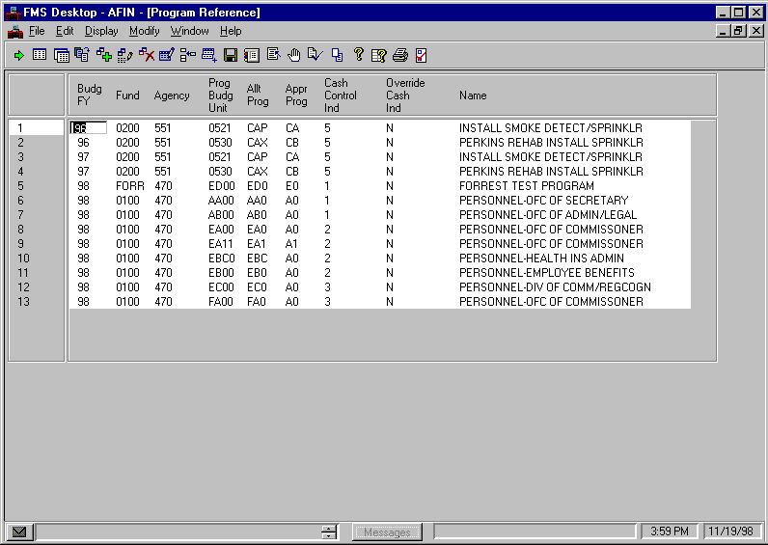
Program Budget Unit will generally be defined as the current STARS Posting Level Program and STARS Posting Level Project (for capital projects). For example, STARS Posting Level Program AAA0 may become MARS Program Budget Unit AAA0. Each Agency will need to analyze their existing Posting Level Program structure to determine what PBUs need to be established in MARS. In some instances, agencies may want to consider establishing their existing STARS Budget Units as PBUs in MARS. The Program Reference table will be maintained by the Controller’s Office.

Cash Control Options

Cash Control options in MARS are also established when setting up PBUs on the PRFT table. Valid Cash Control levels in MARS are:

- Fund
- Fund/Agency
- Fund/Agency/Appropriation Program
- Fund/Agency/Appropriation Program/Allotment Program
- Fund/Agency/Appropriation Program/Allotment Program/PBU

Note: Only the last four bytes of the Appropriation Unit field (PBU) will be required to be coded on accounting documents.

Object

The Object (OBJ2) table defines valid expenditure objects used on accounting transactions.

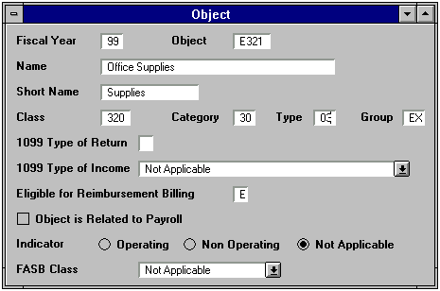
The Object code in MARS is an alpha/numeric field 4 bytes in length, which is the same length as the STARS Minor Object Code. The MARS Object Code will be comprised of a 1 byte alpha prefix, followed by a 3 byte numeric code. The current “Expenditure” Minor Object codes (“E” prefixes) will become MARS Object Codes. In addition the Commonwealth will establish several new sets of Object Codes. The Object Code table will be maintained by the Controller’s Office.

The following identifies the object prefixes that will be used.

E Expenditures
J Residual Equity Transfer Out (same prefix used for revenue source)
L University and Other Entity Transfers Out (same prefix used for revenue source)
T Operating Transfers Out
U Other Financing Uses Charged to Allotments
W Other Financing Uses not Charged to Allotments
X Non-Budgeted Transfers Out

Agencies may choose to further breakdown Object codes into Sub-Object codes (See section 3.2.2).

Object code rollups are defined in the following table.

ADVANTAGE Element |  | Hierarchy |  | Length |  | STARS Element or Reserved Use
Object | Code |  | 4 |  | Minor Object
 | Class |  | 3 |  | Sub-Object
 | Category |  | 2 |  | Major Object (CAFR)
 | Type |  | 2 |  | Major Object Group
 | Group |  | 2 |  | Nominal GLs (9000 Series)

Revenue Source

The Revenue Source table (RSR2) defines valid Revenue Source codes used on accounting transactions.

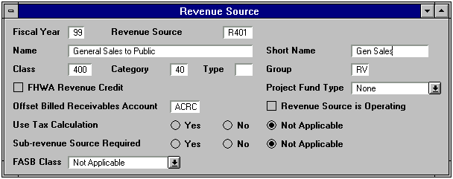
The Revenue Source code in MARS is an alpha/numeric field 4 bytes in length, which is the same length as the STARS Minor Object Code. The MARS Revenue Source code will be comprised of a 1 byte alpha prefix, followed by a 3 byte numeric code. The current “Revenue” Minor Object codes (“R” prefixes) will become MARS Revenue Source Codes. In addition the Commonwealth will establish several new sets of Revenue Source Codes. The Revenue Source table will be maintained by the Controller’s Office.

The following identifies the Revenue Source prefixes that will be used:

R Revenues
J Residual Equity Transfers In (same prefix used for object codes)
L University and Other Entity Transfers In (same prefix used for object codes)
N Operating Transfers In
S Other Financing Sources
H Revenue Refunds
M Non-Budgeted Transfers In

Agencies may choose to further breakdown Revenue Source codes into Sub-Revenue Source codes (See section 3.2.3).

Revenue Source code rollups are defined in the following table.

ADVANTAGE Element |  | Hierarchy |  | Length |  | STARS Element or Reserved Use
Revenue Source | Code |  | 4 |  | Minor Object
 | Class |  | 3 |  | Sub-Object
 | Category |  | 2 |  | Major Object (CAFR)
 | Type |  | 2 |  | Undefined
 | Group |  | 2 |  | Nominal GLs (9000 Series)

Balance Sheet Account

The Balance Sheet Account (BAC2) table defines valid Balance Sheet Accounts for each asset, liability or fund balance account in MARS.

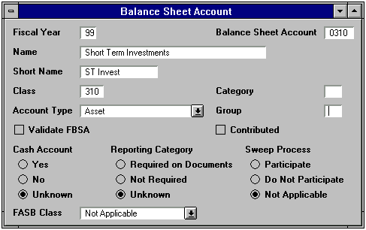
Higher level classifications of the Balance Sheet Account codes (class, category and group) may also be defined on the Balance Sheet Account table.

The Balance Sheet Account code in MARS is an alpha/numeric field 4 bytes in length. The Commonwealth will use Balance Sheet Accounts to define the STARS subsidiary ledgers in MARS. The MARS Balance Sheet Class will be used to identify the STARS General Ledger accounts. The Balance Sheet Account table will be maintained by the Controller’s Office.

Balance Sheet Account code rollups are defined in the following table.

ADVANTAGE Element |  | Hierarchy |  | Length |  | STARS Element or Reserved Use
Balance Sheet Account | Code |  | 4 |  | Subsidiary Accounts or General Ledger Accounts
 | Class |  | 3 |  | General Ledger Accounts
 | Category |  | 2 |  | Undefined
 | Type |  | 2 |  | Reserved for Account Types such as Asset[01], Liability[02], Fund Balance[03], and Assets Offset to Expense[11]
 | Group |  | 2 |  | Undefined

Bank Account Code

The Bank account table (BANK) defines codes for all of the bank accounts maintained in MARS.

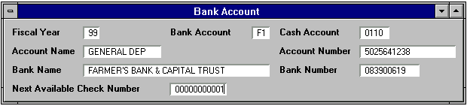
The General Ledger cash account is inferred from the Bank Account coded on transactions (unless a different Cash Account is coded on the transaction). The Commonwealth will set up and maintain several bank accounts in MARS. The Bank Account table will be maintained by the Controller’s Office.

Statewide Crosswalk Matrix

STARS Accounting Elements |  |  |  |  | MARS Data Elements
Field Name | Defined within | Length | Input |  | Field Name | Defined Within | Length | Input
Fund | Statewide | 2 | Y |  | Fund | Statewide | 4 | Y
Cabinet | Statewide | 2 | Y |  | Agency Class: Looked up from Agency | Statewide | 4 | N
 |  |  |  |  | Agency | Statewide | 3 | Y
Department | Statewide | 3 | Y |  | Organization (Level 1) | Agency | 4 | Y
 |  |  |  |  | Agency | Statewide | 3 | Y
Program | Department | 4 | Y |  | Appropriation Program | Fund/Agency | 2 | N
 |  |  |  |  | Allotment Program | Fund/Agency/Appr | 3 | N
 |  |  |  |  | Program Budget Unit | Fund/Agency | 4 | Y
Object | Statewide | 4 | Y
 |  |  |  |  | Object | Statewide | 4 | Y
 |  |  |  | or | Revenue Source | Statewide | 4 | Y
 |  |  |  | or | Budget Object | Statewide | 4 | Y
Division | Department | 2 | Y |  | Organization (Level 2-12) | Agency/Org | 4 | Y
Branch | Dept-Division | 2 | Y
Section | Dept-Branch | 2 | Y
Unit | Dept-Section | 2 | Y
General Ledger Account | Statewide | 4 | Y/N |  | Balance Sheet Code | Statewide | 4 | Y
 |  |  |  |  | Balance Sheet Class | Statewide | 3 | N
 |  |  |  |  | See Objects Above for Nominals | Statewide
Subsidiary Account | Statewide | 4 | Y |  | Balance Sheet Code | Statewide | 4 | Y
N/A |  |  |  |  | Bank Account | Statewide | 2 | Y/N

Agency Chart of Accounts

Overview
Agency chart of account data elements provide additional breakdowns of statewide chart of account elements. They are used to track expenditures and revenues for such activities as grants and highway projects at a much lower level than the statewide chart of account elements. Agency chart of account data elements in MARS will generally be maintained by the agencies.

The MARS team has met with five Commonwealth agencies to discuss agency chart of account elements. Appendix A of this document is a matrix describing an initial crosswalk of STARS agency chart of account elements to MARS agency chart of account elements for these five agencies. This crosswalk is provided as reference information, but is subject to change during implementation.

Element Descriptions

Sub-Organization

Sub-Organizations are divisions of individual Organizations. An Organization may divide into any number of Sub-Organizations or not divide at all. The Sub-Organization table (SORG) defines codes for all valid Sub-Organization values, and establishes relationships between Organization and Sub-Organization.

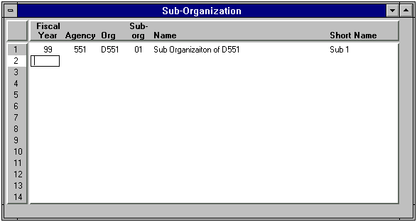
The MARS Sub-Organization field is an alpha/numeric field 2 bytes in length.

Sub-Object

Sub-Objects are usually used to further breakdown individual Object codes. However, the MARS Sub-Object code is unique within Agency and may be used for other purposes. The Sub-Object table (SOBJ) defines valid Sub-Object values and establishes Agency/Sub-Object relationships.

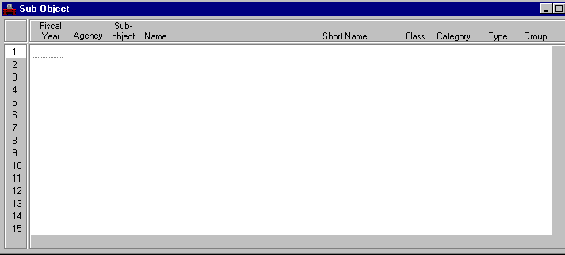
The MARS Sub-Object is an alpha/numeric field 2 bytes in length.

Sub-Object code rollups are listed in the following table.

ADVANTAGE Element |  | Hierarchy |  | Length |  | STARS Element or Reserved Use
Sub-Object | Code |  | 2 |  | Agency Defined
 | Class |  | 4 |  | Agency Defined
 | Category |  | 4 |  | Agency Defined
 | Type |  | 4 |  | Agency Defined
 | Group |  | 4 |  | Agency Defined

Sub-Revenue Source

Sub-Revenue Sources are usually used to further breakdown individual Revenue Source codes. However, the MARS Sub-Revenue Source code is unique within Agency and may be used for other purposes. The Sub-Revenue Source table (SREV) defines valid Sub-Revenue Source codes and establishes Agency/Sub-Revenue Source relationships.

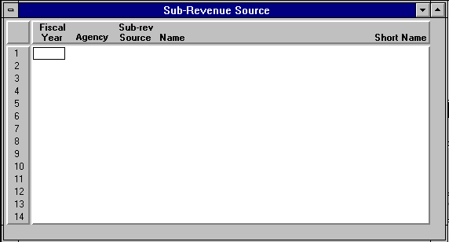

The MARS Sub-Revenue Source field is an alpha/numeric fields 2 bytes in length.

Function

Function codes generally define broad operational objectives, such as instruction, support services and facilities acquisition, but will also be used in MARS to define such items as location. The Function table (FUNC) defines valid Function codes and also groups similar Functions into higher level classifications.

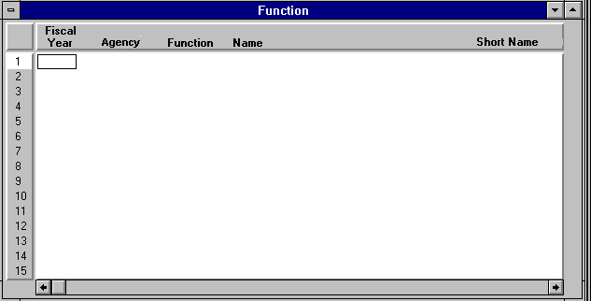
The MARS Function is an alpha/numeric field 4 bytes in length. Generally, STARS Location codes will be defined as MARS Function codes. However, each agency will need to evaluate how to use the MARS Function code.

Function code rollups are defined in the following table:

ADVANTAGE Element |  | Hierarchy |  | Length |  | STARS Element or Reserved Use
Function | Code |  | 4 |  | Agency Locations
 | Class |  | 4 |  | STARS County Codes
 | Category |  | 4 |  | Agency Defined
 | Type |  | 4 |  | Agency Defined
 | Group |  | 2 |  | Agency Defined

Activity

An Activity is an internal program that an agency may choose to define for budgeting and/or reporting purposes. The Activity table (ACT2) defines valid Activity codes and can also be used to group similar Activities into higher level classifications.

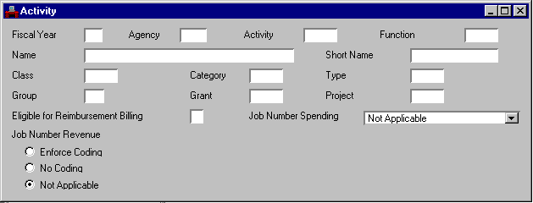

The MARS Activity is an alpha/numeric field 4 bytes in length. Generally, STARS Function codes will be defined as MARS Activity codes. However, each agency will need to evaluate how to use the MARS Activity code.

Note: The MARS Activity code is used by the MARS grant/project billing system in conjunction with object codes to identify eligible/ineligible expenditures for reimbursement.

Activity code rollups are listed in the following table:

ADVANTAGE Element |  | Hierarchy |  | Length |  | STARS Element or Reserved Use
Activity | Code |  | 4 |  | Agency Defined
 | Class |  | 4 |  | Agency Defined
 | Category |  | 4 |  | Agency Defined
 | Type |  | 4 |  | Agency Defined
 | Group |  | 2 |  | Agency Defined

Project / Sub-project, Phase

Projects are used to account for grants, capital projects, highway projects, jobs and any other project like activities. The MARS Project is an alpha/numeric field 5 bytes in length. The MARS Sub-Project is an alpha/numeric field 2 bytes in length. The MARS Phase is an alpha/numeric field 1 byte in length. These three elements are always used together in MARS.

For more detailed information on setup and usage of Project, Sub-Project and Phase please refer to the Cost Accounting Classification and Reporting Plan.

Project used for grants

A grant is an agreement with another entity where that entity agrees to fund all or part of an initiative. The grant identifier consists of Project, Sub-Project and Phase. Valid Project/Sub Project/Phase combinations and their associated funding ratios are established in MARS by processing PJ (Project Management Master) and PZ (Project Participation) documents. Project number is the base element for identifying a grant. Sub-Project will be used to distinguish separately reportable components of a grant or to distinguish components of a grant that are financed at different ratios of grantor/state participation. Phase, though not required for grant accounting, is required by the MARS system. Therefore an arbitrary value will be established for use with grants.

Note: If there are multiple agencies participating in a grant, each agency will establish a Project and use a lookup element called Entity Wide Project number to link those grants for reporting purposes.

Project used for projects

Project identifies a specific activity for which funds are appropriated or expended. Sub-Project will be used to identify major tasks or sub-sections of a Project. Phase identifies the lowest level of activity on a project. Valid Project/Sub Project/Phase combinations and their associated funding ratios are established in MARS by processing PJ (Project Management Master) and PZ (Project Participation) documents.

Note: If there are multiple agencies participating in a project, each agency will establish a Project and use a lookup element called Entity Wide Project number to link those projects for reporting purposes.

Job Number (Used with Projects)

The most common use of job costing is for the collection of costs and the application of overhead rates for the calculation of full costs. A Job Number is established for specific work to be performed by an agency. As the agency occurs expenses directly related to the work, they are charged directly to the job. At the end of an accounting period, overhead rates may be applied to certain expense items and full costs are then calculated. Non expense based charges may also be recorded against a job by entering a JC (Job Charges) document.

Expenses incurred on a Job Number may be accumulated to a Project, or expenses incurred on a Project may be accumulated to a Job Number. This precedence is established on the Fund Agency (FGY2) table.

Reporting Category

The Reporting Category table (RPTG) defines general purpose reporting categories for individual agencies.

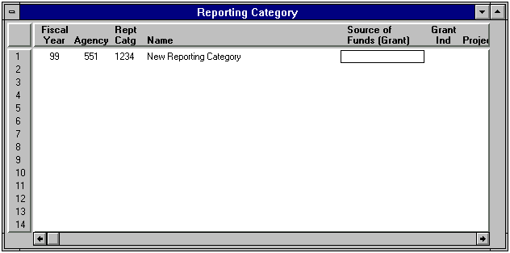
During the initial agency crosswalking, no specific uses were identified for Reporting Category. However, each agency will need to evaluate whether/how to use the MARS Reporting Category. The MARS Reporting Category is an alpha/numeric field 4 bytes in length.

Termini

The Termini Validation table (TERM) will be used by the Transportation Cabinet to establish valid mile marker codes and other breakdowns associated with highway maintenance projects in MARS.

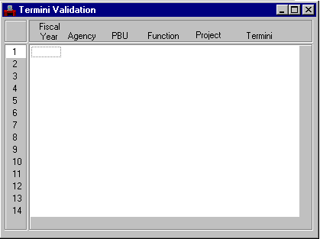

The MARS Termini is an alpha/numeric field 7 bytes length. In general MARS Termini will be defined as the STARS Termini.

Note: This field is also available for use by any Commonwealth agency.

Agency Crosswalk Matrix

The following matrix contains a suggested crosswalk for agency chart of account elements. However, during implementation agencies may determine a more practical/functional crosswalk for their data elements.

STARS Accounting Elements |  |  |  |  | MARS Data Elements
Field Name | Defined within | Length | Input |  | Field Name | Defined Within | Length | Input
Function | Department | 3 | Y |  | Activity | Agency | 4 | Y
Location | Department | 5 | Y |  | Function | Agency | 4 | Y
Budget Unit | Department | 4 | Y |  | Program Budget Unit | Fund/Agency | 4 | Y
Agency Object | Department | 7 | Y |  | Sub Object | Agency | 2 | Y
Grant/Yr/SubGrant | Department | 8 | Y |  | Project | Agency | 5 | Y
 |  |  |  |  | Sub Project | Agency/Proj | 2 | Y
 |  |  |  |  | Phase | Agency/Proj/Sub Proj | 1 | Y
N/A |  |  |  |  | Sub Revenue Source | Agency | 2 | Y
N/A |  |  |  |  | Sub Organization | Agency / Organization | 2 | Y
N/A |  |  |  |  | Reporting Category | Agency | 4 | Y
Funding Source | Statewide | 3 | Y |  | N/A
Participation Indicator | Statewide | 1 | Y |  | N/A
Termini | Department | 7 | Y |  | Termini | Agency | 7 | Y
Sequence | Department | 3 | Y |  | Sub-Project | Agency/ Project | 2 | Y
Phase of Operation | Department | 1 | Y |  | Phase | Agency/Proj/Sub Proj | 1 | Y

Appendix A – Agency Chart of Account Crosswalk

Cabinet | STARS Element | MARS Element | Actuals |  | Comment
Cabinet | STARS Element | MARS Element | Expenditure | Revenue | Comment
Justice Cabinet (Department of Corrections) | Location | Function Class | N/A | N/A | Used to record county as it relates to facilities recorded in the MARS Function Code.
 | Location | Function | Yes | Yes | Used to record facilities, such as Blackburn Correctional Complex.
 | Function | Activity | Yes | Yes | Used to record activities, such as hog operations (HOG), or cattle operations (CAT).
 | Budget Unit | N/A | N/A | N/A | No longer needed as it will be tracked through the MARS Organization structure.
Tourism Development (Parks Department) | Location | Function Class | N/A | N/A | Used to record county.
 | Location | Function | Yes | No | Used to record county. As county is the only information recorded in the MARS Function, a one-to-one relationship will be created between the Function Code and Function Class.
 | Budget Unit | Organization | Yes | Yes | Used to record cost centers.  While the MARS Organization structure will capture the information contained in the STARS Budget Unit, there will be no crosswalk between the two elements. The reason for this is that the Organization structure created in MARS will contain the STARS Budget Unit information.
 | Agency Object | N/A | N/A | N/A | Used to record objects for prior year claims. This practice is no longer needed in MARS.
 | Revenue Source Codes (currently outside of STARS) | Sub-Revenue Source | N/A | Yes | Used to record revenue information at a level lower than what is centrally mandated. For example, slip rentals at the Lake Cumberland boat dock.
Cabinet for Workforce Development – Department 534 (Department for the Blind) | Agency Object | Sub-Object | Yes | Yes | The first two characters of the STARS Agency Object are used to record the status of patients (i.e., ‘New Patient’).  The Agency Object is only entered on the STARS expenditure Management Budgets due to system edits in the application. It is not necessary for budgetary purposes.
 | Agency Object | Activity | Yes | Yes | The middle two characters of the STARS Agency Object are used to record activities, such as ‘Diagnostic and Evaluation’.
 | Agency Object | Vendor | Yes | Yes | The last two characters of the STARS Agency Object are used to record vendor information, such as ‘State Rehabilitation Facility’, ‘Other State Agencies’, or ‘Private Vendor’. This assumes that vendor codes will be passed on intra-governmental transactions.
 | Location | Function Class | N/A | N/A | Used to record county as it relates to facilities recorded in the MARS Function.
 | Function | Function | Yes | Yes | Used to record facilities and physical entities, such as ‘Bowling Green Vocational School’, or ‘Jefferson County Courthouse Vending Stand’.
 | Budget Unit | Program Budget Unit | Yes | Yes | Used as a breakout of Posting Level Program in STARS. In MARS, additional, lower-level Program Budget Units (PBU’s) will be established as needed.
Cabinet for Workforce Development – Department 546 (Technical Education) | Agency Object | Sub-Object | Yes | Yes | The last four characters of the STARS Agency Object are used to track educational programs such as Electronics versus Biomedical. Issue with use of Sub-Object on Expense Budget.  The Agency Object is only entered on the STARS expenditure Management Budgets due to system edits in the application. It is not necessary for budgetary purposes.
 | Agency Object | Sub-Object Hierarchy | Yes | Yes | The first two characters of the STARS Agency Object are used to categorize programs recorded in the MARS Sub-Object. An example of this would be ‘Industrial Education’ for a Sub-Object of ‘Carpentry’.
 | Location | Function Class | N/A | N/A | Used to record county as it relates to facilities recorded in the MARS Function.
 | Location | Function | Yes | Yes | Used to record facilities, such as ‘Fivco Boyd Co Ashland Comm College’.
 | Function | Activity Hierarchy | N/A | N/A | In STARS, the Function is used to record activity categories and activities, such as ‘ Voc Ed-Sex Equity’. In MARS, the Activity Hierarchy may be used to record the category, such as ‘Vocational Education’.
 | Function | Activity | Yes | Yes | In STARS, the Function is used to record activity categories and activities, such as ‘ Voc Ed-Sex Equity’. In MARS, the Activity may be used to record the activity, such as ‘Sex Equity’.
 | Budget Unit | Program Budget Unit | Yes | Yes | Used as a breakout of Posting Level Program in STARS. In MARS, additional, lower-level Program Budget Units (PBU’s) will be established as needed.
Natural Resources Cabinet – Department 375 | Agency Object | Project | Yes | No | Used to group payroll transactions by Commonwealth employee activity for reports. The Agency Object has the following format at present:  AA BB CCC  AA represents the Grant/Sub-grant combination except when coded with ‘ZZ’, which is undefined. In STARS, there is no way to distinguish the Grant from the Sub-grant.  BB represents the function group being tracked.  CCC represents the activity being tracked.  For example, in the following code:  FE DB A13  FE = Section E18 – Endangered Species Grant  DB = Survey/Inventory  A13 = Weeds  In STARS the grant number associated with ‘FE’ is recorded in the STARS Grant element. There is a 1-to-1 relationship between the first two characters of the STARS Agency Object and the STARS Grant.  For this example, the STARS Grant is ‘067698’.  So, in this case, the MARS Project would be ‘06768’ and the Project Name would be ‘Section E18 – Endangered Species Grant’. The code ‘FE’ will no longer be used in MARS. The last two characters of the STARS Grant represent the year in which the grant was made, so the last character is retained in MARS as a significant digit to denote the year.
 | Agency Object | Sub-Project | Yes | No | Using the above example:  FE DB A13  FE = Section E18 – Endangered Species Grant  DB = Survey/Inventory  A13 = Weeds  The STARS code ‘A13’ represents the Federal Reporting Category for this grant. For this reason, the MARS Sub-Project is used. The MARS Sub-Project is a two character, alphanumeric element, therefor the MARS Sub-Project would be ‘A3’ for ‘Weeds’.
 | Agency Object | Reporting Category | Yes | No | Using the above example:  FE DB A13  FE = Section E18 – Endangered Species Grant  DB = Survey/Inventory  A13 = Weeds  The MARS Reporting Category is a four character, alphanumeric element, therefor the MARS Reporting Category would be ‘DB00’ for ‘Survey/Inventory’.
 | Location | Function Class | N/A | N/A | Used to record county.
 | Location | Function | Yes | No | Used to record county for Capital Projects. A 1-to-1 relationship will be established with the Function Class.
 | Grant | Project | Yes | No | Used to record the grant number. See the Comment column for the STARS Agency Object element for more information on the relationship of STARS Grant to MARS Project.
Natural Resources Cabinet – Department 569 (Scenario 1) | Agency Object | Project | Yes | No | Used to group payroll transactions by Commonwealth employee activity for reports. The Agency Object has the following format at present:  AA BB CCC  AA represents the Grant/Sub-grant combination except when coded with ‘ZZ’, which is undefined. In STARS, there is no way to distinguish the Grant from the Sub-grant.  BB represents the function group being tracked.  CCC represents the activity being tracked.  For example, in the following code:  KX AD 042  KX = Paducah Gas Diffusion Plant Grant  AD = Information Management  042 = Computer Programming  In STARS the grant number associated with ‘KX’ is recorded in the STARS Grant element. There is a 1-to-1 relationship between the first two characters of the STARS Agency Object and the STARS Grant.  For this example, the STARS Grant is ‘136891’.  Because the MARS Project is only five, alphanumeric characters, the value would be ‘13681’ and the Project Name would be ‘Paducah Gas Diffusion Plant Grant’. The code ‘KX’ will no longer be used in MARS. The last two characters of the STARS Grant represent the year in which the grant was made, so the last character is retained in MARS as a significant digit to denote the year.
 | Agency Object | Reporting Category | Yes | No | Using the above example:  KX AD 042  KX = Paducah Gas Diffusion Plant Grant  AD = Information Management  042 = Computer Programming  The MARS Reporting Category is a four character, alphanumeric element, therefor the MARS Reporting Category would be ‘AD42’ for ‘Information Management – Computer Programming’.
 | Location | Function Class | N/A | N/A | Used to record county.
 | Location | Function | Yes | No | Used to record county for Capital Projects. A 1-to-1 relationship will be established with the Function Class.
 | Grant | Project | Yes | No | Used to record the grant number. See the Comment column for the STARS Agency Object element for more information on the relationship of STARS Grant to MARS Project.
Natural Resources Cabinet – Department 569 (Scenario 2) | Agency Object | Project | Yes | No | Used to group payroll transactions by Commonwealth employee activity for reports. The Agency Object has the following format at present:  AA BB CCC  AA represents the Grant/Sub-grant combination except when coded with ‘ZZ’, which is undefined. In STARS, there is no way to distinguish the Grant from the Sub-grant.  BB represents the function group being tracked.  CCC represents the activity being tracked.  For example, in the following code:  BA AD 028  BA = State Funded Division of Water Project  AD = Information Management  028 = Water – Body System  In STARS the grant number associated with ‘BA’ is recorded in the STARS Grant element. For this example, the STARS Grant number represents projects that are state funded and have no actual grant associated.  For these cases, the STARS Grant is ‘069998’.  Because the MARS Project is only five, alphanumeric characters, the value would be ‘06998’ and the Project Name would be ‘Stated Funded Project’. The last two characters of the STARS Grant represent the current budget fiscal year, so the last character is retained in MARS as a significant digit to denote the year.
 | Agency Object | Sub-Project | Yes | No | Using the above example:  BA AD 028  BA = State Funded Division of Water Project  AD = Information Management  028 = Water – Body System  Because the MARS Project is used to denote that this is a state funded project with no grant associated, the MARS Sub-Project is used to identify the division and project for this example. The MARS Sub-Project is a two character, alphanumeric element, therefor the MARS Sub-Project would be ‘BA’ for ‘State Funded Division of Water Project’.
 | Agency Object | Reporting Category | Yes | No | Using the above example:  BA AD 028  BA = State Funded Division of Water Project  AD = Information Management  028 = Water – Body System  The MARS Reporting Category is a four character, alphanumeric element, therefor the MARS Reporting Category would be ‘AD28’ for ‘Information Management – Water – Body System’.
 | Location | Function Class | N/A | N/A | Used to record county as it relates to clean-up sites recorded in the MARS Function.
 | Location | Function | Yes | No | Used to record clean-up sites for grants.
 | Grant | Project | Yes | No | Used to record the grant number. See the Comment column for the STARS Agency Object element for more information on the relationship of STARS Grant to MARS Project.
Natural Resources Cabinet – Department 590 | Agency Object | Project | Yes | No | Used to group payroll transactions by Commonwealth employee activity for reports. The Agency Object has the following format at present:  AA BB CCC  AA represents the Grant/Sub-grant combination except when coded with ‘ZZ’, which is undefined. In STARS, there is no way to distinguish the Grant from the Sub-grant.  BB represents the function group being tracked.  CCC represents the activity being tracked.  For example, in the following code:  NA AB 010  NA = 106 Grant – Surface Water Sub-grant  AB = Internal Support  010 = Clerical Support  In STARS the grant number associated with ‘NA’ is recorded in the STARS Grant element.  For this example, the STARS Grant is ‘135498’.  Because the MARS Project is only five, alphanumeric characters, the value would be ‘13548’ and the Project Name would be ‘106 Grant’. The code ‘NA’ will no longer be used to represent both the grant and sub-grant in MARS. The last two characters of the STARS Grant represent the year in which the grant was made, so the last character is retained in MARS as a significant digit to denote the year.
 | Agency Object | Sub-Project | Yes | No | Using the above example:  NA AB 010  NA = 106 Grant – Surface Water Sub-grant  AB = Internal Support  010 = Clerical Support  The STARS code ‘NA’ represents both the grant and sub-grant. Because the grant information is also captured by the STARS Grant element and recorded in the MARS Project, the MARS Sub-Project is used to capture the sub-grant information. The MARS Sub-Project is a two character, alphanumeric element, therefor the MARS Sub-Project would be ‘NA’ for ‘Surface Water Sub-grant’.
 | Agency Object | Reporting Category | Yes | No | Using the above example:  NA AB 010  NA = 106 Grant – Surface Water Sub-grant  AB = Internal Support  010 = Clerical Support  The MARS Reporting Category is a four character, alphanumeric element, therefor the MARS Reporting Category would be ‘AB10’ for ‘Internal Support – Clerical Support’.
 | Location | Function Class | N/A | N/A | Used to record county as it relates to the clean-up sites recorded in the MARS Function.
 | Location | Function | Yes | No | Used to record clean-up sites.
 | Grant | Project | Yes | No | Used to record the grant number. See the Comment column for the STARS Agency Object element for more information on the relationship of STARS Grant to MARS Project.
Natural Resources Cabinet – Department 595 | Agency Object | Project | Yes | No | Used to group payroll transactions by Commonwealth employee activity for reports. The Agency Object has the following format at present:  AA BB CCC  AA represents the Grant/Sub-grant combination except when coded with ‘ZZ’, which is undefined. In STARS, there is no way to distinguish the Grant from the Sub-grant.  BB represents the function group being tracked.  CCC represents the activity being tracked.  For example, in the following code:  ZZ NA 000  ZZ = Undefined  NA = Fire Suppression  000 = Undefined  In STARS the grant number associated with ‘ZZNA’ is recorded in the STARS Grant element.  For this example, the STARS Grant is ‘065498’.  Because the MARS Project is only five, alphanumeric characters, the value would be ‘06548’ and the Project Name would be ‘Consolidated Forestry Grant’. The code ‘ZZ’ will no longer be used in MARS. The last two characters of the STARS Grant represent the year in which the grant was made, so the last character is retained in MARS as a significant digit to denote the year.
 | Agency Object | Reporting Category | Yes | No | Using the above example:  ZZ NA 000  ZZ = Undefined  NA = Fire Suppression  000 = Undefined  The STARS code ‘NA’ represents the activity associated with the grant. The MARS Reporting Category is used to capture the activity information for this grant. The MARS Reporting Category is a four character, alphanumeric element, therefor the MARS Sub-Project would be ‘NA00’ for ‘Fire Suppression’.
 | Location | Function Class | N/A | N/A | Used to record county.
 | Location | Function | Yes | No | Used to record county for Capital Projects. A 1-to-1 relationship will be established with the Function Class.
 | Grant | Project | Yes | No | Used to record the grant number. See the Comment column for the STARS Agency Object element for more information on the relationship of STARS Grant to MARS Project.
 | Sub-Grant | Sub-Project | Yes | No | For the above example, the STARS Sub-grant is ‘01’ which represents the ‘UFA’ sub-grant. Because the grant for this example must be broken into separate sub-grants, the MARS Sub-Project is used to record this information. So, for the above example the MARS Sub-Project would be coded as ‘01’.
Natural Resources Cabinet – Department 600 | Location | Sub-Object | Yes | No | Used to record activities for contractors, such as ‘Administration’.
 | Location | Function Class | N/A | N/A | Used to record county.
 | Location | Function | Yes | No | Used to record county for Capital Projects. A 1-to-1 relationship will be established with the Function Class.
 | Function | Sub-Project | Yes | No | Used to record sub-grant number for Federal reporting classifications such as Administration, Construction, Permitting, etc.
 | Grant | Project | Yes | No | Used to record grant number. An example of this would be ‘068698’. Because the MARS Project is only five, alphanumeric characters, the value would be ‘06868’. The last two characters of the STARS Grant represent the year in which the grant was made, so the last character is retained in MARS as a significant digit to denote the year.
 | Sub-Grant | Activity | Yes | No | Used to record generic location where the grant funds will be used. For example, Osborne Branch, Arkansas Creek, etc. The MARS Job element was originally discussed to track this information, but this may not be a good fit due to the many-to-many relationship between grant/sub-grant and generic location. By using the MARS Activity element, many-to-many relationships can be established with the MARS Project.
Transportation Cabinet | Agency Object | Commodity (Procurement Desktop) | Yes | No | Used to record commodities, such as ‘#4 Gravel’ or ‘Salt’. Commodity information is to be tracked through the PPD portion of MARS.
 | Location | Function Class | N/A | N/A | Used to record county.
 | Location | Function | Yes | No | The last 3 characters of the STARS Location code are used to record county. A 1-to-1 relationship will be established with the Function Class.
 | Location | Organization | Yes | No | The first 2 characters of the STARS Location code are used to record district.
 | N/A | Activity Hierarchy | N/A | N/A | The MARS Activity Hierarchy may be used to record categories of activities recorded in the MARS Activity element.
 | Function | Activity | Yes | No | Used to record activities, such as ‘Snow Removal’ and ‘Dead Animal Pick-up’.
 | Budget Unit | Project | Yes | No | Used to record highway routes, such as ‘US127’ or ‘US060’.
 | Phase | Phase | Yes | No | Used to record phase, such as ‘M’ for maintenance.
 | Termini | Termini | Yes | No | Used to record termini, bridge identifiers, or to potentially identify sign trusses and traffic signals.
 | Sequence | Sub-Project | Yes | No | Used to define breakouts of highway construction projects.

