Topic 2 – Using Document Direct

Purpose

Objectives

The purpose of this topic is to introduce the student to basic functionality available through Document Direct. Document Direct is one tool available to users to access MARS Standard Reports.

At the end of this topic, you will:

- Have a working knowledge of Document Direct, understand how to

- Identify and locate a report in Document Direct, and

- Understand how a report is printed.

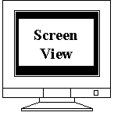

Document Direct Window

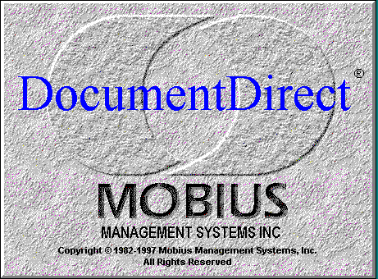



What is Document Direct?
Document Direct is a client-server application for the Windows operating system that provides a common user interface to view documents and images.
The Commonwealth will use Document Direct for records management and archival of legally required documents.
Document Direct provides options for displaying information which include:
- Scaling
- Full page document display
- Freezing column and row headings
- Moving data elements for easy viewing
Document Direct has several printing options:
- Single pages
- A range of pages
- The entire report
Now let’s open a document.



Desktop

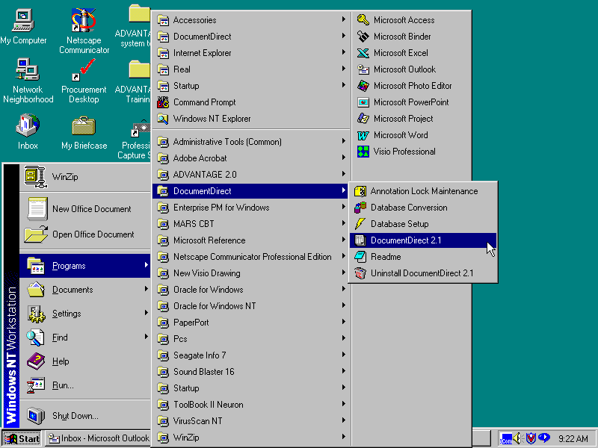

Opening a Document Direct Report

To begin viewing documents, you must first access the Document Direct Software on your computer. To do so follow these easy steps:

Step 1 At the bottom left hand corner of your desktop, left-click, with your mouse, on the button.

Step 2 Slide your mouse up to the button.

Step 3 Move your mouse to the button.

Step 4 Move your mouse to the button, and left-click on it.

Document Direct will now open.
.

Document Direct Main Screen
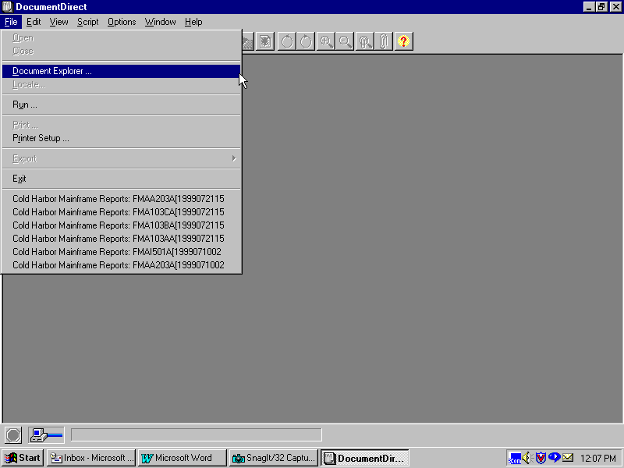

Once you have arrived at the main screen of Document Direct, you will need to follow these steps:

Step 1 Move your mouse to the button and left-click.

A pop-up box will appear.

Step 2 Move your mouse down to the button and left-click.

The Document Explorer window will apprear.

Document Explorer Window

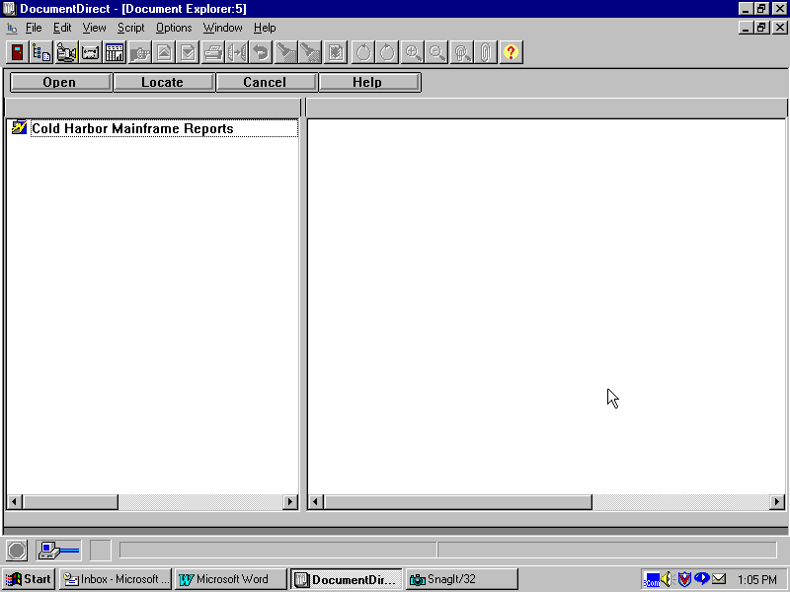
Document Direct Toolbar
Document Explorer Toolbar
Caption Bar
Status Bar
Document Server Processing Icon
Stop Button

Document Explorer Window

Let’s identify the important parts of the Document Explorer Window.

Document Direct Toolbar

Click the toolbar buttons for quick access to Document Direct functions. To display pop-up text explaining what the button does, hold the mouse pointer over button. We will explain the toolbar icons in a few pages.

Document Explorer Toolbar

Toolbar buttons provide the following functions:

- Open: Open a selected document.
- Locate: Locate a selected document
- Cancel: Close the Document Explorer window.
- Help: Access Document Explorer Help.

Document Explorer Window

Document Direct Toolbar
Document Explorer Toolbar
Caption Bar
Status Bar
Document Server Processing Icon
Stop Button



Caption Bar

The network connection server.

Document Server Processing Icon

Indicates whether document server communication is in progress:

- Black background – communication is in progress

- Gray background – communication is not in progress

Stop Button

Stops communications with document servers. Button is red when document server communications are taking place.

Status Bar

- Left Side: Displays document server processing messages, annotation indicator, and report and section names for the current report.

- Right Side: Displays page numbers for the current report.

Now let’s look at the different Document Direct Toolbar icons.

Document Direct Toolbar
1 2 3 4 5 6 7 8 9 10 11 12 13 14 15 16 17 18 19 20 21

Document Direct Toolbar

The Document Direct toolbar buttons function as listed below.

- Exit Document Direct
- Display Document Explorer Window
- Start/stop script recording
- Play back a script
- Start DocuAnalyzer
- Go to a page in an open document
- Page up in an open document
- Page down in an open document
- Print the current page
- Copy current selection to the clipboard
- Undo last action
- Find text in an open document
- Find next occurrence of text in an open document
- Clear view
- Rotate image counter-clockwise 90 degrees
- Rotate image clockwise 90 degrees
- Enlarge page by 25%, centering any marked data or the part of the page in the viewing area
- Reduce the page by 20%, centering any marded data or the part of the page in the viewing area
- Display annotations
- Edit annotations
- View help

Attach To Server Window
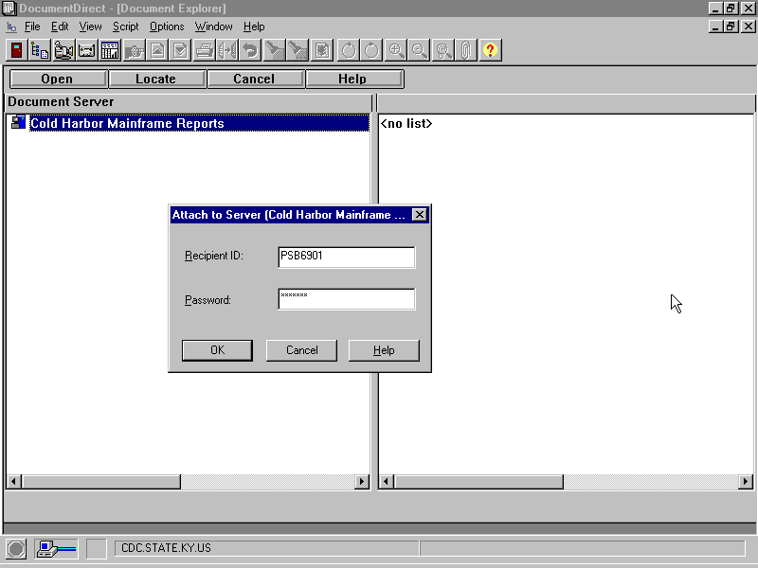

Attaching to the Server

Once you have the Document Explorer screen on your desktop, you will need to connect to the server. You do that by following the steps below.

Step 1 With your mouse, left click on the icon in the Caption Bar.

An Attach to Server Window will appear.

Step 2 Type your User ID “☺☺☺☺☺☺☺” in the Recipient ID field.

Step 3 In the PASSWORD field type your password. An example would be “CATS7”

Step 4 Select the “OK” button.

Now, you are ready to locate the report(s) you need.

Document Explorer Window
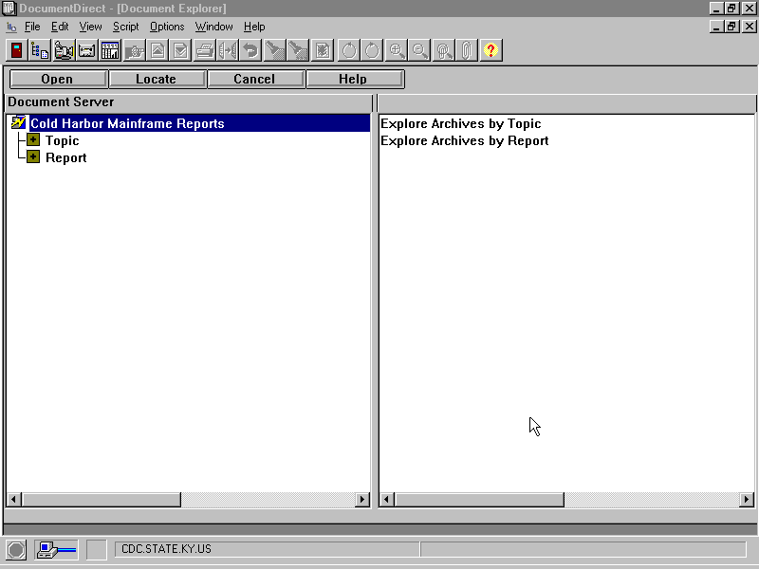

Locating a Report

Now that you have the Explorer Window on your desktop, you can proceed with finding your report(s).

Step 1 With your mouse, left-click on the Report field.

A list of reports will be displayed on both sides of the page.

Locate Window
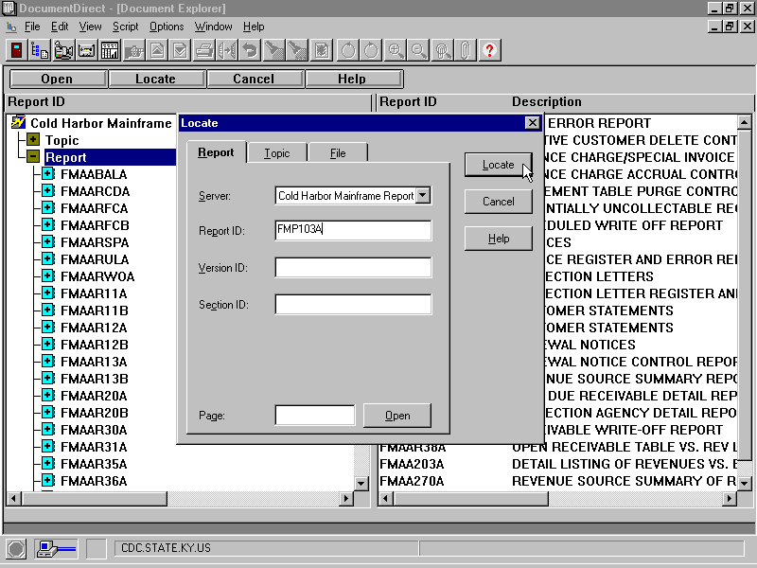

Locating a Report

Step 1 On your Document Direct Toolbar, select “Locate”.

A Locate Window will appear. You will notice the Locate Window has three different tabs; REPORT, TOPIC, and FILE. In this class the only tab that we will use will be the REPORT tab.

Step 2 Enter the following values in the corresponding fields:

SERVER Name of the server you want to search. Leave as default.

REPORT ID The identification number (alpha-numeric) of the report for which you are searching. Type, FMP☺☺☺☺☺.

VERSION ID The version identificaiton of the report you wish to locate. Leave blank.

SECTION ID The section identification of the report you wish to locate. Leave blank.

PAGE Page number to which you want to open the section. Page number applies to the section indicated in the SECTION ID field. Leave blank.

Step 3 With your mouse, left-click on the LOCATE button.

Document Direct will search for your report.

Locate Window

When using the Locate Window, keep the following guidelines in mind:

- If you leave the fields in the Locate window blank, Locate assumes you want the first entry of that type. For example, if you enter a Version ID but leave the Report ID blank, Locate finds the first report in the list and tries to match the Version ID. Locate lets you enter a prefix of the name.

- If Locate finds no exact match for the data entered in the Locate window, it searches for the next closest name or the next most recent date for Version ID’s.

- A Version ID consists of a date followed by a time. Document Direct expects date and time formats to conform to the date and time formats set in the International dialog of the Windows Control Panel. Locate lets you enter a prefix for the Version ID. Date and time elements default to the largest permissible value. For example, if you enter a Version ID of 03/10, and your date format is set to MM/DD/CCYY, the year defaults to the current year and the time defaults to 12:59:59 PM.

Now that we have searched for the report, it will appear on your desktop.

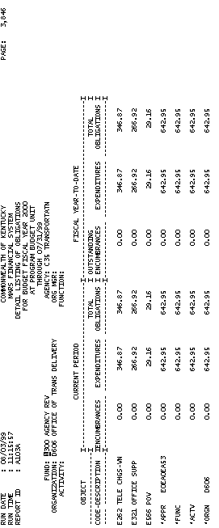

The report you searched for FMP☺☺☺☺☺.is now displayed.

Now that you have the report in front of you, let’s talk about viewing the document.

Find Window
