

Searching For Text
One of the things you will want to do with Document Direct is find a certain item on a report (ie. Agency, Appropriation, Object, etc.).

Document Direct allows you to search for specific text using the Find option on the Edit menu. Find can search up or down within a document and can be case sensitive.

To search for specific text within the report you are viewing follow these steps:

Step 1 Pull down the Edit menu and select Find

The Find Window is now displayed.

Step 2 Find What Type the text for which you want to search. Type E321.

AS IS (CASE SENSITIVE) Perform a search that distinguishes between uppercase and lowercase letters. In a case sensitive search, you must specify the text exactly as it appears in the file. For example: Equipment does not find EQUIPMENT nor does EQUIPMENT find Equipment.

DIRECTION UP/DOWN Search for text in the specified direction. Down is the default selection. Leave as Default.

FIND Begin the search

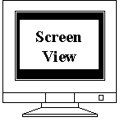

Find Window
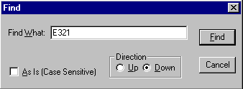

CANCEL End the search.

Step 3 Select the FIND button.

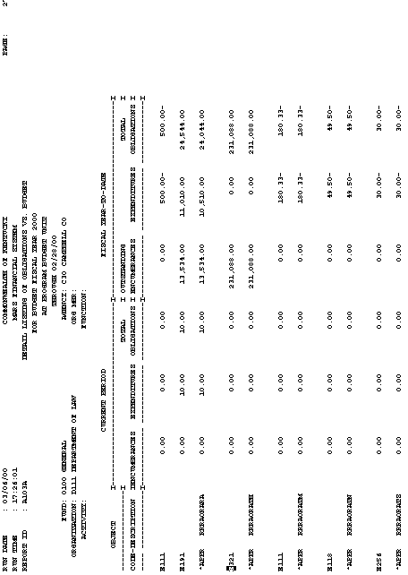
Object Code E321

As you can see from the example on the previous page once the Find button is selected the report goes to where object code E321 is first displayed on the report.
Now let’s take a look at how to print a report.

.

Menu Window
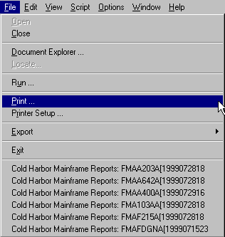

Printing a Report

You can print any document that you can display in Document Direct. When you display a document using a True Type font, Document Direct prints it exactly as it appears on the screen.

To print a report:

Step 1 Open the Document Explorer and display the desired document.

Step 2 Pull down the File menu and choose Print.

The Print Dialog Window will appear.

Print Dialog Window
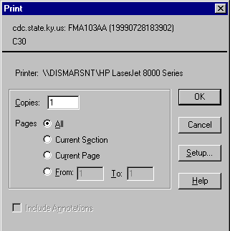

Step 1 Enter the following values in the corresponding fields:

COPIES To print multiple copies, type the number of copies you want to print. Defaults to 1.

PAGES ALL Print all pages of the document currently displayed. Leave blank.

PAGES CURRENT SELECTION Print only the section currently displayed. Choose this button.

PAGES CURRENT PAGE Print only the page currently displayed. Leave blank.

PAGES FROM: The number of the first page in the range you want to print. Leave blank.

PAGES TO: The number of the last page in the range you want to print. Leave blank.

INCLUDE ANNOTATIONS Print the document with any and all annotations that are attached to it. Leave blank.

OK When all the option buttons are correct and you are ready to print.

CANCEL If you are not ready to print.

SETUP This feature changes your printing options. Choose this option.

The Print Setup Window will be displayed on your desktop.

Print Setup Window
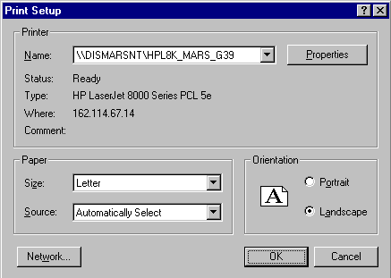

Print Setup Window

Step 1 Enter the following values in the corresponding fields:

NAME Select the desired printer from the drop-down list.

STATUS Show the status of the chosen printer. Default information.

TYPE Displays the type of printer. Default information

WHERE The location of the printer. Default information.

COMMENT Any comment about the printer that may be pertinent to the print job. Default information.

PROPERTIES To set your printing options. Choose this option.

Your Print Options Windows will display on your desktop.

Print Properties Window
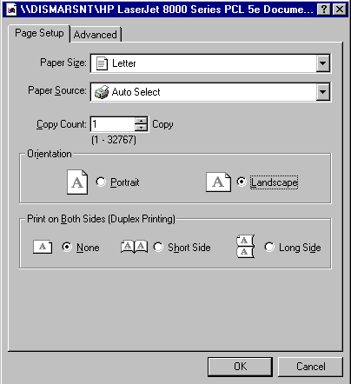

Step 1 Enter the following values in the corresponding fields.

PAGE SETUP TAB

PAPER SIZE The size of paper you want to print on. Defaults to Letter.

Paper Source The tray you want the copier to print from. Defaults to Auto Select.

copy Count the number of copies you want. Defaults to 1.

Orientation Portrait The report will print on the paper as a portrait.

Orientation Landscape The report will print on the paper in the landscape format. Choose this option.

PRINT ON BOTH SIDES (DUPLEX PRINTING) NONE Choose this option when you want to print on only one side.

PRINT ON BOTH SIDES (DUPLEX PRINTING) SHORT SIDE Choose this option when you want the pages in book format.

PRINT ON BOTH SIDES (DUPLEX PRINTING) LONG SIDE Choose this option when you want the pages in flip chart format. Choose this option.

Now let’s move to the ADVANCED TAB.

Print Properties Window
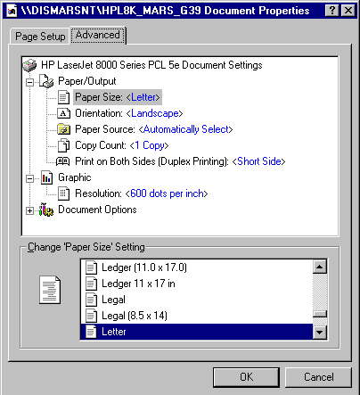

aDVANCED TAB

The ADVANCED TAB shows the options that have already been chosen in an enhanced view.

Step 1 Press the OK button.

This will take you back to the Print Setup Window.

Print Setup Window

Be sure to check that all options are set correctly for this screen.

Step 1 If all options on the window are correct, select the OK button. If there is a problem, go back to the Print Properties Window or select the CANCEL button. Select OK.

This will send you back to the original Print Dialog Window.

Print Dialog Window

Be sure that everything on the Printer Dialog Window is accurate.

Step 1 If everything is correct select OK. If there is something not accurate select SETUP or CANCEL. Select OK.

This initiates the printing. The only thing remaining is to go to the printer and retrieve the report.

This page intentionally left blank

Now that you know how to navigate through Document Direct, you may ask, “How do I get Document Direct loaded onto my machine?”

You will need to inform your agency system administrator that you need Document Direct on your machine and for what reason. Your system administrator will then take the appropriate steps to obtain the needed software as well as the required security access.

This page intentionally left blank.


Activity 2 - 1

True or False

- When using the Locate Window in Document Direct to locate a report, if no exact match for the data entered is found, the next closest name or the most recent date will be displayed.

- True
- False

- Document Direct will not let you find a specific item from a report.

- True
- False

3. You can print any report from Document Direct that you can display.

A. True
- False
This page intentionally left blank.



Solution 2 – 1

True/False

1. When using the Locate Window in Document Direct to locate a report, if no exact match for the data entered is found, the next closest name or the most recent date will be displayed.

A. True
B. False

Answer: A. True

2. Document Direct will not let you find a specific item from a report.

A. True
B. False

Answer: B. False

3. You can print any report from Document Direct that you can display.

A. True
B. False

Answer: A. True
This page intentionally left blank.



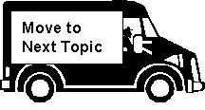
Are there any questions about the navigation process of Document Direct?

In this topic we have:

- Gained a working knowledge of Document Direct,

- Identified how to locate a report in Document Direct, and

- Reviewed the steps required to print a report.

