Topic 3 – Encumbrance and Expenditure Standard Reports

Purpose

Objectives

The purpose of this topic is to provide the MARS end-user with a working knowledge of what information is provided by select MARS Encumbrance and Expenditure Standard Reports.

By the end of this topic you will have:

- Covered specific reports included as Encumbrance and Expenditure Standard Reports, and

- Viewed information and specific fields contained in these reports.

Encumbrance and Expenditure Standard Reports

Report ID - FMP103AA - Detail Listing of Obligations at the Program Budget Unit Level

Report ID - FMP103BA - Detail Listing of Obligations at the Allotment Level

Report ID - FMP103CA - Detail Listing of Obligations at the Appropriation Level

Report ID - FMPA400A - Detail Listing of Encumbrances vs. Expenses by Accounting Distribution

Report ID - FMPA642A - Outstanding Purchase Orders Report



The portion of the MARS Reporting that involves encumbrances and expenditures is separated into five separate reports. Those reports include:

- Detail Listing of Obligations at the Program Budget Unit Level (FMP103AA)

- Detail Listing of Obligations at the Allotment Level (FMP103BA)

- Detail Listing of Obligations at the Appropriation Level (FMP103CA)

- Detail Listing of Encumbrances vs Expenses by Accounting Distribution (FMPA400A)

- Outstanding Purchase Orders Report (FMPA642A)

As you can see from the names of these reports, the information on A103A, A103B, and A103C is similar. Since the Commonwealth breaks the Appropriation Unit into three sections, there are three reports to show the affects of accounting transactions on each section. The A103A Report shows accounting transactions from the Program Budget Unit perspective. Report A103B shows accounting transactions from an Allotment perspective and Report A103C shows accounting transactions from an Appropriation standpoint.

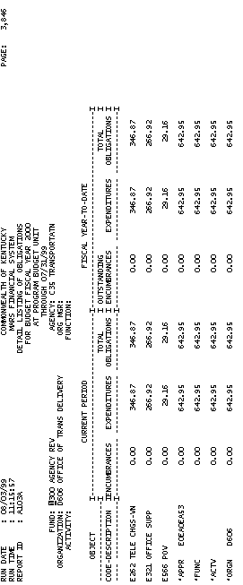

Report ID – FMP103AA - Detail Listing of Obligations at the Program Budget Unit Level

Report A103 is a monthly report broken down by Program Budget Unit. Each report is a detail listing of Obligations by fund, agency, organization, activity and function. Encumbrances and Expenditures for the current period, and fiscal year-to-date are shown for each object.
.

Report ID – FMP103AA - Detail Listing of Obligations at the Program Budget Unit Level (Continued)

FUND A fund is a fiscal and accounting entity with a self-balancing set of accounts recording cash and other financial resources together with all related liabilities, and residual equities and changes therein, which are segregated for the purpose of carrying on specific activities or attaining certain objectives. Fund codes are centrally maintained on the Fund Table (FUN2) by the Finance and Administration Cabinet.

AGENCY All agencies that record information in the financial system will be recorded in MARS on the Agency table (AGC2).

ORGANIZATION The Organization data element is a breakdown of Agency (i.e., Department, Division, Branch, Section, Unit). The Organization structure can be up to twelve levels. In MARS, the Organization data element can be used for a variety of purposes. The Agency and Organization data elements can also be used for security restrictions for transaction processing. Valid values are maintained on the Organization table (ORG2).

ORG MGR (ORGANIZATION MANAGER) The person responsible for the organization.



Report ID - FMP103AA - Detail Listing of Obligations at the Program Budget Unit Level (Continued)

ACTIVITY Activity table (ACT2) defines valid codes for activities and can also be used to group similar activities into higher level classifications. An activity is an internal program that you want to define for budgeting and/or reporting purposes.

FUNCTION The Function code is a data element in MARS that is generally used to identify location information. Also, Function codes and the associated data elements in the Function hierarchy are defined by agency and fiscal year. This allows MARS User Agencies to tailor and maintain a set of function codes specific for agencies’ use for each fiscal year. The requirement for the use of the Function code is established on the Fund/Agency (FGY2) table within each fund/agency combination for each fiscal year. When a Function code is used on an accounting or budget transaction line, the associated hierarchy for the Function code can be obtained from the Function table (FUNC) for reporting purposes.

Report ID - FMP103AA - Detail Listing of Obligations at the Program Budget Unit Level (Continued)

OBJECT CODE- DESCRIPTION Objects represent the coding level for recording all expenditures in MARS. Valid object codes are maintained on the Object table (OBJ2).

CURRENT PERIOD ENCUMBRANCES The current accounting fiscal month’s accounting transaction activity such as purchase orders and contracts.

CURRENT PERIOD EXPENDITURES The current accounting fiscal month’s accounting transaction activity such as payments, journal vouchers, and manual warrants.

CURRENT PERIOD TOTAL OBLIGATIONS The sum total of the current period’s encumbrances and expenditures for the accounting fiscal month.

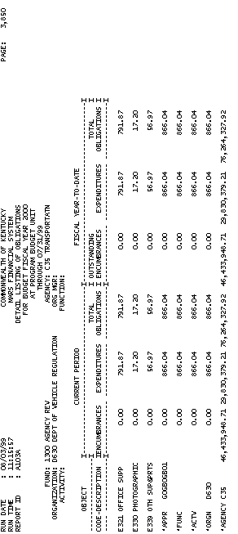

Report ID - FMP103AA - Detail Listing of Obligations at the Program Budget Unit Level (Continued)

FISCAL YEAR-TO-DATE OUSTANDING ENCUMBRANCES The accounting fiscal year’s transaction such as purchase orders and contracts from the beginning of the fiscal year to the current accounting period.

FISCAL YEAR-TO-DATE EXPENDITURES The accounting fiscal year’s transaction such as payments, journal vouchers, and manual warrants from the beginning of the fiscal year to the current accounting period.

FISCAL YEAR-TO-DATE TOTAL OBLIGATIONS The sum total of the fiscal year-to-date encumbrances and expenditures from the beginning of the fiscal year to the current accounting period.

APPR (Unit of Appropriation) The appropriation charged for the encumbrances and/or expenditures. The unit of appropriation field is a 9-character data field that consists of an appropriation program (2 characters maintained on EAP2 table), and allotment program (3 characters maintained on EALL table), and a program budget unit (4 characters maintained on PRFT table).
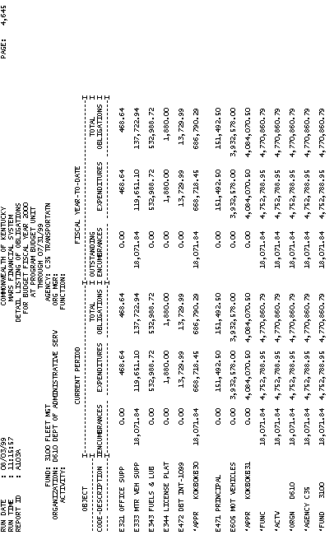

Report ID - FMP103AA - Detail Listing of Obligations at the Program Budget Unit Level (Continued)

APPR (Total Appropriation Unit) This field contains the total amounts grouped by budget fiscal year, fund, agency, organization, activity, function and appropriation unit (appropriation program, allotment program, and program budget unit).

FUNC (Total Function) This field contains the total amounts grouped by budget fiscal year, fund, agency, organization, activity and function.

ACTV (Total Activity) This field contains the total amounts grouped by budget fiscal year, fund, agency, organization and activity.

ORGN (Total Organization) This field contains total amounts grouped by budget fiscal year, fund, agency and organization.

AGENCY (Total Agency) This field contains the total amounts grouped by budget fiscal year, fund and agency.

FUND (Total Fund) This field contains the total amounts grouped by budget fiscal year and fund.

Report ID - FMP103AA - Detail Listing of Obligations at the Program Budget Unit Level (Continued)

GRAND TOTAL This field contains grand totals for current encumbrances, current expenditures, total obligations, fiscal year-to-date outstanding encumbrances, fiscal year-to-date expenditures and fiscal year-to-date total obligations.

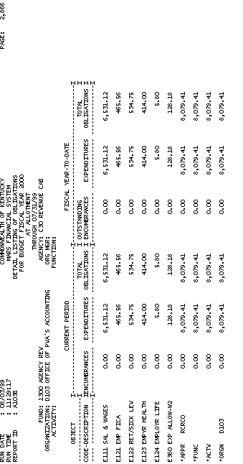

Report ID - FMP103BA - Detail Listing of Obligations at the Allotment Level

Report A103B is a monthly report broken down by Allotment Program. Each report is a detail listing of Obligations by fund, agency, organization, activity and function. Encumbrances, and expenditures for the current period and fiscal year-to-date are shown for each object.

Report ID - FMP103BA - Detail Listing of Obligations at the Allotment Level (Continued)

FUND A fund is a fiscal and accounting entity with a self-balancing set of accounts recording cash and other financial resources together with all related liabilities, and residual equities and changes therein, which are segregated for the purpose of carrying on specific activities or attaining certain objectives. Fund codes are centrally maintained on the Fund table (FUN2) by the Finance and Administration Cabinet.

AGENCY All agencies that record information in the financial system will be recorded in MARS on the Agency table (AGC2) .

ORGANIZATION The Organization data element is a breakdown of Agency (i.e., Department, Division, Branch, Section, Unit). The Organization structure can be up to twelve levels. In MARS, the Organization data element can be used for a variety of purposes. The Agency and Organization data elements can also be used for security restrictions for transaction processing. Valid values are maintained on the Organization table (ORG2).

ORG MGR (ORGANIZATION MANAGER) The person responsible for the organization.

Report ID - FMP103BA - Detail Listing of Obligations at the Allotment Level (Continued)

ACTIVITY Activity table (ACT2) defines valid codes for activities and can also be used to group similar activities into higher level classifications. An activity is an internal program that you want to define for budgeting and/or reporting purposes.

FUNCTION The Function code is a data element in MARS that is generally used to identify location information. Also, Function codes and the associated data elements in the Function hierarchy are defined by agency and fiscal year. This allows MARS User Agencies to tailor and maintain a set of function codes specific for agencies’ use for each fiscal year. The requirement for the use of the Function code is established on the Fund/Agency table (FGY2) within each fund/agency combination for each fiscal year. When a Function code is used on an accounting or budget transaction line, the associated hierarchy for the Function code can be obtained from the Function table (FUNC) for reporting purposes.

Report ID - FMP103BA - Detail Listing of Obligations at the Allotment Level (Continued)

OBJECT CODE- DESCRIPTION Objects represent the coding level for recording all expenditures in MARS. Valid object codes are maintained on the Object table (OBJ2).

CURRENT PERIOD ENCUMBRANCES The current accounting fiscal month’s accounting transaction activity such as purchase orders and contracts.

CURRENT PERIOD EXPENDITURES The current accounting fiscal month’s accounting transaction activity such as payments, journal vouchers, and manual warrants.

CURRENT PERIOD TOTAL OBLIGATIONS The sum total of the current period’s encumbrances and expenditures for the accounting fiscal month.

FISCAL YEAR-TO-DATE OUSTANDING ENCUMBRANCES The accounting fiscal year’s transactions such as purchase orders and contracts from the beginning of the fiscal year to the current accounting period.

