
Report ID - FMP103BA - Detail Listing of Obligations at the Allotment Level (Continued)

FISCAL YEAR-TO-DATE EXPENDITURES The accounting fiscal year’s transactions such as payments, journal vouchers, and manual warrants from the beginning of the fiscal year to the current accounting period.

FISCAL YEAR-TO-DATE TOTAL OBLIGATIONS The sum total of the fiscal year-to-date encumbrances and expenditures from the beginning of the fiscal year to the current accounting period.

APPR (Unit of Appropriation) The appropriation charged for the encumbrances and/or expenditures. The unit of appropriation field is a 9 character data field that consists of an appropriation program (2 characters maintained on EAP2 table), and allotment program (3 characters maintained on EALL table), and a program budget unit (4 characters maintained on PRFT table).

APPR (Total Appropriation Unit) This field contains the total amounts grouped by budget fiscal year, fund, agency, organization, activity, function and appropriation unit (appropriation program and allotment program).

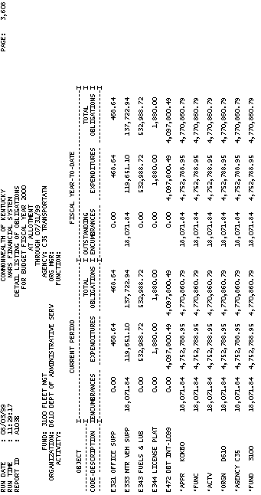
Report ID - FMP103BA - Detail Listing of Obligations at the Allotment Level (Continued)

FUNC (Total Function) This field contains the total amounts grouped by budget fiscal year, fund, agency, organization, activity and function.

ACTV (Total Activity) This field contains the total amounts grouped by budget fiscal year, fund, agency, organization and activity.

ORGN (Total Organization) This field contains total amounts grouped by budget fiscal year, fund, agency and organization.

AGENCY (Total Agency) This field contains the total amounts grouped by budget fiscal year, fund and agency.

FUND (Total Fund) This field contains the total amounts grouped by budget fiscal year and fund.

GRAND TOTAL This field contains grand totals for current encumbrances, current expenditures, total obligations, fiscal year-to-date outstanding encumbrances, fiscal year-to-date expenditures and fiscal year –to-date total obligations.

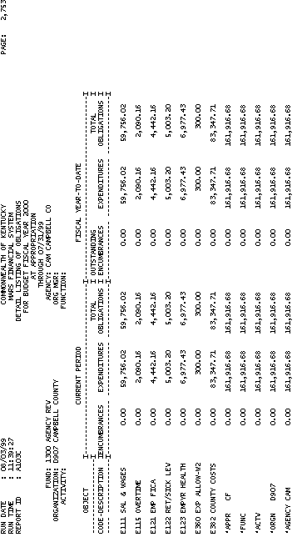

Report ID - FMP103CA - Detail Listing of Obligations at the Appropriation Level

Report A103C is a monthly report broken down by Appropriation Program. Each report is a detail listing of Obligations by fund, agency, organization, activity and function. Encumbrances and expenditures for the current period and fiscal year-to-date are shown for each object.

Report ID - FMP103CA Detail Listing of Obligations at the Appropriation Level

FUND A fund is a fiscal and accounting entity with a self-balancing set of accounts recording cash and other financial resources together with all related liabilities, and residual equities and changes therein, which are segregated for the purpose of carrying on specific activities or attaining certain objectives. Fund codes are centrally maintained on the Fund table (FUN2) by the Finance and Administration Cabinet.

AGENCY All agencies that record information in the financial system will be recorded in MARS on the Agency table (AGC2)

ORGANIZATION The Organization data element is a breakdown of Agency (i.e., Department, Division, Branch, Section, Unit). The Organization structure can be up to twelve levels. In MARS, the Organization data element can be used for a variety of purposes. The Agency and Organization data elements can also be used for security restrictions for transaction processing. Valid values are maintained on the Organization table (ORG2).

ORG MGR (ORGANIZATION MANAGER) The person responsible for the organization.

Report ID - FMP103CA- Detail Listing of Obligations at the Appropriation Level (Continued)

ACTIVITY Activity table (ACT2) defines valid codes for activities and can also be used to group similar activities into higher level classifications. An activity is an internal program that you want to define for budgeting and/or reporting purposes.

FUNCTION The Function code is a data element in MARS that is generally used to identify location information. Also, Function codes and the associated data elements in the Function hierarchy are defined by agency and fiscal year. This allows MARS User Agencies to tailor and maintain a set of function codes specific for agencies’ use for each fiscal year. The requirement for the use of the Function code is established on the Fund/Agency table (FGY2) within each fund/agency combination for each fiscal year. When a Function code is used on an accounting or budget transaction line, the associated hierarchy for the Function code can be obtained from the Function table (FUNC) for reporting purposes.

Report ID - FMP103CA - Detail Listing of Obligations at the Appropriation Level

OBJECT CODE- DESCRIPTION Objects represent the coding level for recording all expenditures in MARS. Valid object codes are maintained on the Object table (OBJ2).

CURRENT PERIOD ENCUMBRANCES The current accounting fiscal month’s accounting transaction activity such as purchase orders and contracts.

CURRENT PERIOD EXPENDITURES The current accounting fiscal month’s accounting transaction activity such as payments, journal vouchers, and manual warrants.

CURRENT PERIOD TOTAL OBLIGATIONS The sum total of the current period’s encumbrances and expenditures for the accounting fiscal month.

Report ID – FMP103CA - Detail Listing of Obligations at the Appropriation Level

FISCAL YEAR-TO-DATE OUSTANDING ENCUMBRANCES The accounting fiscal year’s accounting transaction activity such as purchase orders and contracts from the beginning of the fiscal year to the current accounting period.

FISCAL YEAR-TO-DATE EXPENDITURES The accounting fiscal year’s accounting transaction activity such as payments, journal vouchers, and manual warrants from the beginning of the fiscal year to the current accounting period.

FISCAL YEAR-TO-DATE TOTAL OBLIGATIONS The sum total of the fiscal year-to-date encumbrances and expenditures form the beginning of the fiscal year to the current accounting period.

APPR (Unit of Appropriation) The appropriation charged for the encumbrances and/or expenditures. The unit of appropriation field is a 9 character data field that consists of an appropriation program (2 characters maintained on EAP2 table), and allotment program (3 characters maintained on EALL table), and a program budget unit (4 characters maintained on PRFT table).

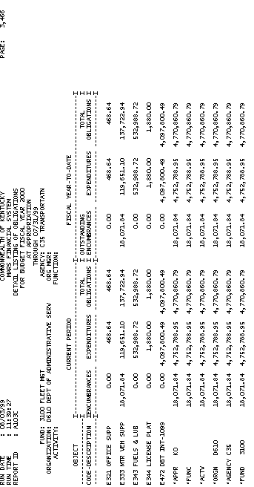

Report ID – FMP103CA - Detail Listing of Obligations at the Appropriation Level

APPR (Total Appropriation Unit) This field contains the total amounts grouped by budget fiscal year, fund, agency, organization, activity, function and appropriation unit (appropriation program).

FUNC (Total Function) This field contains the total amounts grouped by budget fiscal year, fund, agency, organization, activity and function.

ACTV (Total Activity) This field contains the total amounts grouped by budget fiscal year, fund, agency, organization and activity.

ORGN (Total Organization) This field contains total amounts grouped by budget fiscal year, fund, agency and organization.

AGENCY (Total Agency) This field contains the total amounts grouped by budget fiscal year, fund and agency.

FUND (Total Fund) This field contains the total amounts grouped by budget fiscal year and fund.
GRAND TOTAL This field contains grand totals for current encumbrances, current expenditures, total obligations, fiscal year-to-date outstanding encumbrances, fiscal year-to-date total obligations.

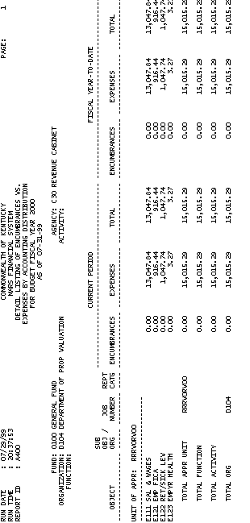

Report ID – FMPA400A – Detail Listing of Encumbrances vs. Expenses by Accounting Distribution

This report displays all encumbrances vs. expenses by accounting distribution. The report is sorted by FUND, AGENCY, ORGANIZATION, ACTIVITY, and FUNCTION. The complete list of fields and their descriptions are listed below:

FUND The fund charged for the encumbrances and/or expenses. A Fund is a fiscal and accounting entity with a self-balancing set of accounts recording cash and other financial resources. The Finance and Administration Cabinet centrally maintain fund codes on the Fund table (FUN2).

AGENCY The agency charged for the encumbrances and/or expenses. All agencies that record information in the financial system will be recorded in MARS on the Agency table (AGC2).

ORGANIZATION The organization charged for the encumbrances and/or expenses. The Organization data element is a breakdown of Agency (i.e., Department, Division, Branch, Section, Unit). The Organization structure can be up to twelve levels. In MARS, the Organization data element can be used for a variety of purposes. Valid values are maintained on the Organization table (ORG2).



Report ID – FMPA400A – Detail Listing of Encumbrances vs. Expenses by Accounting Distribution (Continued)

ACTIVITY The activity charged for the encumbrances and/or expenses. An activity is an internal program that you want to define for budgeting and/or reporting purposes. Valid activity codes are maintained on the Activity table (ACT2).

FUNCTION The Function charged for the encumbrances and/or expenses. The Function code is a data element in MARS that is generally used to identify location information. Also, Function codes and the associated data elements in the Function hierarchy are defined by agency and fiscal year. This allows MARS User Agencies to tailor and maintain a set of function codes specific for agencies’ use for each fiscal year. Valid values are maintained on the Function table (FUNC).

OBJECT The expenditure object code charged for the encumbrances and/or expenses. Objects represent the coding level for recording all expenditures in MARS. Objects can be designated as operating or non-operating expenditures; as payroll expenses; or as 1099 reportable. Valid object codes are maintained on the Object table (OBJ2).

Report ID – FMPA400A – Detail Listing of Encumbrances vs. Expenses by Accounting Distribution (Continued)

SUB OBJ / ORG (Sub-Object / Sub-Organization)
The sub-object and/or sub-organization charged for the encumbrances and/or expenses. Sub-Object codes are generally used to provide agencies with the capability of tracking objects of expenditures at a more detailed level than expense object. They may be used to track expenditures as required by user agencies. Accounting transactions may be recorded by sub-object thus allowing expenditures to accumulate at the sub-object level. Valid sub-object codes are stored on the Sub-Object table (SOBJ).

Each Organization can be assigned one or more Sub-Organizations that are defined on the Sub-Organization table (SORG). Sub-organization defines a particular organization in more detail. They may be used to track expenditures or revenues as required by agencies.

Report ID – FMPA400A – Detail Listing of Encumbrances vs. Expenses by Accounting Distribution (Continued)

JOB NUMBER Jobs are mechanisms for accumulating expenses and other costs for the purposes of billing, preparing grant claims, recording certain specified accounting transactions, or providing cost accounting information to MARS User Agencies. Valid job number codes can be found on the Job table (JOBT).

REPT CATG (REPORTING CATEGORY) Reporting Category codes may be used to provide MARS User Agencies with an additional accounting element to capture reporting information to meet specific user agency needs. Valid reporting category codes must be established on the Reporting Category table (RPTG).

CURRENT PERIOD ENCUMBRANCES This represents the amount submitted on a purchase order document. such transactions are posted as account type 21. A sum of all transactions performed during this period is displayed.

Report ID – FMPA400A – Detail Listing of Encumbrances vs. Expenses by Accounting Distribution (Continued)

CURRENT PERIOD EXPENSES This field is a sum of all transactions posted as expenditure (account type 22) and expense (account type 24). Expenditure account is used when items and services are purchased. This is a sum of all transactions performed during this period. An expense account is recorded when previously acquired goods or services are used, such as depreciation, receipt of prepaid items, and depletion of inventories.

CURRENT PERIOD TOTAL This field sums current period encumbrances and current period expenses.

FISCAL YEAR-TO-DATE ENCUMBRANCES
This field contains the sum of all encumbrances recorded year to date.

FISCAL YEAR-TO-DATE EXPENSES This field contains the sum of all expenses recorded year to date.

FISCAL YEAR-TO-DATE TOTAL This field sums fiscal year-to-date encumbrances and fiscal year-to-date expenses.

