`

Report ID – FMPA400A – Detail Listing of Encumbrances vs. Expenses by Accounting Distribution (Continued)

UNIT OF APPR (Unit of Appropriation) The appropriation charged for the encumbrances and/or expenses. An appropriation is a dollar amount allocated by law for a specific purpose. The unit of appropriation field is a 9 character data field that consists of an appropriation program (2 characters maintained on EAP2 table), and allotment program (3 characters maintained on EALL table), and a program budget unit (4 characters maintained on PRFT table).

TOTAL APPR UNIT (Total Appropriation Unit) This field contains the total amounts grouped by budget fiscal year, fund, agency, organization, activity, function and appropriation unit.

TOTAL FUNCTION This field contains the total amounts grouped by budget fiscal year, fund, agency, organization, activity and function.

TOTAL ACTIVITY This field contains the total amounts grouped by budget fiscal year, fund, agency, organization and activity.

TOTAL ORG (Total Organization) This field contains total amounts grouped by budget fiscal year, fund, agency and organization.

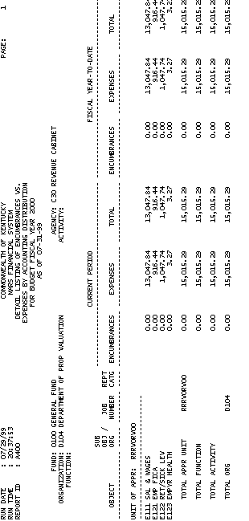

Report ID – FMPA400A – Detail Listing of Encumbrances vs. Expenses by Accounting Distribution (Continued)

TOTAL AGENCY This field contains the total amounts grouped by budget fiscal year, fund and agency.

TOTAL FUND This field contains the total amounts grouped by budget fiscal year and fund.

GRAND TOTAL This field contains grand totals for current encumbrances, current expenses, current total, fiscal year-to-date encumbrances, fiscal year-to-date expenses and fiscal year-to-date total.

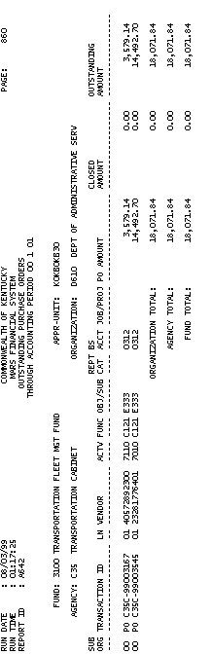

Report ID - FMPA642A – Outstanding Purchase Orders

This report displays all outstanding Purchase Orders (PO) in MARS. The report is sorted by FUND, AGENCY and ORGANIZATION. The complete list of fields and their corresponding description are listed below:

FUND A fund is a fiscal and accounting entity with a self-balancing set of accounts recording cash and other financial resources together with all related liabilities, and residual equities and changes therein, which are segregated for the purpose of carrying on specific activities or attaining certain objectives. Fund codes are centrally maintained on the Fund table (FUN2) by the Finance and Administration Cabinet.

APPR-UNIT (APPROPRIATION) An appropriation is a dollar amount allocated by law for a specific purpose. In MARS, appropriations are represented by Appropriation Programs. In the Commonwealth of Kentucky, the Budget Bill establishes one or more appropriation(s) of funds for each agency. The Appropriation Unit field is a 9- character data field that consists of an Appropriation Program (2 characters maintained on EAP2), an Allotment Program (3 characters maintained on EALL), and a Program Budget Unit (4 characters maintained on PRFT).
Report ID - FMPA642A – Outstanding Purchase Orders (Continued)

AGENCY All agencies that record information in the financial system will be recorded in MARS on the Agency table (AGC2).

ORGANIZATION The Organization data element is a breakdown of Agency (i.e., Department, Division, Branch, Section, Unit). The Organization structure can be up to twelve levels. In MARS, the Organization data element can be used for a variety of purposes. The Agency and Organization data elements can also be used for security restrictions for transaction processing. Valid values are maintained on the Organization table (ORG2).

SUB ORG (SUB-ORGANIZATION) Each Organization can be assigned one or more Sub-Organizations that are defined on the Sub-Organization table (SORG). In essence, the sub-organization defines a portion of the organization. They may be used to track expenditures or revenues as required by agencies.

Report ID - FMPA642A – Outstanding Purchase Orders (Continued)

TRANSACTION ID This field contains the Purchase Order document number of that was entered in MARS.

LN (LINE) This field contains the line number that of the purchase order document in MARS.

VENDOR An entity that provides goods and/or services for the Commonwealth.

ACTIVITY An activity is an internal program that you want to define for budgeting and/or reporting purposes. Valid values are maintained on the Activity table (ACT2).

FUNCTION The Function code is a data element in MARS that is generally used to identify location information. Also, Function codes and the associated data elements in the Function hierarchy are defined by agency and fiscal year. This allows MARS User Agencies to tailor and maintain a set of function codes specific for agencies’ use for each fiscal year. Valid values are maintained on the Function table (FUNC).

Report ID - FMPA642A – Outstanding Purchase Orders (Continued)

OBJ/SUB (OBJECT/SUB-OBJECT) Objects represent the coding level for recording all expenditures in MARS. Objects can be designated as operating or non-operating expenditures; as payroll expenses; or as 1099 reportable. Valid object codes are maintained on the Object table (OBJ2).

Sub-Object Codes are generally used to provide agencies with the capability of tracking objects of expenditures at a level lower than expense object. They may be used to track expenditures as required by user agencies. Accounting transaction lines may be recorded by sub-object thus allowing expenditures to accumulate at the sub-object level. Valid Sub-Object codes are stored on the Sub-Object table (SOBJ).

REPORTING CATEGORY Reporting Category codes may be used to provide MARS User Agencies with an additional accounting element to capture reporting information to meet specific user agency needs. Valid reporting category codes must be established on the Reporting Category table (RPTG).

Report ID - FMPA642A – Outstanding Purchase Orders (Continued)

BS ACCT (BALANCE SHEET ACCOUNT) Balance sheet accounts identify assets, liabilities, and fund balance. Balance sheet account codes are most often inferred from the document type.

JOB/PROJ (JOB/PROJECT NUMBER) Jobs are mechanisms for accumulating expenses and other costs for the purposes of billing, preparing grant claims, recording certain specified accounting transactions, or providing cost accounting information to MARS User Agencies. Valid Job number codes are present on Job table (JOBT).

PO AMOUNT This field contains the purchase order amount that was entered in MARS.

CLOSED AMOUNT This field contains the portion of the purchase order amount closed by processing a PV referencing a particular PO.

OUTSTANDING AMOUNT This field contains the difference between the PO AMOUNT and the CLOSED AMOUNT.

Report ID - FMPA642A – Outstanding Purchase Orders (Continued)

ORGANIZATION TOTAL This field contains the total amount grouped by fund, agency, appropriation and organization.

AGENCY TOTAL This field contains the total amount grouped by fund and agency.

FUND TOTAL This field contains the total amount grouped by fund

This page is intentionally left blank



Activity 3 - 1

- This is a monthly report that is broken down by Program Budget Unit.
A. FMP103AA
B. FMP103BA
C. FMP103CA

- This report displays all encumbrances vs. expenditures.
- FMP103AA
- FMP103CA
- FMPA400A
- FMPA642A

- This report displays all outstanding Purchase Orders (PO) in MARS.
- FMP103AA
- FMP103BA
- FMPA400A
- FMPA642A

This page intentionally left blank.



Solution 3 - 1

1. This is a monthly report that is broken down by Program Budget Unit.
A. FMP103AA
B. FMP103BA
C. FMP103CA

Answer: A. FMP103AA

2. This report displays all encumbrances vs. expenditures.
A. FMP103AA
B. FMP103CA
C. FMPA400A
D. FMPA642A

Answer: C. FMPA400A.

This page is intentionally left blank.

3. This report displays all outstanding Purchase Orders (PO) in MARS.
A. FMP103AA
B. FMP103BA
C. FMPA400A
D. FMPA642A

Answer: D. FMPA642A

This page intentionally left blank




Do you have a question about any of the Encumbrance and Expenditure Standard Reports?

In this topic we:

- Covered specific reports included as Encumbrance and Expenditure Standard Reports, and

- Viewed functionality and specific fields covered in the specific reports.

