Topic 5 - Disbursement Standard Reports

Purpose

Objectives

The purpose of this topic is to provide the MARS end-user with a working knowledge of what functionality is provided by select MARS Disbursement Standard Reports.

By the end of this topic you will have:

- Covered select reports that are included as Disbursement Standard Reports, and

- Viewed the functionality and specific fields contained in each report.

DISBURSEMENT STANDARD REPORTS

Report ID - FMPA652A - OUTSTANDING PAYMENT VOUCHERS

Report ID - FMPVOFTA - VENDOR OFFSET FUNDS TRANSFER REPORT

Report ID - FMPVOFTB - VENDOR OFFSET DETAIL INTERCEPT REPORT

Report ID - FMPCKCSB - PAYMENTS NOT PAID DUE TO INSUFFICIENT CASH



Disbursement Standard Reports

There are four Disbursement Standard Reports discussed in this topic. These four reports cover MARS functionality that includes outstanding payment vouchers, vendor offsets and payments not paid due to insufficient cash. The specific reports are listed below:

- Report ID - FMPA652A - OUTSTANDING PAYMENT VOUCHERS

- Report ID - FMPVOFTA - VENDOR OFFSET FUNDS TRANSFER REPORT

- Report ID - FMPVOFTB - VENDOR OFFSET DETAIL INTERCEPT REPORT

- Report ID - FMPCKCSB - PAYMENTS NOT PAID DUE TO INSUFFICIENT CASH

Let’s go ahead and take a look at the first report.
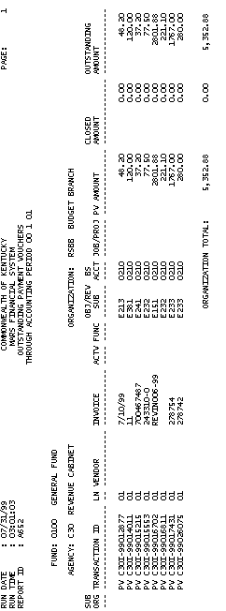
Report ID - FMPA652A - Outstanding Payment Vouchers

This report displays all outstanding Payment Vouchers for a particular fiscal year up to a specified accounting period. These outstanding Payment Vouchers are sorted by FUND, AGENCY, ORGANIZATION, SUB-ORG, TRANSACTION ID, and LINE NUMBER. The complete list of fields and their descriptions are listed below:

FUND The fund charged on the payment voucher. A fund is a fiscal and accounting entity with a self-balancing set of accounts recording cash and other financial resources. The Finance and Administration Cabinet centrally maintain fund codes on the Fund table (FUN2).

AGENCY The agency charged on the payment voucher. All agencies that record information in the financial system will be recorded in MARS on the Agency table (AGC2).
Report ID - FMPA652A - Outstanding Payment Vouchers (Continued)

ORGANIZATION The organization charged on the payment voucher. The Organization data element is a breakdown of Agency (i.e., Department, Division, Branch, Section, Unit). The Organization structure can be up to twelve levels. In MARS, the Organization data element can be used for a variety of purposes. Valid values are maintained on the Organization table (ORG2).

SUB-ORG (Sub-Organization) The sub-organization charged on the payment voucher. Each Organization can be assigned one or more Sub-Organizations that are defined on the Sub-Organization table (SORG). In essence, the sub-organization defines a portion of the organization. They may be used to track expenditures or revenues as required by agencies.

TRANSACTION ID Each document created has an individual transaction number. This number can be system generated or user entered. The first two positions define the transaction type, next three define the agency number, and the last eleven positions define the document number.

Report ID - FMPA652A - Outstanding Payment Vouchers (Continued))

LN (Line Number) The corresponding line number associated with a particular payment voucher .

VENDOR The Vendor Code (11 characters) used on the payment voucher. This code is assigned to identify a particular vendor. The last two characters in the code is an address indicator used to identify multiple locations. Valid values are maintained on the Vendor table (VEN2).

INVOICE The vendor invoice number used on the payment voucher.

ACTV (Activity) The activity charged on the payment voucher. An activity is an internal program defined for budgeting and/or reporting purposes. Valid values are maintained on the Activity table (ACT2).

Report ID - FMPA652A - Outstanding Payment Vouchers (Continued))

FUNC (Function) The function code charged on the payment voucher. The Function code is a data element in MARS that is generally used to identify location information. This allows MARS User Agencies to customize and maintain a set of function codes for each fiscal year. Valid values are maintained on the Function table (FUNC).

OBJ/REV/SUB (Object/Revenue/Sub-Object/Sub-Revenue) The object and/or sub-object charged on the payment voucher. Objects represent the coding level for recording all expenditures in MARS. Objects can be designated as operating or non-operating expenditures; as payroll expenses; or as 1099 reportable. Valid object codes are maintained on the Object table (OBJ2).

Sub-Object codes are generally used to provide agencies with the capability of tracking objects of expenditures at a level lower than expense object. They may be used to track expenditures as required by user agencies. Valid sub-object codes are stored on the Sub-Object table (SOBJ).

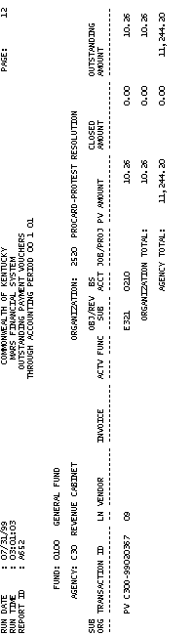
Report ID - FMPA652A - Outstanding Payment Vouchers (Continued))

OBJ/REV/SUB (Object/Revenue/Sub-object/Sub-revenue) The revenue source and/or sub-revenue source charged on the payment voucher. Revenue source represents the coding level for recording all revenues in MARS. Revenue source can be designated as operating or non-operating. Valid revenue codes are maintained on the Revenue Source table (REV2).

Sub-Revenue source codes are generally used to provide agencies with the capability of tracking revenues at a level lower than revenue source account code. Valid sub-revenue codes are maintained on the Sub-Revenue Source table (SREV).

BS ACCT (Balance Sheet Account) The offsetting liability balance sheet account for the payment voucher. Valid balance sheet codes are maintained on the Balance Sheet Account Balance table (BAC2).

Report ID - FMPA652A - Outstanding Payment Vouchers (Continued)

JOB/PROJ (Job Number/Project Number) The job number or project number charged on the payment voucher. The job/project code is used to identify specific Project Authorization codes and may be used for Capital Projects, Grants, and Highway Projects. In MARS, Grants and Projects are established and defined as “Projects”.

PV AMOUNT (Payment Voucher Amount) The amount of the payment voucher line.

CLOSED AMOUNT The amount of the payment voucher line that is no longer outstanding.

OUTSTANDING AMOUNT The amount of the payment voucher line for which a disbursement has not been processed.

ORGANIZATION TOTAL The organization total of each column (pv amount, closed amount, and outstanding amount) within that fund and agency.

AGENCY TOTAL The agency total of each column (pv amount, closed amount, and outstanding amount) within that fund and organization.

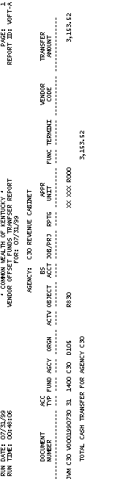
Report ID - FMPVOFTA - Vendor Offset Fund Transfer Report

This report shows the total cash transfer as the result of Vendor Offsets by specific agencies and document/transaction ID’s. The complete list of fields and their descriptions are listed below:

AGENCY The agency receiving the funds from the intercepted payments. All agencies that record information in the financial system will be recorded in MARS on the Agency table (AGC2).

DOCUMENT NUMBER The document number to record the accounting entry for funds received from the intercepted payments. Each document created has an individual document number. The first two positions define the transaction type, next three define the agency number, and the last eleven positions define the document number.

Report ID - FMPVOFTA - Vendor Offset Funds Transfer Report (Continued)

ACC TYP (ACCOUNT TYPE) Account Types are pre-determined in MARS. The account type codes (shown in parenthesis) are related in the basic accounting equation of Assets = Liabilities + Fund Balance. When balance sheet accounts are coded on most documents, the associated account types are automatically inferred for the Balance Sheet Account table (BAC2) in ADVANTAGE Financial. There are some “temporary” sub-accounts types that exist. They are used to identify individual expenditure and revenue transactions. Account types are required on journal voucher documents and useful for ad-hoc reporting.

FUND The fund that received the intercepted payment. A fund is a fiscal and accounting entity with a self-balancing set of accounts recording cash and other financial resources. The Finance and Administration Cabinet centrally maintain fund codes on the Fund table (FUN2).

Report ID - FMPVOFTA - Vendor Offset Funds Transfer Report (Continued)

AGCY (Agency) The agency that received the intercepted payment. All agencies that record information in the financial system will be recorded in MARS on the Agency table (AGC2).

ORGN (Organization) The organization that received the intercepted payment. The Organization data element is a breakdown of Agency (i.e., Department, Division, Branch, Section, Unit). The Organization structure can be up to twelve levels. In MARS, the Organization data element can be used for a variety of purposes. Valid values are maintained on the Organization table (ORG2).

ACTV (Activity) An activity is an internal program that you want to define for budgeting and/or reporting purposes. Value values are maintained on the Activity table (ACT2).

Report ID - FMPVOFTA - Vendor Offset Funds Transfer Report (Continued)

OBJECT Objects represent the coding level for recording all expenditures in MARS. Objects can be designated as operating or non-operating expenditures; as payroll expenses; or as 1099 reportable. Valid object codes are maintained on the Object table (OBJ2).

BS ACCT (Balance Sheet Account) Balance sheet accounts identify assets, liabilities, and fund balance. Valid balance sheet codes are maintained on the Balance Sheet Account Balance table (BBAL).

JOB/PRJ (Job Number/Project Number)
The job/project code is used to identify specific Project Authorization codes and may be used for Capital Projects, Grants, and Highway Projects. In MARS, Grants and Projects are established and termed as “Projects.”

Report ID - FMPVOFTA - Vendor Offset Funds Transfer Report (Continued)

RPTG (Reporting Category) Reporting category codes may be used to provide MARS User Agencies with an additional accounting element to capture reporting information to meet specific user agency needs. Valid reporting category codes must be established on the Reporting Category table (RPTG).

APPR UNIT (Appropriation Unit) An appropriation is a dollar amount allocated by law for a specific purpose. The appropriation unit field is a 9 character data field that consists of an appropriation program (2 characters), an allotment program (3 characters), and a program budget unit (4 characters).

Report ID - FMPVOFTA - Vendor Offset Funds Transfer Report (Continued)

FUNC (Function) The Function code is a data element in MARS that is generally used to identify location information. Also, function codes and the associated data elements in function hierarchy are defined by agency and fiscal year. This allows MARS User Agencies to tailor and maintain a set of function codes specific for agencies’ use for each fiscal year. Valid values are maintained on the Function table (FUNC).

TERMINI The Termini code is used to record the mile point, range of mile points, or bridge identifier at which work is performed for a given Highway Route.
Valid values are maintained on the TERM table.

VENDOR CODE The vendor being paid by this intercept. The code assigned to a vendor to identify vendors. The last two characters in the code is an address indicator used to identify multiple locations. Valid values are maintained on the Vendor table (VEN2).

Report ID - FMPVOFTA - Vendor Offset Funds Transfer Report (Continued)

TRANSFER AMOUNT Amount of transfer for this specific line of the report based on the accounting codes providing for the offset.

TOTAL CASH TRANSFER FOR AGENCY The total amount of the cash transfer for this agency.

