
Report ID - FMPVOFTB - Vendor Offset Detail Intercept Report

The FMPVOFT-B report is an alternate view of much of the same information contained in the FMPVOFT-A report. The FMPVOFT-B report shows the disbursements that have been intercepted. The complete list of fields and their descriptions are listed as follows:

AGENCY The agency receiving the intercepted vendor payment. All agencies that record information in the financial system will be recorded in MARS on the Agency table (AGC2).

CLAIM REASON The reason the payment was intercepted. Valid values are maintained on the Claim Reason Code table (CRCT).

VENDOR TIN The vendor/taxpayer identification number with an outstanding debt to the Commonwealth of Kentucky whose payment was intercepted. The vendor tin number is the vendor code without the associated locator code.

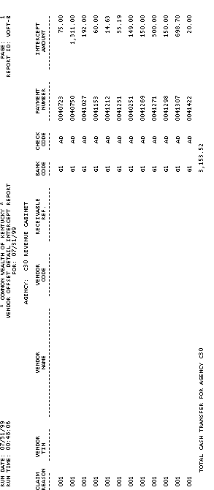
Report ID - FMPVOFTB - Vendor Offset Detail Intercept Report (Continued)

VENDOR NAME The name of the company or individual that has an outstanding debt to the Commonwealth of Kentucky whose payment was intercepted.

VENDOR CODE The vendor/taxpayer identification number with an outstanding debt to the Commonwealth of Kentucky whose payment was intercepted. The code assigned to a vendor to identify vendors. The last two characters in the code are an address indicator used to identify multiple locations. Valid values are maintained on the Vendor table (VEN2).

RECEIVABLE REF (Receivable reference) Not currently used.

BANK CODE The code used to identify the physical bank account number of the bank. Valid bank codes are maintained on the BANK table (BANK).

Report ID - FMPVOFTB - Vendor Offset Detail Intercept Report (Continued)

CHECK CODE The code used to identify Automated Disbursements (AD) or Electronic Fund Transfers (EF).

PAYMENT NUMBER The actual check or EFT number which can be found on the Open Payment Voucher Line Inquiry table (OPVL) and the Open Check Header Inquiry for Agencies table (OPCA).

INTERCEPT AMOUNT The actual amount of the payment to the vendor that has been “intercepted”. The vendor owes at least this amount before he/she can be paid.

TOTAL CASH TRANSFER FOR AGENCY The total amount of transfer for this agency.

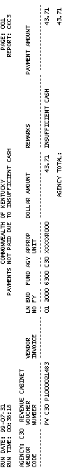
Report ID - FMPCKCSB - Payments Not Paid Due to Insufficient Cash

This report displays all payments not paid due to insufficient cash per specific agencies and document/transaction ID’s. The complete list of fields and their descriptions are listed below:

AGENCY The agency with insufficient cash for making payments. All agencies that recorded information in the financial system will be recorded in MARS on the Agency table (AGC2).

VENDOR CODE Payment was not made to this vendor. The code assigned to a vendor to identify vendors. The last two characters in the code are an address indicator used to identify multiple locations.

VOUCHER NUMBER The document not paid. Each document created in ADVANTAGE Financial has a voucher number. This number can be system generated or user entered. The two three positions define the transaction type, the next three positions define the agency number, and the last eleven positions define the document number.

Report ID - FMPCKCSB - Payments Not Paid Due to Insufficient Cash (Continued)

VENDOR INVOICE The invoice not paid due to insufficient cash.

LN NO (Line Number) The line on the payment voucher not paid

BUD FY (Budget Fiscal Year) The budget fiscal year associated with the payment.

FUND The fund charged on the payment voucher. A fund is a fiscal and accounting entity with a self-balancing set of accounts recording cash and other financial resources. The Finance and Administration Cabinet centrally maintain fund codes on the Fund table (FUN2).

AGY (Agency) The agency charged on the payment voucher. All agencies that record information in the financial system will be recorded in MARS on the Agency table (AGC2).

Report ID - FMPCKCSB - Payments Not Paid Due To Insufficient Cash (Continued)

APPROP UNIT (Appropriation Unit) The appropriation unit charged on the payment voucher. An appropriation is a dollar amount allocated by law for a specific purpose. The appropriation unit field is a 9-character data field that consists of an appropriation program (2 characters), an allotment program (3 characters), and a program budget unit (4 characters).

DOLLAR AMOUNT The amount of the payment voucher not paid due to insufficient cash.

REMARKS The reason the payment voucher was not paid.

PAYMENT AMOUNT The amount of the payment voucher not paid due to insufficient cash.

AGENCY TOTAL The total amount of payments not paid due to insufficient cash for that agency.

This page intentionally left blank.



Activity 5 - 1

- This report shows the total cash transfer as the result of Vendor Offsets by specific agencies and document/transaction ID’s.

- FMPA652A
- FMPVOFTA
- FMPVOFTB
- FMPA642A

- This report displays all outstanding Payment Vouchers for a particular fiscal year up to a specified accounting period.

- FMPA652A
- FMPVOFTA
- FMPVOFTB
- FMPA642A

This page intentionally left blank.


Solution 5 - 1

1. This report shows the total cash transfer as the result of Vendor Offsets by specific agencies and document/transaction ID’s.

A. FMPA652A
B. FMPVOFTA
C. FMPVOFTB
D. FMPA642A

Answer: B. FMPVOFTA

2. This report displays all outstanding Payment Vouchers for a particular fiscal year up to a specified accounting period.

A. FMPA652A
B. FMPVOFTA
C. FMPVOFTB
D. FMPA642A

Answer: FMPA. 652A

This page intentionally left blank.




Are there any questions concerning what we have covered so far in this topic on Disbursement Standard Reports? If not, let go ahead and move on to the next topic.

In this topic we have:

- Covered what specific reports are included as Disbursement Standard Reports, and

- Viewed the functionality and specific fields contained in each report.

