Topic 6 – Document Listing Maintenance

Purpose

Objectives

The purpose of this topic is to explain the I501 Report otherwise know as the Pending Transactions in Suspense File in Excess of 30 Days Report.

By the end of this topic, you will have:

- Discussed the functionality of the I501 Report, and

- Reviewed the fields and the relevant field descriptions associated with the I501 Report.

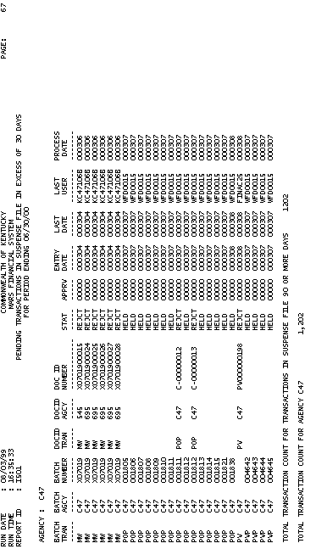


Report ID - FMPI501A - Pending Transactions in Suspense File in Excess of 30 days
The Pending Transactions in Suspense File in Excess of 30 Days Report (I501) creates a listing of transactions that are on the Suspense File (SUSF) in ADVANTAGE Financial in excess of 30 days. This report will list, by agency, the transactions that generally require user intervention to proceed. This report will be run monthly.
All records on the Suspense File (SUSF) will be read and only document transactions with entry dates greater than 30 days will be selected to be reported records. They are then separated in the report into three sections.
Section 1 30 – 59 days
Section 2 60 – 89 days
Section 3 greater than 90 days
The report includes all transactions having the status of REJCT, HELD, PEND1 and SCHED. The documents that are not included on I501 are those having the status of ACCPT.



Report ID - FMPI501A - Pending Transactions in Suspense File in Excess of 30 days (Continued)

AGENCY The agency with outstanding document transactions with entry dates in excess of 30 days. All agencies that record information in the financial system will be recorded in MARS on the Agency table (AGC2). Agency is used in combination with the Fund data element to establish the highest level of budgetary control for appropriation programs and allotment programs. The Agency number is a required field to be coded on most documents.

BATCH TRAN (Batch Transaction) The transaction code associated with a batch. Generally used when modifying documents.

BATCH AGCY (Batch Agency) The agency code associated with a batch. Generally, used when modifying documents.

BATCH NUMBER. The batch number associated with a batch. Generally, used for modifying documents.

DOCID TRAN (Document ID Transaction) This refers to the type of transaction it is in ADVANTAGE Financial (e.g. AL (Allotment), CR (Cash Receipt), or JVC (Journal Voucher Correction).

Report ID - FMPI501A - Pending Transactions in Suspense File in Excess of 30 days (Continued)

DOCID AGCY (Document ID Agency) The agency that is responsible for the document being out on the system.

DOC ID NUMBER (Document ID Number) The document that on Suspense File (SUSF) in excess of 30 days. Each document created in ADVANTAGE Financial has a document number. This number can be system generated or user entered.

STAT (STATUS) Each document on the Suspense File (SUSF) in ADVANTAGE Financial has a status. The document transactions that are recorded on the I501 report will have the status of:

REJCT The document has errors or has not been properly completed.

HELD The document does not have sufficient information to be edited on the system or the user wishes to hold the document to be processed some time in the future.

PEND1 The first level of the processing flow has been completed and is ready for the first level of approval.

Report ID - FMPI501A - Pending Transactions in Suspense File in Excess of 30 Days (Continued)

The documents that are not included on the I501 report are those having the status of ACCPT.

APPRV (Approvals) Each document has up to five levels of approval. If a document has three levels of approval and only one level has been applied the approval code will look like this: “YAA00.” When the second level of approval is applied, the code will look like this: “YYA00.”

ENTRY DATE The date the document was entered into the system.

LAST DATE The last date a user entered a field on a document.

LAST USER The last user to enter a field on the document. The user is identified by a system User ID.

PROCESS DATE The date the document is to be processed.

Report ID - FMPI501A - Pending Transactions in Suspense File in Excess of 30 Days (Continued)

TOTAL TRANSACTION COUNT FOR TRANSACTIONS IN SUSPENSE FILE At the end of each reported agency there is a breakdown of the number of documents according to the length of time they have been on the system. The breakdown is 30 to 59 days, 60 to 89 days, and more than 90 days.

TOTAL TRANSACTION COUNT FOR AGENCY Total number of documents in excess of 30 days for that agency.

This page intentionally left blank.



Activity 6 - 1

True/False

- The FMPI501A report creates a listing of transaction that are on the Suspense File (SUSF) in ADVANTAGE Financial in excess of 30 days.

- True
- False

- Documents with ACCEPT status will be included on the FMPI501A report.

- True
- False

- The FMPI501A report will list by agency, the transactions requiring action and will run monthly.

- True
- False

This page intentionally left blank.



Solution 6 - 1

1. The FMPI501A report creates a listing of transaction that are on the Suspense File (SUSF) in ADVANTAGE Financial in excess of 30 days.

A. True
B. False

Answer: A. True.

2. Documents with ACCEPT status will be included on the FMPI501A report.

A. True
B. False

Answer: B. False.

3. The FMPI501A report will list by agency, the transactions requiring action and will run monthly.

A. True
B. False

Answer: A. True.

This page intentionally left blank





Are there any questions about the pending transactions in suspense file in excess of 30 days?

In this topic we

- Viewed the I501 Report and the associated functionality, and

- Discussed each of the fields and their relevant descriptions.

