Topic 7 – Fixed Assets Standard Reports

Purpose

Objectives

The purpose of this topic is to provide the MARS end-user with a working knowledge of what functionality is provided by select MARS Fixed Assets Standard Reports.

By the end of this topic you will have:

- Covered select reports that are considered as Fixed Assets Standard Reports, and

- What functionality and specific fields are provided by the Fixed Assets Standard Reports.

FIXED ASSETS STANDARD REPORTS

Report ID – FMPX002A – FIXED ASSET TRANSACTION DETAIL

Report ID -- FMPX003A – FIXED ASSET DEPRECIATION REPORT

Report ID – FMPX011A – STATEMENT OF FIXED ASSETS BY AGENCY AND ORGANIZATION

Report ID – FMPX027A – FIXED ASSET FUNDING SOURCE / FBT1 OUT OF SYNC

Report ID – FMPFDGNA – FIXED ASSET DISPOSITION COMING TO SURPLUS PROPERTY

Report ID – FMARFLST – FIXED ASSET LEDGER LISTING



Fixed Asset Standard Reports

There are six Fixed Asset Standard Reports discussed in this topic. These six reports cover MARS fixed asset related information such as depreciation, disposition and fixed asset daily transactions. The select MARS fixed Assets Standard Reports discussed in this topic are:

- Report ID - FMPX002A - FIXED ASSET TRANSACTION DETAIL

- Report ID - FMPX003A - FIXED ASSET DEPRECIATION REPORT

- Report ID - FMPX011A - STATEMENT OF FIXED ASSETS BY AGENCY AND ORGANIZATION

- Report ID - FMPX027A - FIXED ASSET FUNDING SOURCE / FBT1 OUT OF SYNC

- Report ID - FMPFDGNA - FIXED ASSET DISPOSITION COMING TO SURPLUS PROPERTY

- Report ID - FMARFLST - FIXED ASSET LEDGER LISTING

Let’s go ahead and take a look at the first one on the next page.
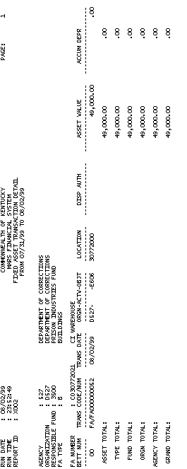

Report ID - FMPX002A - Fixed Asset Transaction Detail

This report displays all fixed asset transactions processed between the range of dates displayed on the report. The complete list of fields and their descriptions are listed below:

AGENCY The agency that is primarily responsible for the fixed asset. All agencies that record information in the financial system will be recorded in MARS on the Agency table (AGC2).
ORGANIZATION The organization primarily responsible for the fixed asset. The Organization data element is a breakdown of Agency (i.e., Department, Division, Branch, Section, Unit). The Organization structure can be up to twelve levels. In MARS, the Organization data element can be used for a variety of purposes. Valid values are maintained on the Organization table (ORG2).

RESPONSIBLE FUND The fund that is primarily responsible for the fixed asset. A fund is a fiscal and accounting entity with a self-balancing set of accounts recording cash and other financial resources. The Finance and Administration Cabinet centrally maintain fund codes on the Fund table (FUN2).

Report ID - FMPX002A - Fixed Asset Transaction Detail (Continued)

FA TYPE (Fixed Asset Type) Fixed asset type indicates the fixed asset type which includes the following values: L=land, B=buildings, I=improvements (non-buildings), E=equipment and machinery, C=construction in progress, and V=vehicles.

FA NUMBER (Fixed Asset Number) The fixed asset number which is the unique identifier (property tag number) for the fixed asset and description of the fixed asset.

BETT NUM (Betterment Number) The betterment number that increases the value of the asset due to improvements made to the fixed asset. A betterment number of “00” is associated with a fixed asset when it is established.

TRANS CODE/NUM (Transaction Code/Number) The transaction code is the document type which includes the following values: FA=Fixed Asset Acquisition, FB=Fixed Asset Betterment, FD=Fixed Asset Disposition, FS=Fixed Asset Internal Sale, FC=Fixed Asset Modification, and FT=Fixed Asset Transfer and the number is the transaction document number.

TRANS DATE (Transaction Date) This is the date the document/transaction was created.

Report ID –FMPX002A - Fixed Asset Transaction Detail (Continued)

ORGN (Organization) The organization charged for the fixed asset. The Organization data element is a breakdown of Agency (i.e., Department, Division, Branch, Section, Unit). The Organization structure can be up to twelve levels. In MARS, the Organization data element can be used for a variety of purposes. Valid values are maintained on the Organization table (ORG2).

ACTV (Activity) The activity code charged for the fixed asset. An activity is an internal program that you want to define for budgeting and/or reporting purposes. Valid activity codes are maintained on the Activity table (ACT2).

OBJT (Object) The expenditure object code charged for the fixed asset. Object represents the coding level for recording all expenditures in MARS. Objects can be designated as operating or non-operating expenditures; as payroll expenses, or as 1099 reportable. Valid object codes are maintained on the Object table (OBJ2).

Report ID - FMPX002A - Fixed Asset Transaction Detail (Continued)

LOCATION The location code that defines where the asset is located.

DISP AUTH (Disposition Authority) The document number or name of individual who authorized the disposal of the fixed asset.

ASSET VALUE The proportion of the fixed asset value associated with this agency, fund, organization, activity and object.

ACCUM DEPR (Accumulated Depreciation) The accumulated depreciation amount for the fixed asset, including all betterments.

ASSET TOTAL (Asset Value) Total asset value sum for that fixed asset. This amount includes all betterments.

ASSET TOTAL (Accum Depr) Total accumulated depreciation sum for that fixed asset. This amount includes all betterments.

TYPE TOTAL (Asset Value) The total asset value for that fixed asset type within that agency, organization and responsible fund.
TYPE TOTAL (Accum Depr) The total accumulated depreciation for that fixed asset type within that agency, organization and responsible fund.

FUND TOTAL (Asset Value) The total asset value amount for that fund within that fixed asset type.

FUND TOTAL (Accum Depr) The total accumulated depreciation amount for that fund within that fixed asset type.

ORGN TOTAL (Asset Value) The total asset value amount for that organization within fund and fixed asset type.

ORGN TOTAL (Accum Depr) The total accumulated depreciation amount for that organization within fund and fixed asset type.

AGENCY TOTAL (Asset Value) The total asset value amount for that agency.

AGENCY TOTAL (Accum Depr) The total accumulated depreciation amount for that agency.

GRAND TOTAL (Asset Value) The total asset value for all agencies, organizations, responsible funds and fixed asset types.
GRAND TOTAL (Accum Depr) The total accumulated depreciation for all agencies, organizations, responsible funds and fixed asset types.
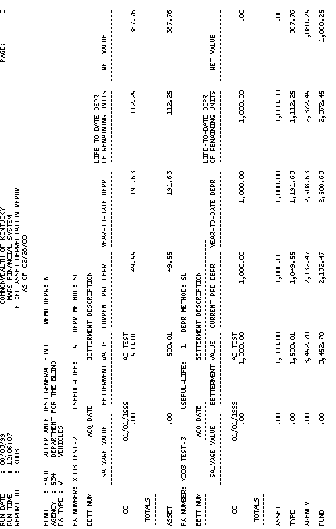

Report ID - FMPX003A – Fixed Asset Depreciation Report

This report displays depreciation by Fund and Agency for each betterment of each depreciable asset. The complete list of fields and their description are listed below:

FUND The fund that is primarily responsible for the fixed asset. A fund is a fiscal and accounting entity with a self-balancing set of accounts recording cash and other financial resources. The Finance and Administration Cabinet centrally maintain fund codes on the Fund table (FUN2).

MEMO DEPR (Memo Depreciation) Default is N (no). Y (yes) if depreciation for this fund is for memo only.

AGENCY The agency that is primarily responsible for the fixed asset. All agencies that record information in the financial system will be recorded in MARS on the Agency table (AGC2).

Report ID – FMPX003A - Fixed Asset Depreciation Report (Continued)

FA TYPE (Fixed Asset Type) Fixed asset type indicates the fixed asset type which includes the following values: L=land, B=buildings, I=improvements (non-buildings), E=equipment and machinery, C=construction in progress, and V=vehicles.

FA NUMBER (Fixed Asset Number) The fixed asset number which is the unique identifier (property tag number) for the fixed asset.

USEFUL-LIFE The expected useful life for the fixed asset.

DEPR METHOD (Depreciation Method) The depreciation method used for this asset. Depreciation methods are SL=straight line, SY=sum of the years digits, DD=double declining balance, NNN=variable declining balance, MC=manually computed, and NA=not applicable.

BETT NUM (Betterment Number) The betterment number that increases the value of the asset due to improvements made to the fixed asset. A betterment number of “00” is associated with a Fixed Asset when it is established.

ACQ DATE (Acquisition Date) The date (mm dd ccyy) the asset was acquired.

