
Report ID - FMPX003A - Fixed Asset Depreciation Report (Continued)

BETTERMENT DESCRIPTION Description of the fixed asset.

SALVAGE VALUE The salvage value of the investment in the original asset or betterment.

BETTERMENT VALUE The dollar value of the investment in the original asset or betterment.

CURRENT PRD DEPR (Current Period Depreciation) Depreciation amount for the current accounting period.

YEAR-TO-DATE DEPR (Year-To-Date Depreciation)
Accumulated year-to-date depreciation amount.

LIFE-TO-DATE DEPR OF REMAINING UNITS
(Life-to-Date Depreciation of Remaining Units) Depreciation amount for life-to-date of fixed asset that have not been sold, destroyed, or considered obsolete, etc. This amount is from the Fixed Asset Betterment Inquiry table.

NET VALUE The net asset value of the fixed asset, which is the betterment value, amount minus the life--to-date depreciation of remaining units amount.
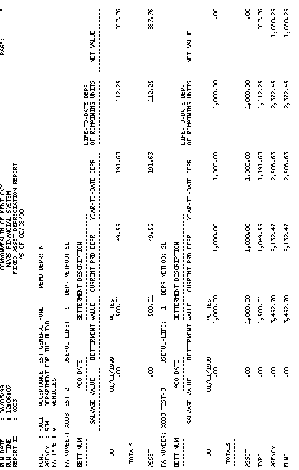

Report ID - FMPX003A - Fixed Asset Depreciation Report (Continued)

TOTALS ASSET The total of the fixed asset for each column (salvage value, betterment value, current prd depr, year-to-date depr, life-to-date depr of remaining units and net value) within that fund, agency and fixed asset type.

TOTALS TYPE The total of fixed asset type for each column (salvage value, betterment value, current prd depr, year-to-date depr, life-to-date depr of remaining units and net value) within that fund and agency.

TOTALS AGENCY The agency total for each
column (salvage value, betterment value, current prd depr, year-to-date depr, life-to-date depr of remaining units and net value) within that fund.

TOTALS FUND The fund total for each column (salvage value, betterment value, current prd depr, year-to-date dept, life-to-date depr of remaining units and net value).

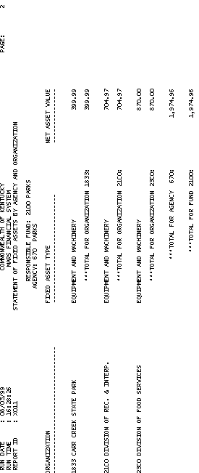

Report ID - FMPX011A - Statement of Fixed Assets by Agency and Organization

This report displays the total of all asset values for each organization, agency and fund. The complete list of fields and their descriptions are listed below.

RESPONSIBLE FUND The fund that is primarily responsible for the fixed asset. A fund is a fiscal and accounting entity with a self-balancing set of accounts recording cash and other financial resources. The Finance and Administration Cabinet centrally maintain fund codes on the Fund table (FUN2).

AGENCY The agency that is primarily responsible for the fixed asset. All agencies that record information in the financial system will be recorded in MARS on the Agency table (AGC2).

ORGANIZATION The organization primarily responsible for the fixed asset and the organization name. The Organization data element is a breakdown of Agency (i.e., Department, Division, Branch, Section, Unit). The Organization structure can be up to twelve levels. In MARS, the Organization data element can be used for a variety
of purposes. Valid values are maintained on the Organization table (ORG2).

Report ID - FMPX011A - Statement of Fixed Assets by Agency and Organization (Continued)

FIXED ASSET TYPE Displays the name of the fixed asset type. Fixed asset types are land, buildings, improvements (non-buildings), equipment and machinery, construction in progress, and vehicles.

NET ASSET VALUE The net asset value of the fixed asset that is the asset value and betterment value amount minus the accumulated depreciation amount.

TOTAL FOR ORGANIZATION The total of all fixed asset types for that organization within that fund and agency.

TOTAL FOR AGENCY The total of all fixed asset types for that agency within that fund.

TOTAL FOR FUND The total of all fixed asset types for that fund.

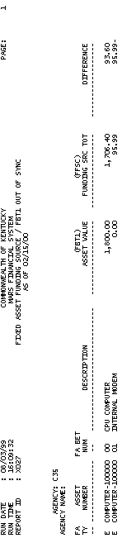
Report ID – FMPX027A – Fixed Asset Funding Source / FBT1 Out Of Sync

This report displays the out of sync amount between the asset value on the Fixed Asset Betterment Inquiry table (FBT1) and the funding source total on the Funding Source Inquiry table (FFSC). The complete list of fields and their descriptions are listed below.

AGENCY The agency that is primarily responsible for the fixed asset. All agencies that record information in the financial system will be recorded in MARS on the Agency table (AGC2).

AGENCY NAME The agency name of the agency that is primarily responsible for the fixed asset.

FA TY (Fixed Asset Type) Fixed asset type indicates the fixed asset type which includes the following values: L=land, B=buildings, I=improvements (non-buildings), E=equipment and machinery, C=construction in progress, and V=vehicles.

Report ID - FMPX027A - Fixed Asset Funding Source / FBT1 Out Of Sync (Continued)

ASSET NUMBER The fixed asset number which is the unique identifier (property tag number) for the fixed asset.

FA BET NUM (Fixed Asset Betterment Number) The betterment number that increases the value of the asset due to improvements made to the fixed asset.

DESCRIPTION The description of the fixed asset.

FBT1 ASSET VALUE The amount is the asset value from the Fixed Asset Betterment Inquiry table (FBT1).

FFSC FUNDING SRC TOT ( FFSC Funding Source Total) The amount is the funding source total for the fixed asset from the Funding Source Inquiry table (FFSC).

DIFFERENCE The amount is the difference between the asset value on the Fixed Asset Betterment Inquiry table (FBT1) and the funding source total on the Funding Source Inquiry table (FFSC).

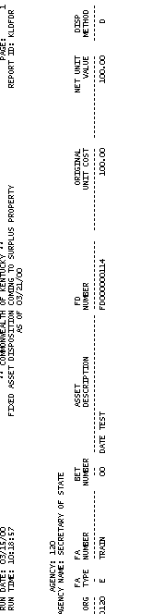

Report ID - FMPFDGNA - Fixed Asset Disposition Coming To Surplus Property

This report displays the fixed asset disposition from each agency transferring to surplus property. The complete list of fields and their descriptions are listed below.

AGENCY The agency that is primarily responsible for the fixed asset. All agencies that record information in the financial system will be recorded in MARS on the Agency table (AGC2).

AGENCY NAME The agency name of the agency that is primarily responsible for the fixed asset.

ORG (Organization) The organization charge for the fixed asset. The Organization data element is a breakdown of Agency (i.e., Department, Division, Branch, Section, Unit). The Organization structure can be up to twelve levels. In MARS, the Organization data element can be used for a variety of purposes. Valid values are maintained on the Organization table (ORG2).

Report ID - FMPFDGNA - Fixed Asset Disposition Coming To Surplus Property (Continued)

FA TYPE (Fixed Asset Type) Fixed asset type indicates the fixed asset type which includes the following values: L=land, B=buildings, I=improvements (non-buildings), E=equipment and machinery, C=construction in progress, and V=vehicles.

FA NUMBER (Fixed Asset Number) The fixed asset number which is the unique identifier (property tag number) for the fixed asset.

BET NUMBER (Betterment Number) The betterment number that increases the value of the asset due to improvements made to the fixed asset.

ASSET DESCRIPTION Description of the fixed asset.

FD NUMBER (Fixed Asset Disposition Number) The Fixed Asset Disposition document number.

ORIGINAL UNIT COST The original value of the fixed asset.

NET UNIT VALUE This amount is the summary asset value amount minus the accumulated depreciation amount.

REPORT ID - FMPFDGNA - Fixed Asset Disposition Coming To Surplus Property (Continued)

DISP METHOD (Disposition Method) The disposition method used in disposing of the fixed asset. Disposition method includes the following values: A=transferred to other agency, D=destroyed, K=cannibalized, L=leave termination, S=sold, T=trade-in, and U=lost/stolen.

DISPOSITION AUTHORITY SIGNATURE The signature of the individual who authorized the disposal of the fixed asset.

