
Report FMPMEMOK – Project Billing Setup Assurance Program

PFST BILLING CYCLE <> PBGR – This error occurs when the billing cycle showing for the Federal provider project/sub-project/phase on the Project Funding Source (PFST) is different from the billing cycle specified for the project billing drawdown group on PBGR. Correct the billing cycle for the drawdown group on PBGR, process a PJ document to assign the project to the correct drawdown group, or process a PZ document to correct the billing cycle for the Federal Program Provider.

PGPV FUNDING SOURCE <> PBGR – This error occurs when the funding source associated with the Program/Provider used in setting up an agreement amount with the Project Participation (PZ) document is different from the funding source associated with the Drawdown Group showing for the Project on the Agency Project Inquiry (AGPR). Correct the Funding Source for the drawdown group on PBGR or correct the funding source for the Program/Provider on PGPV.
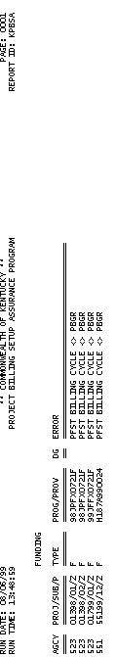

Report FMPMEMOK – Project Billing Setup Assurance Program

PGPV EFT/CHECK <> PBFS - This error occurs when the EFT/CHECK indicator associated with the Program/Provider used in setting up an agreement amount with the Project Participation (PZ) document is different from the EFT/CHECK indicator associated with the Drawdown Group showing for the project on the Agency Project Inquiry (AGPR). Correct the EFT/CHECK indicator for the drawdown group on PBGR or correct the EFT/CHECK indicator for the Program/Provider on PGPV. (This may also require correcting the EFT/CHECK indicator for the related Funding Source on PBFS).

Report FMPPBDQA – SUMMARY OF DRAWDOWN GROUP

This report displays expenditures that have resulted in a federal billing or draw. Amounts shown are “post-split,” meaning they are the federal portion of expenditures. Note that actual draw amounts may be lower due to reductions shown on the FMPPBRQA report. The two reports must be used together to understand how draws were calculated. This report provides sub-project/phase level totals, agency, project level totals and drawdown group level totals. The complete list of fields and their corresponding descriptions are listed below:

DRAW this is the drawdown group assigned to the project/subproject/phase. A single deposit (represented by a single Cash Receipt document) is made for each drawdown group. Valid drawdown group codes are maintained on the Drawdown Group (PBGR) table.

ENTITY MARS provides a higher level attribute to link together multiple projects for reporting purposes, called the ENTITY Wide Project Number. This information is maintained on the Entity Wide Project (ENPR) table.

Report FMPPBDQA – SUMMARY OF DRAWDOWN GROUP

AGENCY All agencies that record information in the financial system will be recorded in MARS on the Agency (AGC2) table. Agency is used in combination with the Fund data element to establish the highest level of budgetary control for appropriation programs and allotment programs.

PROJECT The project code is used to identify specific Project Authorization codes and may be used for Capital Projects, Grants, and Highway Projects. In MARS, Grants and Projects are established and termed as “Projects.” Grants and Projects are distinguished by a PROJECT/GRANT INDICATOR on the Agency Project (AGPR) table.

SUB-PROJECT The SUB-PROJECT code identifies major tasks or subsections of a project. This code provides the ability to infer background information from the Project/Sub-Project setup. Valid Project/subproject/Phase combinations are on the Project Budget Line Inquiry (PRBL) table.

Report FMPPBDQA – SUMMARY OF DRAWDOWN GROUP

PHASE The Phase code is hierarchical below Project. The code identifies the phase of operation for a Project. There may be single or multiple phases to a project. Phase codes are stored on the Project Phase (PRPH) table.

FUND A fund is a fiscal and accounting entity with a self-balancing set of accounts recording cash and other financial resources together with all related liabilities, and residual equities and changes therein, which are segregated for the purpose of carrying on specific activities or attaining certain objectives. Fund codes are centrally maintained on the Fund Table (FUN2) by the Finance and Administration Cabinet.

ORGANIZATION The Organization data element is a breakdown of Agency (i.e., Department, Division, Branch, Section, Unit). The Organization structure can be up to twelve levels. In MARS, the Organization data element can be used for a variety of purposes. The Agency and Organization data elements can also be used for security restrictions for transaction processing. Valid values are maintained on the Organization Table (ORG2).

Report FMPPBDQA – SUMMARY OF DRAWDOWN GROUP

APPR UNIT (APPROPRIATION UNIT) An appropriation is a dollar amount allocated by law for a specific purpose. In MARS, appropriations are represented by Appropriation Programs. In the Commonwealth of Kentucky, the Budget Bill establishes one or more appropriation(s) of funds for each agency. The Appropriation Unit field is a 9 character data field that consists of an Appropriation Program (2 characters maintained on EAP2), an Allotment Program (3 characters maintained on EALL), and a Program Budget Unit (4 characters maintained on PRFT).

Report FMPPBDQA – SUMMARY OF DRAWDOWN GROUP

ACTIVITY Activity (ACT2) defines valid codes for activities and can also be used to group similar activities into higher level classifications. An activity is an internal program that you want to define for budgeting and/or reporting purposes. Activity is one of the two coding elements (Object being the other) that determine if a transaction is “ELIGIBLE” to be billed to an external provider of funds.

The activity code is the starting point for a classification hierarchy that puts similar activity codes together in progressively larger groups. Similar activities make an activity class, similar activity classes make an activity category, etc.

Report FMPPBDQA – SUMMARY OF DRAWDOWN GROUP

OBJT (OBJECT) Objects represent the coding level for recording all expenditures in MARS. Objects can be designated as operating or non-operating expenditures; as payroll expenses; or as 1099 reportable. Object is one of the two coding elements (activity being the other) that determine if a transaction is “eligible” to be billed to an external provider of funds. Valid object codes are maintained on the Object Table (OBJ2).

DOLLAR AMOUNT This field contains the post-split federal portion of expenditures that will result in a draw note that actual draw amounts may be lower due to reductions shown on the FMPPBRQA report. The two reports must be used together to understand how draws are calculated.

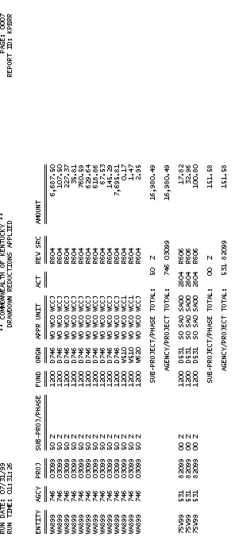
Report FMPPBRQA – DRAWDOWN REDUCTIONS APPLIED

This report displays all expenditure credits and revenue that have been applied to reduce a federal billing or draw. Amounts shown on this report will, if possible, reduce draw amounts that will be reflected on generated Receivable (RE) and Cash Receipt (Electronic Deposit) (C1) documents. For any expenditure and revenue credits with amounts so large that they would cause a negative draw, the excess is recorded on the Reductions to be Applied (REDA) table to be applied to draws calculated in subsequent billing cycles. The complete list of fields and their corresponding descriptions are listed below:

ENTITY MARS provides a higher level attribute to link together multiple projects for reporting purposes, called the Entity-Wide Project Number. This information is maintained on the Entity -Wide Project (ENPR) Table.

AGENCY All agencies that record information in the financial system will be recorded in MARS on the Agency (AGC2) table. Agency is used in combination with the Fund data element to establish the highest level of budgetary control for appropriation programs and allotment programs.

Report FMPPBRQA – DRAWDOWN REDUCTIONS APPLIED

PROJECT The project code is used to identify specific Project Authorization codes and may be used for Capital Projects, Grants, and Highway Projects. In MARS, Grants and Projects are established and termed as “Projects.” Grants and Projects are distinguished by a PROJECT/GRANT INDICATOR on the Agency Project (AGPR) table.

SUB-PROJECT The SUB-PROJECT code identifies major tasks or subsections of a project. This code provides the ability to infer background information from the Project/Sub-Project setup. Project/Subproject/Phase combinations are on PRBL.

PHASE The Phase code is hierarchical below Project. The code identifies the phase of operation for a Project. There may be single or multiple phases to a project. Phase codes are stored on the Project Phase (PRPH) table.

Report FMPPBRQA – DRAWDOWN REDUCTIONS APPLIED

FUND A fund is a fiscal and accounting entity with a self-balancing set of accounts recording cash and other financial resources together with all related liabilities, and residual equities and changes therein, which are segregated for the purpose of carrying on specific activities or attaining certain objectives. Fund codes are centrally maintained on the Fund Table (FUN2) by the Finance and Administration Cabinet.

ORGN The Organization data element is a breakdown of Agency (i.e., Department, Division, Branch, Section, Unit). The Organization structure can be up to twelve levels. In MARS, the Organization data element can be used for a variety of purposes. The Agency and Organization data elements can also be used for security restrictions for transaction processing. Valid values are maintained on the Organization Table (ORG2).

Report FMPPBRQA – DRAWDOWN REDUCTIONS APPLIED

APPR UNIT (APPRORIATION UNIT) An appropriation is a dollar amount allocated by law for a specific purpose. In MARS, appropriations are represented by Appropriation Programs. In the Commonwealth of Kentucky, the Budget Bill establishes one or more appropriation(s) of funds for each agency. The Appropriation Unit field is a 9 character data field that consists of an Appropriation Program (2 characters maintained on EAP2), an Allotment Program (3 characters maintained on EALL), and a Program Budget Unit (4 characters maintained on PRFT).

Report FMPPBRQA – DRAWDOWN REDUCTIONS APPLIED

ACT (ACTIVITY) Activity (ACT2) defines valid codes for activities and can also be used to group similar activities into higher level classifications. An activity is an internal program that you want to define for budgeting and/or reporting purposes.

The activity code is the starting point for a classification hierarchy that puts similar activity codes together in progressively larger groups. Similar activities make an activity class, similar activity classes make an activity category, etc

REV SRC (REVENUE SOURCE)
The revenue source represents the coding level for recording all revenues in MARS. They can be both designated as operating or non-operating. Valid revenue codes are maintained on the Revenue Source (RSR2) table.

Report FMPPBRQA – DRAWDOWN REDUCTIONS APPLIED

AMOUNT This field contains dollar amount of the reduction that was applied to reduce a draw. If the total credit amount was greater that the draw amount, the amount in excess of the draw that was reduced can be found on the Reductions to be Applied (REDA) table.

SUB-PROJECT/PHASE TOTAL This field contains the sum of all records grouped by ENTITY, AGENCY, PROJECT, SUB-PROJECT and PHASE.

AGENCY/PROJECT TOTAL This field contains the sum of all records grouped by ENTITY, AGENCY and PROJECT.

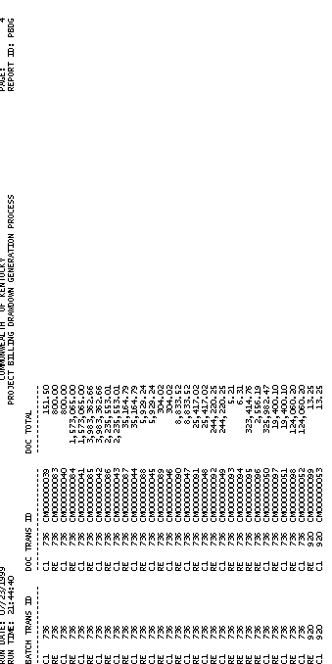
Report FMPPBDGA – PROJECT BILLING DRAWDOWN GENERATION PROCESS

This report displays all transactions created during the MARS’ project billing drawdown generation process. Amounts shown on this report are post-split federal amounts and are derived from the expenditure and Project Charge (PX) transactions recorded during the billing period. Amounts on generated billing documents are calculated as expenditures from the FMPPBDQA report less credits from the FMPPBRQA report. The complete list of fields and their corresponding description are listed below:

BATCH TRANS ID When documents exceed 99 lines, they will be batched. For batched documents, a 6-digit batch number is assigned that is equal to the last six digits of the first document number in the batch. Unbatched document will show only the document type and agency code.

DOCUMENT TRANS ID The actual document numbers (including document type and agency) are listed. They are sorted by agency. Each Cash Receipt (Electronic Deposit) (C1) or Cash Receipt (CR) document contains the same lines as the Receivable (RE) documents listed before it.

Report FMPPBDGA – PROJECT BILLING DRAWDOWN GENERATION PROCESS

DOCUMENT TOTAL This field contains the total dollar amount for the document number that was generated during the project billing drawdown generation process. This amount is calculated as expenditures from the FMPPBDQA report less credits from the FMPPBRQA report.

This page intentionally left blank.



Activity 8 - 1

1. Which report shows any inconsistencies in the drawdown group?

- FMPMEMOA
- FMPMEMOC
- FMPMEMOI
- FMPMEMOK

- Which report displays expenditure debits recorded against a draw in MARS.

- FMPG111A
- FMPPBDGA
- FMPPBRQA
- FMPPBDQA

- This report displays all projects, sub-projects, and phase records that are either on Project Budget Line Inquiry (PRBL) and not on Project Appropriation (PAPR) table or vice versa in MARS.

- FMPP170A
- FMPG110A
- FMPG111A
- FMPMEMOC

This page intentionally left blank.


1. Which report shows any inconsistencies in the drawdown group?

A. FMPMEMOA
B. FMPMEMOC
C. FMPMEMOI
D. FMPMEMOK

Answer: D. FMPMEMOK

2. Which report displays expenditure debits recorded against a draw in MARS.

A. FMPG111A
B. FMPPBDGA
C. FMPPBRQA
D. FMPPBDQA

Answer: D. FMPPBDQA

This page intentionally left blank.

3. This report displays all projects, sub-projects, and phase records that are either on Project Budget Line Inquiry (PRBL) and not on Project Appropriation (PAPR) table or vice versa in MARS.

A. FMPP170A
B. FMPG110A
C. FMPG111A
D. FMPMEMOC

Answer: A. FMPP170A

This page intentionally left blank.




Are there any questions concerning what we have covered on the topic of Projects and Grants Standard Reports?

In this topic we:

- Covered what Project and Grant reports are included as Standard Reports, and

- Covered what specific fields exist on these Projects and Grants related standard reports.

