The first time you logon to ADVANTAGE Financial, you must complete several steps.

Step A - Desktop Sign-on

The following dialog window is presented after launching ADVANTAGE:

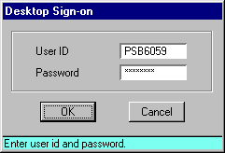

To logon the first time you would do the following:

Step 1 In the USER ID field, type your user ID.

Step 2 In the PASSWORD field, type your CICS (mainframe) password.

Step 3 Click <OK> when completed.

If you have access to the Commonwealth’s mainframe systems, your ADVANTAGE password will be your existing CICS (or mainframe) password and you will probably not be required to change your password (only if it has expired).

If you have not been a mainframe user in the past, the user ID is newly assigned. Your initial password was communicated along with your ID. The system will require you to change your password to a new secret password the first time you log into ADVANTAGE.

Step B - Changing Your ADVANTAGE Password (if necessary)

If a password change is needed, the dialog window similar to the one below will be displayed. If this not displayed, you may proceed to Step C.

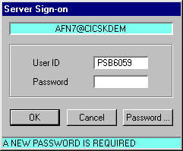

The USER ID field of the Server Sign-on dialog box is automatically populated with the user ID you used for the desktop sign-on. The server sign-on also uses the same password, but you have to enter that yourself.

Step 1 In the PASSWORD field, type your initial password.

Step 2 Click <PASSWORD> when completed.

The Change Server Password dialog box appears:

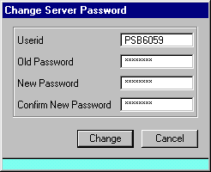

Passwords appear as asterisks (*), so that no one else can see what you are typing.

Step 1 In the USER ID field, type your User ID.

Step 2 In the OLD PASSWORD field, type the password given to you.

Step 3 In the NEW PASSWORD field, type your new password, something only you will know. Your new password must be 4 to 8 characters. It must contain at least one number and it must begin with a letter.

Step 4 In the CONFIRM NEW PASSWORD field, enter the password from step 3.

Step 5 Click <CHANGE>.

The ADVANTAGE Workflow Sign-on dialog box appears.

Step C - Workflow Sign-on

You must provide your Workflow Sign-on user ID and password to provide access to certain workflow features. For subsequent logons, you only need to provide your desktop Sign-on password. The system will save your workflow information.

If you are unable to complete this step without assistance, click Cancel and proceed into ADVANTAGE. The system will function normally with the exception of being able to access the e-mail features of ADVANTAGE workflow. You will be prompted each during each ADVANTAGE sign-on until the workflow User ID is provided.

Your Workflow Email User ID is determined by your Personal Computer’s mail configuration. Follow these steps to determine your Email User ID:
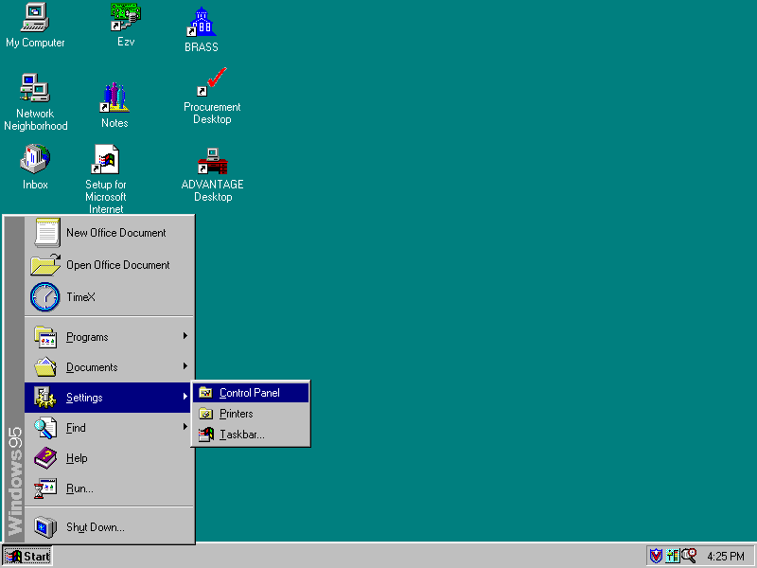
Step 1 – Open the Control Panel

Step 2 – Select Mail and Fax from the Control Panel. This icon may also be titled just ‘Mail’.
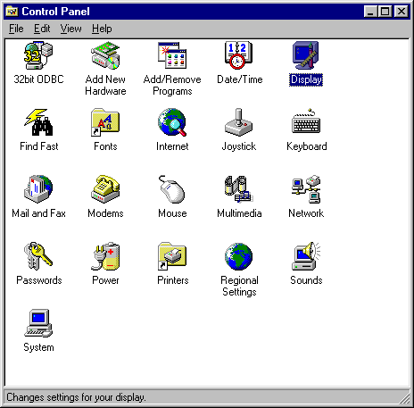

Step 3 – From the Properties Window, click Show Profiles.
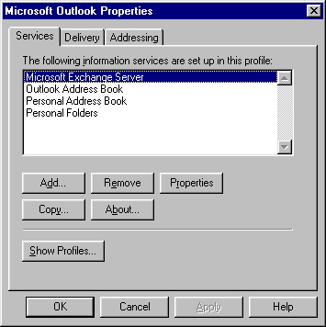

Step 4 – Identify Your Mail Profile Name. This is your ADVANTAGE Workflow user ID.
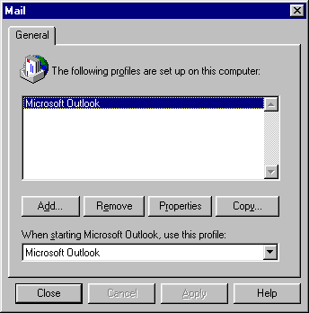

Step 5 – Close the Mail and Control Panel Windows and complete the ADVANTAGE sign-on.

Step 6 – Complete the ADVANTAGE Workflow Sign-on.

In the User ID field, type your mail profile from Step 4.

In the Password field, type your CICS/mainframe password you entered on the Desktop Sign-on panel.

Step D - Confirm the Profile Update

After a successful workflow sign-on, you will then be prompted to save your new user profile. Perform the following steps to save your user profile.

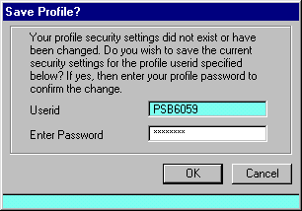

Step 1 In the ENTER PASSWORD field, type the same password you used to sign-on to ADVANTAGE Financial.

Please note that this password is the password you entered when you signed on ADVANTAGE Desktop. If the system prompts you to change the password, enter the new password.

Step 2 Click <OK> to save your profile.

The ADVANTAGE Financial Desktop appears.

