Topic 1 – Paying a Travel Voucher or

Pre-Paid Registration Fee Using a Vendor Payment Voucher (P1) Document

Purpose

Objectives

The purpose of this topic is to ensure that you understand how a Vendor Payment Voucher (P1) document is used to initiate disbursements to individuals or outside vendors for travel reimbursements or pre-paid registration fees. A traveler is an individual who takes a business trip on behalf of the Commonwealth. We will process three P1 documents in this course. One P1 document will be processed to reimburse a Commonwealth Traveler for travel related expenditures. Another P1 will be processed to illustrate how to pay a Pre-Paid Registration Fee. This topic also shows that the P1 document schedules a specific disbursement date for the traveler or vendor payment.

By the completion of this topic you will be able to:
- Describe uses of the P1 document;

- Identify the steps in document processing;

- Create, edit, approve, and run a document;

- Access tables updated by P1 document; and

- Copy a document.

 Document Processing Cycle
Prepare Travel Voucher and Pre-Paid Registration Fee Form(s) as Required

Create a P1 Document and Enter Data

Edit P1 Document for Errors

Rejected
Correct P1 Errors
Pending Approval

Approve P1 Document

Run P1 Document



Paying a Travel Voucher or Pre-Paid Registration Fee using a Vendor Payment Voucher (P1) Document

The Travel Voucher form will be prepared by the traveler to request reimbursement. The Pre-Paid Registration Fee form will generally be prepared by the appropriate staff to request payment for registration fees. Upon completion of these forms, the P1 document is processed in MARS to record transactions and financial information. For example, a P1 document can be used to issue a pre-paid registration advance fee or to reimburse a traveler for expenses incurred on a business trip. When P1 documents are processed for travel reimbursements or advances they will record an expenditure by utilizing an object code.

Once the information has been entered, the next step is to edit the document for errors. This is performed while the document is open. If the document is error free, a message of “PEND1: Ready for Approval” will appear at the bottom of the document. The document is then ready for approvals to be applied. If the document contains errors, a message of “REJCT” will appear at the bottom of the document with a count of the number of errors. When you receive the “REJCT” message, you will need to correct the errors and edit the document again.

Document Processing Cycle
Prepare Travel Voucher and Pre-Paid Registration Fee Form(s) as Required

Create a P1 Document and Enter Data

Edit P1 Document for Errors

Rejected
Correct P1 Errors
Pending Approval

Approve P1 Document

Run P1 Document

Documents cannot be approved until they are free of errors. Once the document is error free, and all the necessary approvals have been applied, a document is then considered “SCHED”. This means that it is ready to be run.

The final step in the document processing cycle is to run the document. This can be done both on-line and off-line. Processing off-line means that a document is run as part of the MARS nightly cycle. Processing on-line means that a document is run by a user before the nightly cycle. After a document has been run, the status changes to “ACCPT.” The document will remain on the Document Listing (SUSF) table for a period of time. During this time period, accepted documents can be reviewed, but not changed.

Document Processing Cycle
Prepare Travel Voucher and Pre-Paid Registration Fee Form(s) as Required

Create a P1 Document and Enter Data

Edit P1 Document for Errors

Rejected
Correct P1 Errors
Pending Approval

Approve P1 Document

Run P1 Document

A document can also be placed on hold prior to being run. Holding a document means that you stop the processing cycle. For example, let’s say that you have created a Vendor Payment Voucher (P1) document and you do not have enough information about the proper accounting distribution to be updated. At this point you would place the document on hold. By placing the document on hold in SUSF, this alerts other users of the system that the document is being worked on by another user. Once the accounting distribution is known, you can add the information in the document and complete the document processing cycle.

Now that we have reviewed the document processing cycle let’s examine the Vendor Payment Voucher (P1) document more closely.

Vendor Payment Voucher Process
Flowchart

Vendor Payment Voucher Process Flowchart
Lecture

The Vendor Payment Voucher (P1) document is used to manage two types of travel transactions. One is to reimburse a traveler for expenses incurred due to a business trip. The other is to issue a pre-paid registration fee advance.

The P1 document recognizes that a debt has been incurred that must be paid. When a P1 document is processed to recognize an outstanding debt, MARS establishes both expenditure and vouchers payable account balances. After processing a P1 document, MARS will disburse cash to the traveler or applicable vendor based on the scheduled payment date entered on the document. Cash disbursements are made through Electronic Funds Transfer (EFT) or Automated Disbursement (AD) (i.e. paper check).

Scenario 1 will illustrate how MARS is used to pay a Pre-Paid Registration Fee form for one traveler. Scenario 2 will demonstrate how MARS is used to pay a Pre-Paid Registration Fee form for two travelers. Scenario 3 will illustrate how MARS is used to reimburse a traveler for incurred expenses. Both types of payments are made using a Vendor Payment Voucher (P1) document.

Overhead

Vendor Payment Voucher Process
Flowchart
The processing of Vendor Payment Voucher (P1) documents is primarily performed by the agencies in a decentralized environment. MARS user agency staff initiate the data entry of the P1 document and apply approvals to the document. Data entry will generally occur after the Pre-Paid Registration Fee or Travel Voucher Forms have been completed. Both forms must be signed by the appropriate staff. These signatures verify that the provided information conforms to travel regulations and contains accurate amounts. Processing of the associated cash disbursement through Electronic Funds Transfer (EFT) or Automated Disbursement (AD) (i.e., paper check) is the responsibility of the Finance and Administration Cabinet and the Office of the State Treasurer.
Lecture

MARS provides a variety of online inquiries and reports to an agency to monitor the status of Vendor Payment Voucher (P1) documents. For example, there are online inquiries that provide information about open payment voucher balances and accounting distribution information. Additionally, reports are available that provide information such as those P1 documents for which a cash disbursement could not be made because of insufficient cash. Moreover, a variety of other reports are available to support the payable process.

Overhead

Vendor Payment Voucher Process
Flowchart
The roles and responsibilities of the primary actors in the Vendor Payment Voucher (P1) process are as follows:
Lecture

Role | Responsibility
Complete Pre-Paid Registration Fee or Travel Voucher form | Traveler
Review and approve form | Traveler Supervisor, Agency Head
Enter information on form into P1 document | Agency staff
Approve and Process  P1 document | Agency Fiscal  Officer/Manager
Disbursement through Automated Disbursement or Electronic Funds Transfer | Finance and Administration Cabinet/  Office of the State Treasurer

During this topic we will cover the steps required to process a P1 document for travel related forms.

Before we process a P1 document, let’s briefly review the document’s structure.

Overhead

Sample Vendor Payment Voucher (P1) Document
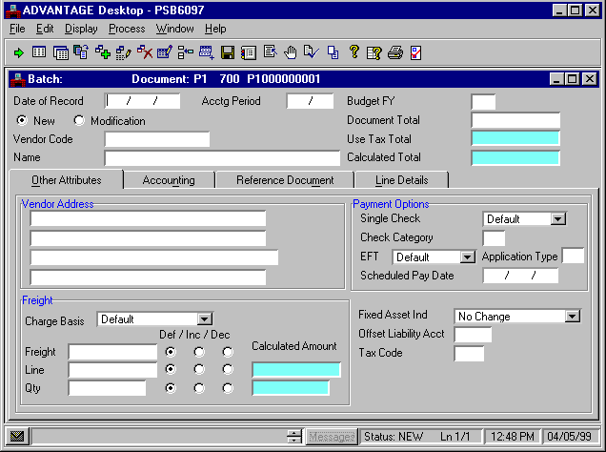
Other Attributes View

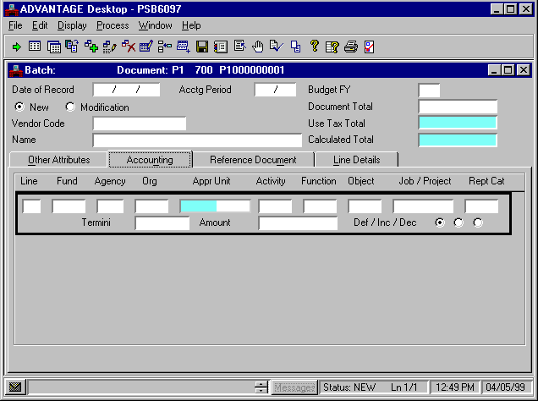
Accounting View
Vendor Payment Voucher (P1) Document
Lecture

The screen print shows a sample P1 document. The P1 document contains fields that specify a variety of information about vendor payments. In MARS a traveler will have a unique Traveler ID. Generally, the Traveler ID will be the traveler’s Social Security number. MARS treats both individual (traveler) and Vendor codes in the same manner. Both are recorded as Vendors. All valid Vendor (or Traveler ID) codes can be found in the Vendor Table (VEN2). Consequently we will record the Traveler ID code in the Vendor field on the input screen.

General payment information is entered in the Header area. This includes information such as Accounting Period, Vendor (Traveler) Code and Document Total. This header information is displayed regardless of the tab selected. Notice that the P1 document consists of four views.

The Other Attributes tab contains information about the traveler’s address and payment options.

The Accounting tab contains limited Chart Of Accounts data element information such as Fund, Agency, Organization, and Object. P1 documents pertaining to travel will always have an object code entered.

Screen View

Sample Vendor Payment Voucher (P1) Document
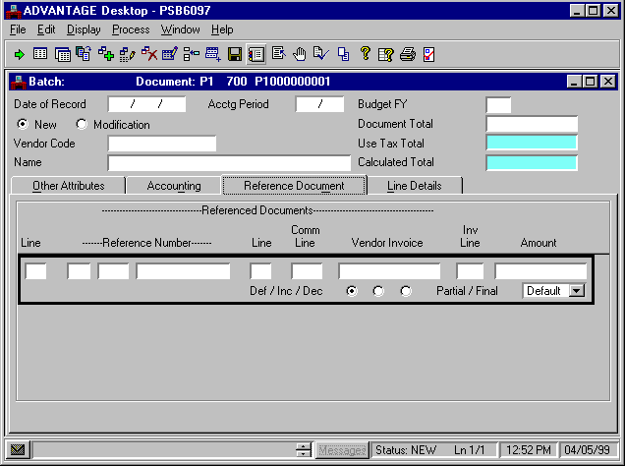
Reference Document View

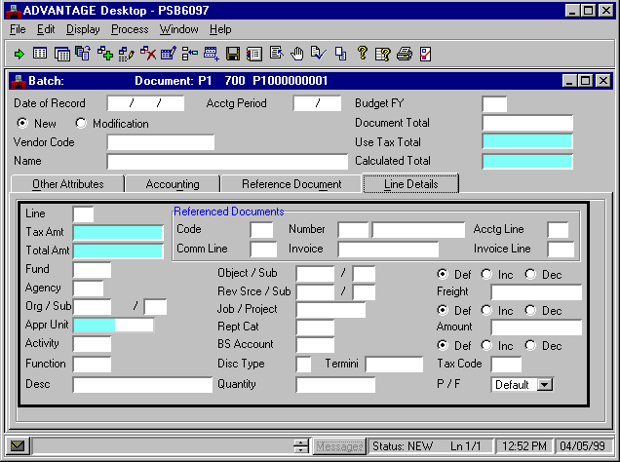
Line Details View

Vendor Payment Voucher (P1) Document
Lecture

The Reference Document tab contains information about associated reference documents. When P1 documents are processed for travel purposes they will not reference another document.

The Line Details tab contains extensive information for each accounting line. For example, as described earlier, this tab includes Chart of Accounts data element field information for the funding strip to which the traveler’s expenses will be charged.

During this topic, we will cover the steps required to process a P1 document to pay a vendor for a traveler’s Pre-Paid Registration Fee and to reimburse a traveler after a business trip.

Now, let’s continue with Scenario 1. We will edit, approve, and run a P1 document. Upon completion of the document processing cycle, we will view a few of the affected tables.


Go to Window

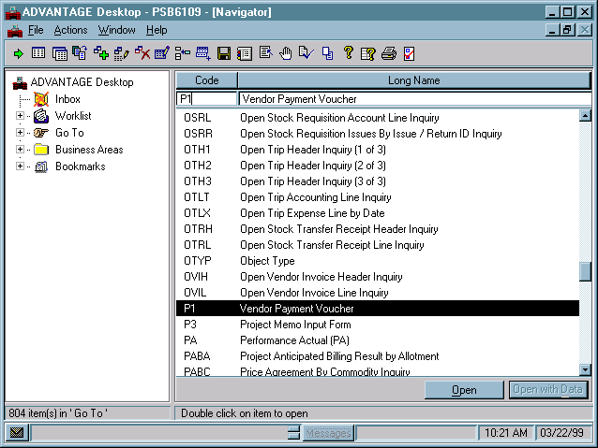



Scenario 1

Our traveler wants to attend a conference on online learning and workforce development. Online Learning Incorporated is the vendor organizing the conference. It will be held in Chicago, IL and the registration fee is $450.00. Assume that the traveler has completed, signed, and submitted the Pre-Paid Registration Fee form to request the registration advance. After the required approvers have reviewed and signed the Pre-Paid Registration Fee form the data will be entered into MARS. The amount specified will be issued through a straight disbursement using the Vendor Payment Voucher (P1) document.

When P1 documents are processed for travel advances or reimbursements they will record a expenditure by utilizing an object code.

Access the P1

Step 1 Open the Go To Window.

Step 2 In the Code field, type “P1” and press the <OPEN> button.

Batch/Document Entry Screen

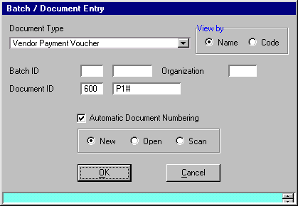

To create a new Vendor Payment Voucher (P1) document, complete the following steps on the Batch/Document Entry screen.

Step 1 Press the <TAB> key until the cursor is in the DOCUMENT ID field for Agency and type “☺☺☺”.

Step 2 Type “P1” in the DOCUMENT ID field for Document Number.

Step 3 Select the Automatic Document Numbering option.

Step 4 Verify the Document Action option is “New” and press <OK>.

Write down the document number the system assigned to your P1. You will use it later to inquire on tables.

P1 _ _ _ P1 _ _ _ _ _ _ _ _ _

Vendor Payment Voucher (P1)
Header / Other Attributes Tab

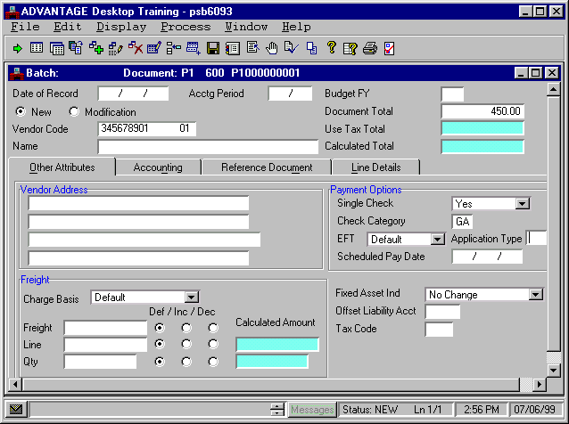

Let’s complete the required information to process the P1 document.

Populate the P1 Document

Step 1 Enter the following values in the corresponding fields of the Header.

DATE OF RECORD Optional. The date for this document. If left blank, this field will be inferred from the system. Leave Blank.

ACCTG PERIOD Optional. The accounting period using fiscal month and fiscal year, for this document. Dual-year processing users will enter accounting period 13 and the applicable accounting fiscal year to indicate closing period and to pay from prior year funds. Leave Blank.

BUDGET FY. Optional. The budget fiscal year for this document. If left blank, this field will be inferred from the system. Leave Blank.

NEW. Default is New. Indicates that this is a new entry. Leave as New.

MODIFICATION. Select when modifying a previously entered document. Leave Blank.

DOCUMENT TOTAL Required. The net amount of all increase and decrease line amounts. Amount due to Vendor for Pre Paid Registration Fee. Type “450.00”.

VENDOR CODE Required. In the instance of a Pre-paid Registration Fee, this code indicates the vendor to whom the registration fee must be paid. Type “345678901 01.”

Vendor Payment Voucher (P1)
Header / Other Attributes Tab

USE TAX TOTAL Protected. This field shows the total amount of tax calculated for this document if the tax codes used on the document are use tax. Leave Blank.

NAME This field is inferred from the Vendor Code entered on the document Leave Blank.

CALCULATED TOTAL Protected. This field contains the system-computed total of the line amounts. Leave Blank.

VENDOR ADDRESS. This field is inferred from the Vendor Code. Leave Blank.

SINGLE CHECK Optional. Used only when traveler or vendor elects to receive payment in a different manner than normally specified. When “Yes” for single check is selected a separate check for this payment will be issued. When “No’ or “Default” is selected for single check, this payment is consolidated with other vouchers to the same Vendor Code for the same disbursement date. Default is “No” for consolidated checks. Select “Yes”.

Screen View

Vendor Payment Voucher (P1)
Header / Other Attributes Tab


Walkthrough
CHECK CATEGORY Optional. This field specifies the check category that this payment voucher is printed under. Payment documents are summarized by the traveler or vendor and check category. If left blank, defaults to General Treasury (GT-check is sealed and mailed by Treasury). The single check flag may be selected requesting that a single check be issued for the payment. If the single check flag is not selected, the payment may be consolidated with all other payments to the traveler or vendor. If agency mailed (GA) is entered (check is returned to you without being sealed) and SINGLE CHECK must be selected. This allows the registration forms to be mailed with the check to the Vendor. If Treasury held (GH) is entered (check is held by treasury without being sealed) and single check must be selected. Type “GA”.

EFT Optional. Required if you want the current payment voucher paid by Electronic Funds Transfer (EFT) and the vendor’s default payment method is through check. This traveler or vendor must have EFT information in vendor table. Leave as Default.

APPLICATION TYPE Conditional. Required if EFT is set to Yes. Leave Blank.

SCHEDULED PAY DATE Required. Enter the date the payment is due to the traveler or vendor.
Type “☺☺/☺☺/☺☺”.

CHARGE BASIS. This field is not used in Kentucky. Leave as Default.

FREIGHT (Amount). This field is not used by the Commonwealth of Kentucky. Leave Blank.
Screen View

Vendor Payment Voucher (P1)
Header / Other Attributes Tab

Walkthrough
FREIGHT (Def/Inc/Dec). This field is not used by the Commonwealth of Kentucky. Leave as Default.

LINE (Amount). This field is not used by the Commonwealth of Kentucky. Leave Blank.

LINE (Def/Inc/Dec). This field is not used by the Commonwealth of Kentucky. Leave as Default.

LINE (Calculated Amount). This field is not used by the Commonwealth of Kentucky. Leave Blank.

QTY (Amount). This field is not used by the Commonwealth of Kentucky. Leave Blank.

QTY (Def/Inc/Dec). This field is not used by the Commonwealth of Kentucky. Leave as Default.

QTY (Calculated Amount). This field is not used by the Commonwealth of Kentucky. Leave Blank.

FIXED ASSET IND. This field is not used by the Commonwealth of Kentucky. Leave as Default.

OFFSET LIABILITY ACCT This field is not used by the Commonwealth of Kentucky. Leave as Default.

TAX CODE. This field is not used by the Commonwealth of Kentucky. Leave Blank.

