

Vendor Payment Voucher (P1)
Line Details Tabs

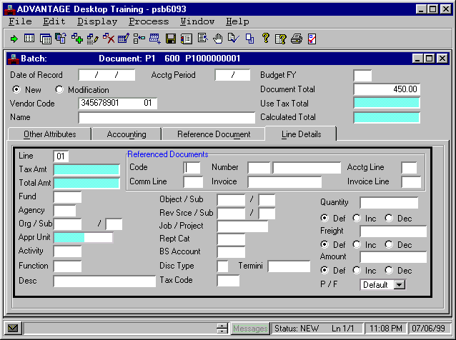



Populate the Line Details Tab

Step 2 Select the Line Details tab and enter the following values in the corresponding fields. It should be noted that the Accounting tab can be used when only limited fields are required. Since the Line Details tab contains all fields, we will use this tab for instructional purposes.

LINE Required. Enter a two-digit unique number for each line on the document. Numbers 01 to 99 are valid. Type “01”

REFERENCED DOCUMENTS CODE Conditional. All P1 documents processed for travel transactions will not reference another document. Leave Blank.

REFERENCED DOCUMENTS NUMBER
Conditional. Leave Blank.

REFERENCED DOCUMENTS ACCTG LINE Conditional. Leave Blank.

Vendor Payment Voucher (P1)

Line Details Tab

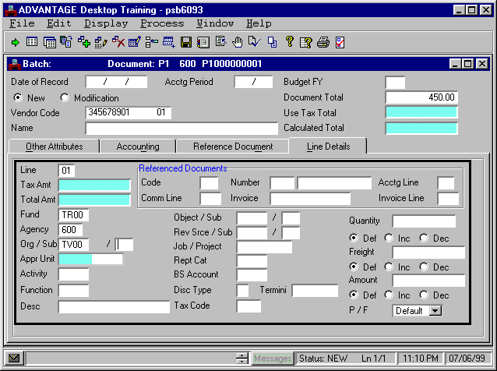

REFERENCED DOCUMENTS COMM LINE Conditional. Leave Blank.

REFERENCED DOCUMENTS INVOICE. If the Pre-Paid Registration Fee form has an associated vendor invoice enter the Vendor Invoice number in this field. If not, Leave Blank

REFERENCED DOCUMENTS INVOICE LINE The field is not used by the Commonwealth of Kentucky. Leave Blank.

TAX AMOUNT Protected. This field is not used by the Commonwealth of Kentucky. Leave Blank.

TOTAL AMT Protected. The system will calculate the total amount from the amount supplied and the calculated adjustment amount. Leave Blank.

FUND Required. The fund paying for this document line. Type “☺☺☺☺”.

AGENCY Required. The agency paying for this document line. Type “☺☺☺”.

ORG (Organization) Required. The organization paying for this document line. Type “☺☺☺☺”.

ORG/SUB (Sub-Organization) Optional. The sub-organization paying for this document line. Required when dictated by agency policy. Leave Blank.

Vendor Payment Voucher (P1)
Line Details Tab

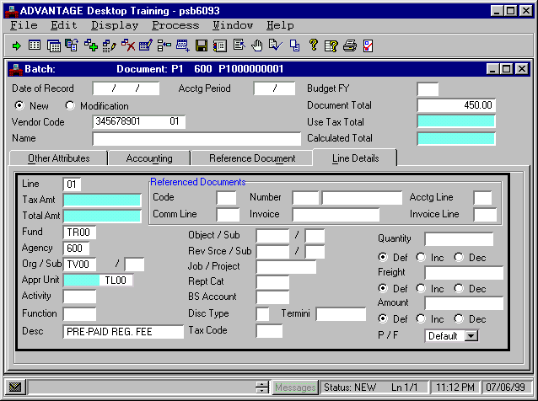

APPR UNIT Required. The Appropriation unit is a 9-character data field that consists of a 2 character Appropriation Program, a 3 character Allotment Program and a 4 digit Program Budget Unit. By typing the 4 digit Program Budget Unit, the other 5 characters will be inferred. Type “☺☺☺☺”.

ACTIVITY Optional. The activity code to be used for this document line. Required when dictated by agency policy. Leave Blank.

FUNCTION Optional. The function code to be used for this document line. Required when dictated by agency policy. Leave Blank.

DESC Optional. The general descriptive information you want recorded with this document line. If entered, the information will print on the check stub and will assist the vendor in determining the reason for payment. Type “Pre-Paid Reg. Fee”.

Vendor Payment Voucher (P1)
Line Details Tab

REV SRCE / SUB (Revenue Source) Conditional. For balance sheet or expenditure object transaction lines, leave this field blank. Required for revenue source transaction lines. All travel transactions will record an expenditure with an object code. Leave Blank

REV SRCE / SUB (Sub Revenue Source) Optional. The sub-revenue source code for this document line. Required when dictated by agency policy. Leave Blank.

JOB / PROJECT Conditional. This job number or project number code to be used for this document line. Required for Federal (1200) and Capital Project (0200) funds and also required when dictated by agency policy. Leave Blank.

REPT CAT Optional. The reporting category number to be used for this document line. Required when dictated by agency policy. Leave Blank.

BS ACCOUNT. Conditional. For expenditure object or revenue source transaction lines, leave this field blank. Required for balance sheet account transaction lines. All travel transactions will record an expenditure with an object code. Leave Blank.

DISC TYPE This field is not used by the Commonwealth of Kentucky. Leave Blank.

TERMINI Optional. The termini code associated with the document line. Required when dictated by agency policy. Leave Blank.

Vendor Payment Voucher (P1)
Line Details Tab

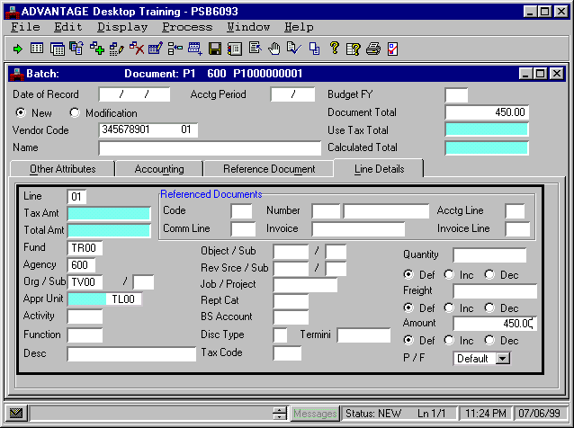

QUANTITY This field is used to enter mileage information. Leave Blank.

DEF/INC/DEC (Quantity). This field is not used by the Commonwealth of Kentucky. Leave as Default.

FREIGHT. This field is not used by the Commonwealth of Kentucky. Leave Blank.

DEF/INC/DEC (Freight). This field is not used by the Commonwealth of Kentucky. Leave as Default.

AMOUNT Required. The amount for this document line. The amount due Vendor for Pre-Paid Registration Fee. Type “450.00”.

DEF/INC/DEC (Amount) Default or increase represents an increase to the amount paid. Decrease represents a decrease to the amount paid. Leave as Default.

TAX CODE. This field is not used by the Commonwealth of Kentucky. Leave Blank.

P / F (Partial / Final). Defaults to Default (i.e., partial) [Blank]. Leave as Default.

Vendor Payment Voucher (P1)

You have now completed populating the fields on the P1 document and are almost ready to have the document approved. However, before you approve a document, you must edit the document for errors. Checking for errors in ADVANTAGE Financial is called editing.

Once a document is free of errors, it will be ready for approval. Before you edit the document for errors, the status of the document is “NEW”. The status will change as you complete document processing cycle.

Edit the P1 document

Step 1 On the Menu Bar, select Process: Edit.

Once you have edited your document, you will get a message in the yellow field on the Status bar. This message will let you know whether or not your document has been rejected due to errors.

Vendor Payment Voucher (P1)
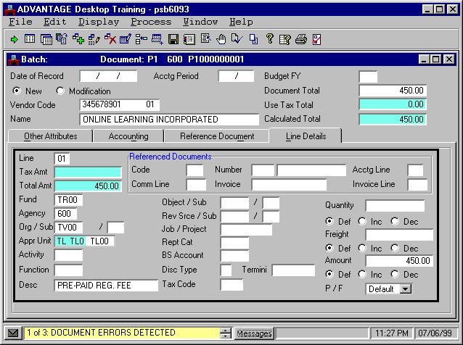

In this example, the status message reads “REJCT”, which means the document contains errors. The message of 1 of 3: DOCUMENT ERRORS DETECTED appears in the yellow box in the Status bar.

Errors can occur for several different reasons, such as leaving a field blank or entering the wrong information in a field. ADVANTAGE Financial will provide information on the location of the errors in the document and the reason for the errors so you don’t have to go through the whole document trying to find them.

Messages screen
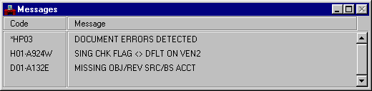
Missing OBJ/REV ACCT Error Message
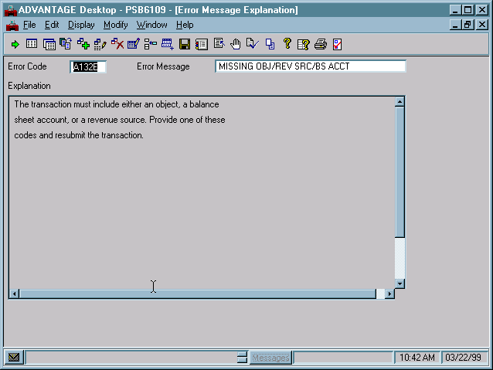

Accessing the Error Message Screen

You know that there is an error in the document because of the REJCT message on the Status Bar. But why was it rejected?
To see why the document was rejected:

Step 1 Click the <MESSAGE> button at the bottom of the screen.

The Messages window appears displaying the error message(s). Sometimes error messages are hard to understand. You can double-click on the error message to see a description of the error.

Step 2 Select the “MISSING OBJ/REV SRC/BS ACCT” message.

Step 3 Double click with your left mouse button.

You can view the Error Message Explanation window for each error. This window provides details about the error and generally tells you what to do to fix the error.

When you have finished viewing the message, close the Error Message Explanation window.

Step 4 Click on the x in the upper right hand corner of the Error Message Explanation window.

Let’s go find the Object Code to correct the error.
Vendor Payment Voucher (P1)

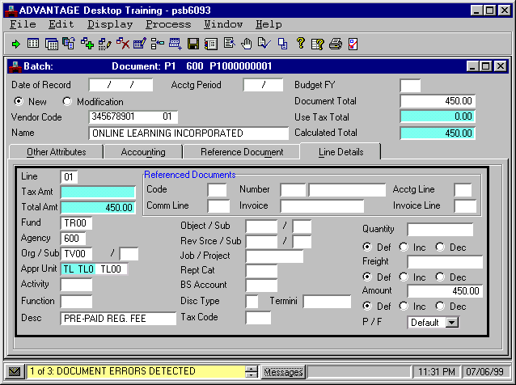

Accessing the Find Code

Some ADVANTAGE Financial fields require codes that can be found in an existing table. Object/Sub is an example of one of these fields. If you know the code you may enter it. If you are unsure of a valid code, you may use the Find Code feature.

To find the OBJECT/SUB code:

Step 1 Click in the Object/Sub field.

Step 2 On the Menu Bar, select Help: Find Code.

Find Code

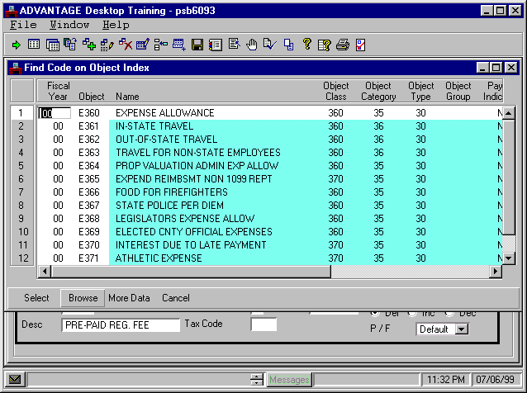

The Find Code list is now on the desktop. The list displays a limited number of codes at a time. You would click More Data at the bottom of the window to see additional codes.

If you know the beginning of the code, you may type it in the field and click the <BROWSE> button. The list will jump to the first code matching the information you entered. Let’s assume you know that the object code you want starts with E36 but you don’t know the last number.

We know that there are three different valid object codes for payments associated with travel. They all begin with E36, but the fourth character indicates whether or not the travel is in-state, out-of-state, or non-state employee travel. We can browse data on E36 to see our available choices.

To find the correct Object Code:

Step 3 In the FISCAL YEAR field, type “00”.

Step 4 In the object field, type”E36”.

Step 5 Click <BROWSE>.

The first “E36” Object code listed is highlighted.

Let’s find the Object Code for our P1.

Find Code

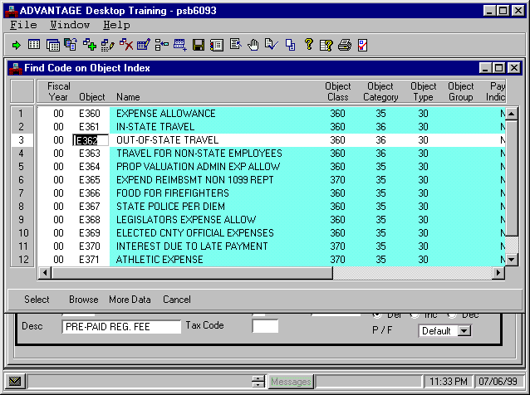

Using the Find Code

The first object that starts with “E36” is displayed in the list. The other objects that start with “E36” appear in the list under the first object. You can look through the list to find the object you want.

Once you find the object that you want, you can select it and populate the Object field in your P1 document.

To select the Object Code:

Step 6 Click Object Code “E362: Out-of-State-Travel”.

Step 7 Click the <SELECT> button at the bottom of the window.

Object Code “E362” is placed in the Object/Sub field on your P1 document.

Vendor Payment Voucher
Line Details Tab
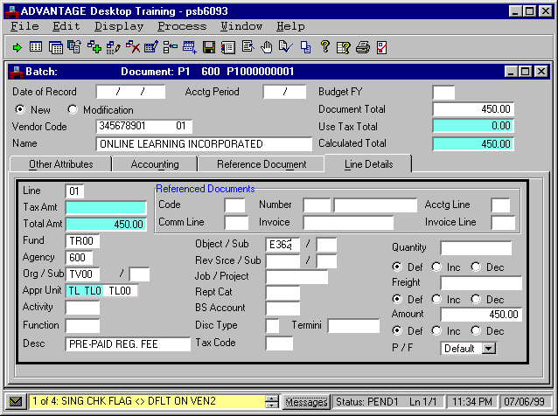

Complete the Edit Process

The Object/SUB field is now populated with the information from the Find Code list.

After you fix the error, you must edit the document again to make sure that everything was fixed correctly.

To edit the document:

Step 1 On the Menu Bar, select Process: Edit.

The status of your document will read “PEND1” to let you know that the document is ready for approval. The other remaining message is just a warning that can be disregarded for training purposes.

Now that you are finished with your document, you can close it. Once you close the document it will be stored in the Document Listing (SUSF) table until it is approved. Generally, if you create and edit the document, someone else would approve it.

To close the document:

Step 2 On the Menu Bar, select Window: Close Open Windows.

Let’s look at the P1 document in SUSF.
This page intentionally left blank.

Document Listing (SUSF) table

Once a document has been created and edited, it is stored in the Document Listing (SUSF) table. SUSF is a large storage area that records the status of documents during document processing.

Previously, you learned that ADVANTAGE Financial checks to see if the data entered into the document is correct during the document editing process. If the data is correct, a document is ready to be approved and run. Documents are stored in SUSF during each of the steps of the document processing cycle with the applicable status.

After you have completed the document processing cycle, the status changes to accepted and it remains in SUSF for a period of time. During this time period, accepted documents can be reviewed, but not changed.

Let’s find your P1 document on SUSF and continue the document processing cycle.

Go To Window

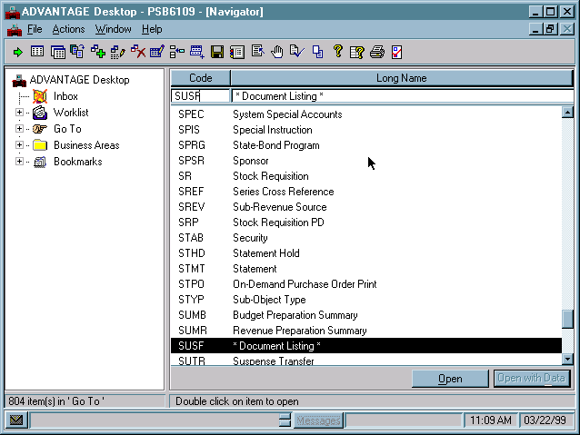

Accessing the Document Listing (SUSF) table

The steps for accessing the document history (SUSF) table are similar to the initial steps you followed in creating a P1 document. Let’s use these steps to access SUSF.

Step 1 Open the Go to Window.

Step 2 In the CODE field, type “SUSF” and press the <OPEN> button to access SUSF.

Document Listing (SUSF)
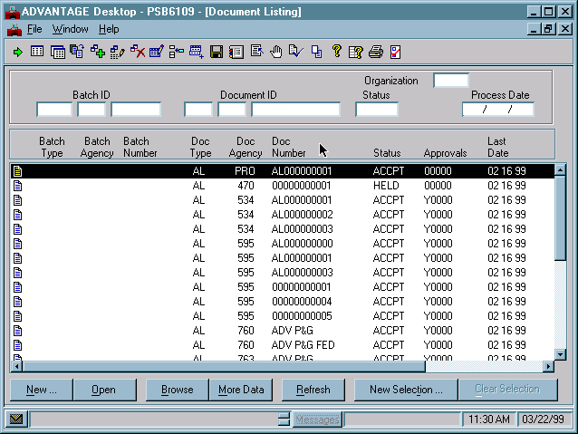

Document Selection
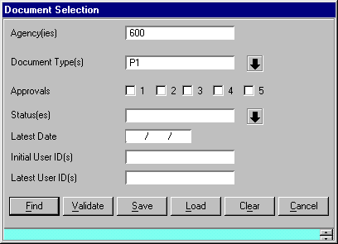


Walkthrough

Let’s assume that your are “all powerful” and can apply approvals to the P1 documents. You want to access only P1 documents that have a PEND 1 status. You could use the <New Selection> button on SUSF to enter specific information about the document you want displayed. Let’s populate the fields to find your P1.

Step 1 Select the <NEW SELECTION> button.

The Document Selection dialog box appears.

Step 2 In the AGENCY(IES) field, type “☺☺☺”.

Step 3 In the DOCUMENT TYPE(S) field, click the downward pointing arrow.

In the View by box select <Code>.

In the Available Choices box click <P1>.

Use the <ADD> button to add P1 to the Selected Choices box.

Click <OK> once P1 is in the Selected Choices box.

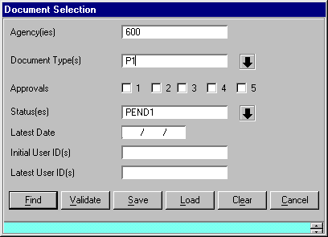
Document Selection

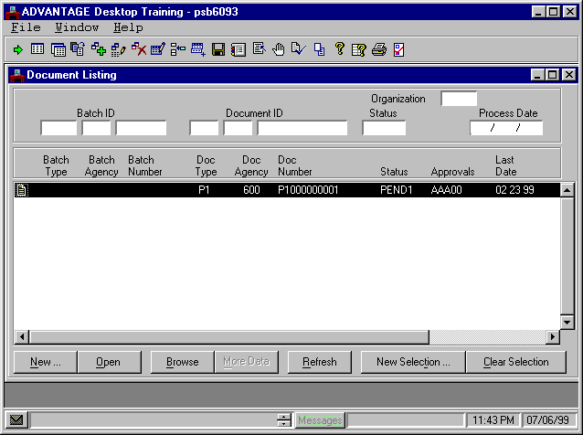

Walkthrough

Populate Document Selection (Continued)

Step 4 In the STATUS(ES) field, click the downward pointing arrow.

In the View by box select <Code>.

In the Available Choices box click <PEND1>.

Use the <ADD> button to add PEND1 to the Selected Choices box.

Click <OK> once PEND1 is in the Selected Choices box.

Step 5 Select the <FIND> buttton.

The Document Selection dialog box closes and opens SUSF with your P1 document highlighted.

Step 6 Verify that the correct P1 is highlighted on line 1 and select the <OPEN> key.

Please note, there is an alternative method for finding a document in SUSF by utilizing the Document ID field. We will use this method during other courses.

Vendor Payment Voucher (P1)

