
Approving the Payment Voucher (P1)

We have retrieved the document that you created. Notice that only one level of approval is required on the P1 document. Remember, this is training. In the “real world”, multiple levels of approvals may be required. Now, supposing that you have the appropriate security, let’s approve the P1.

Step 1 On the Menu Bar, select Process: Approve.

The screen will display “SCHED” in the STATUS field and the message section at the bottom of the screen will display messages stating “APPROVAL 1 APPLIED”.


Vendor Payment Voucher (P1)
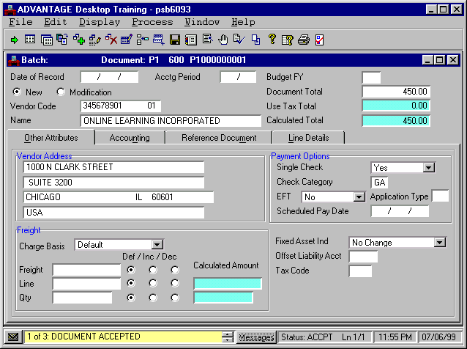

Executing the RUN Command

We are now ready to perform the RUN command.

Step 1 On the Menu Bar, select Process: Run.

Once you have executed the RUN command, the document will be marked as read-only and can no longer be changed.

Note that the STATUS field displays “ACCPT”.

The system checks and updates the corresponding tables based on information contained in the P1 document.

The tables impacted by processing a P1 are:

- Open Payment by Document Number Inquiry (OPVD)
- Open Payment Voucher Header Inquiry (OPVH)
- Open Payment Voucher by Line Inquiry (OPVL)

Step 2 On the Menu Bar, select Window: Close Open Windows.

Let’s view the OPVD table.

Go To Window
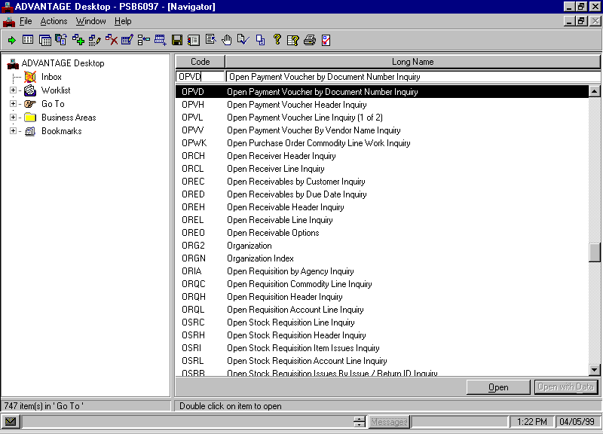

Access the Open Payment by Document Number Inquiry (OPVD)

Step 1 Open the Go To Window.

Step 2 Place a cursor in the CODE field and type “OPVD”.

Step 3 Click the <OPEN> button.

Open Payment Voucher By Document Number Inquiry (OPVD)
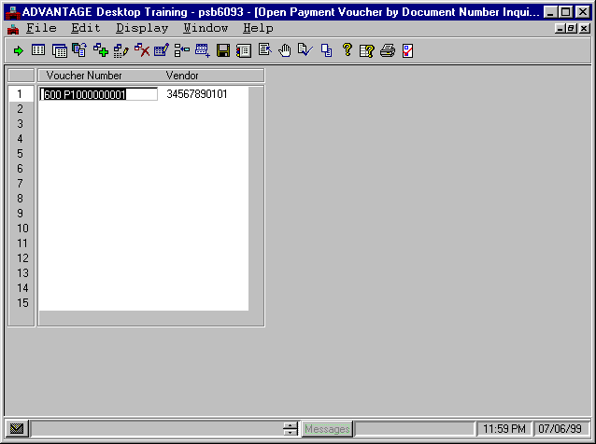

Let’s populate the fields to inquire on the OPVD table.

Step 1 In the VOUCHER NUMBER field, type the Document ID.
Type “☺☺☺ P1☺☺☺☺☺☺☺☺☺”. You recorded the Document ID when we first opened up the P1.

The transaction code, P1 does not need to be entered on the open item tables. All payment vouchers are stored as PVs. For example, your P1 document is stored in the ledgers and tables as PV ☺☺☺ P1☺☺☺☺☺☺☺☺☺.

Step 2 On the Menu Bar, select Display: Browse Data.

Notice that the VENDOR code or Traveler ID is displayed. By using OPVD, you can get to your Payment Voucher without knowing the traveler ID or vendor code.

Now, let’s look at the Open Payment Voucher Inquiry (OPVH) table.

Open Payment Voucher Header Inquiry (OPVH)
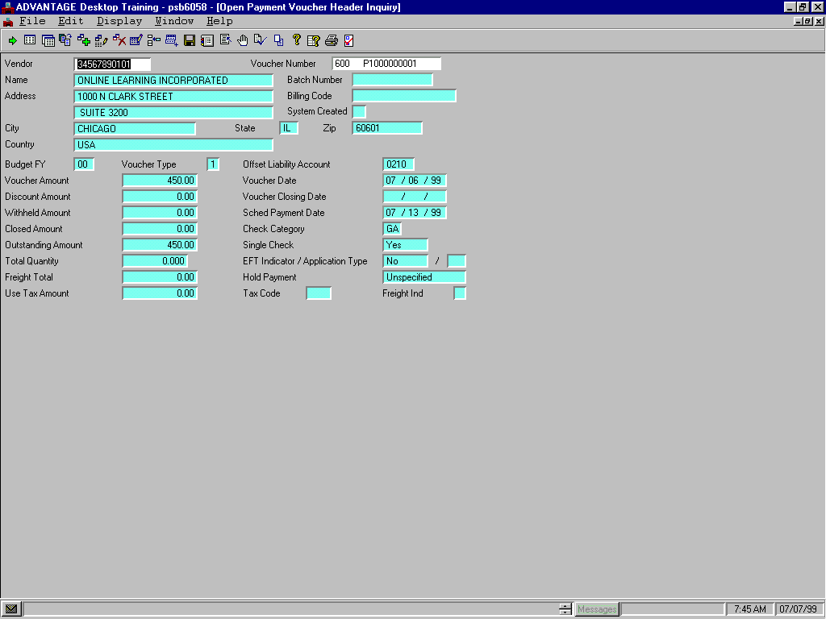

Access Open Payment Voucher Header (OPVH)

Recall that when tables have similar key fields, you can access a specified table from a related table. This is true for tables with similar key fields like Open Payment Voucher by Document Number Inquiry (OPVD) and OPVH. Let’s access the OPVH using the Related Data command.

Step 1 On the Menu Bar, select Display: Related Data.

The OPVH table contains information about open payment vouchers. Notice that the VOUCHER AMOUNT and OUTSTANDING AMOUNT now read “450.00”. Also, notice the SCHED PAYMENT DATE displays the date entered on the payment voucher and the CHECK CATEGORY displays “GA”, the default value.

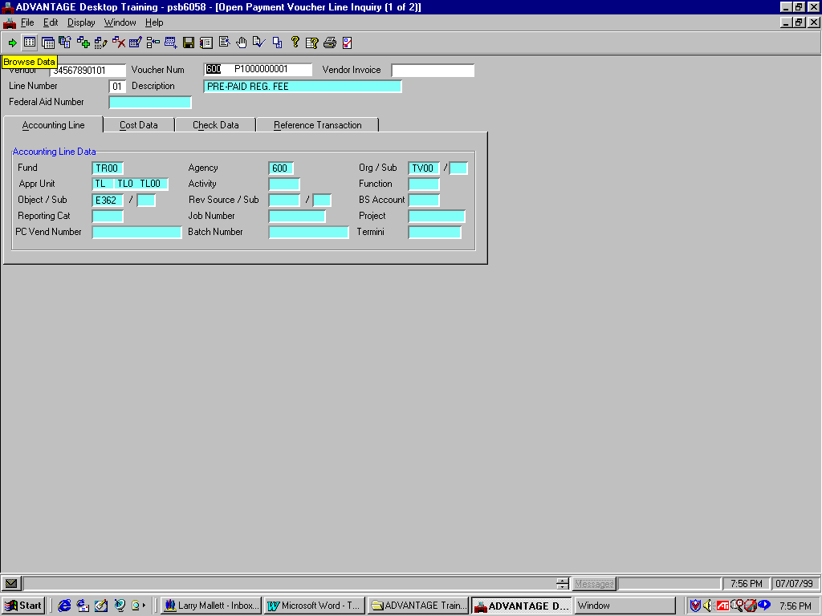
OPVL Header / Accounting Line Tab

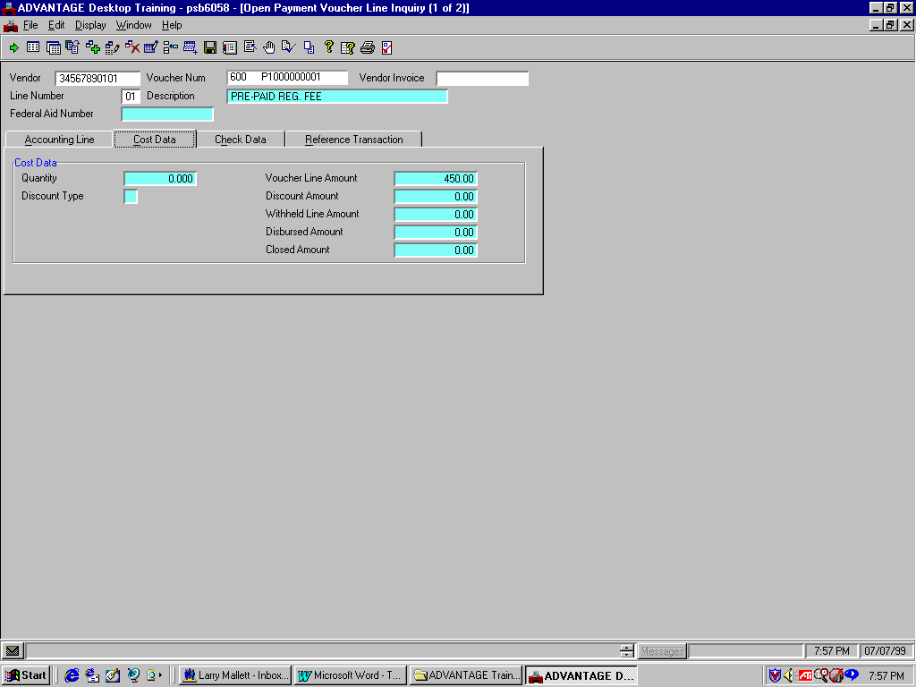
OPVL Header / Cost Data Tab

Access the Open Payment Voucher Line Inquiry (OPVL) table

Recall that when tables have similar key fields, you can access a specified table from a related table. Let’s access the OPVL using the Related Data command.

Step 1 On the Menu Bar, select Display: Related Data.

The top screen shows the Accounting Line tab. The bottom shows the Cost Data tab. We will not reference the Check Data or Reference Data tabs because they display no information at this time that is relevant to our P1 document.

The Accounting Line tab displays information specific to the accounting elements.

In the Cost Data tab note the VOUCHER LINE AMOUNT field reads “450.00”.

Step 2 On the Menu Bar, select Window: Close Open Windows.

This page intentionally left blank.


Are there any questions about creating, editing, approving, or running a P1 document or inquiring on impacted tables?

This page intentionally left blank.

