

Scenario 2

There are two more employees that wish to attend the same Online Learning conference that our traveler in Scenario 1 requested. Assume that the appropriate agency financial staff have prepared a Pre-Paid Registration Fee form to request that a payment be made. One funding strip is going to pay Traveler 1’s registration fee. Another funding strip will pay for Traveler 2’s registration fee. Different Program Budget Units are going to cover the cost of the registration fee for our travelers. The P1 can perform this accounting by recording two lines with two different funding strips for $450.00 each.

The total amount on the check mailed to Online Learning, Inc will be $900.00. The Vendor will still receive one consolidated check despite the fact that the total amount of the Payment Voucher is coming from two different funding strips, because we will indicate that this is a single check on the document.
This Page Intentionally Left Blank.

Copying a Document

There may be times when you want to copy a document that you have already created. For example, in Scenario 2 we have two people registering for the Online Learning Conference. The new P1 document will utilize some of the same codes as our P1 created in Scenario 1. Instead of starting from scratch, we can copy the one we already created and edit the appropriate information. By using the copy feature, you can recreate all the information from the original document without re-entering it onto a new document. For example, copying our original P1 document means we do not have to reenter vendor code, fund, agency, organization/sub-organization, or appropriation unit. This method not only saves time but also lowers the possibility of data entry errors.

Let’s create a new P1 by copying your previously created document.


Go to Window

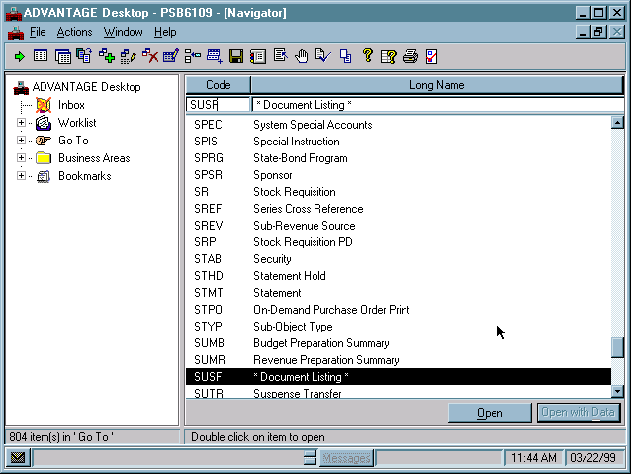

Accessing the Document Listing (SUSF) table

Perform the following steps to access the SUSF table.

Step 1 Open the Go to Window on your desktop.

Step 2 Place a cursor in the CODE field and type “SUSF”.

Step 3 Press the <OPEN> button to access SUSF.

Let’s populate the fields to inquire on the SUSF table.

Document Listing (SUSF) table
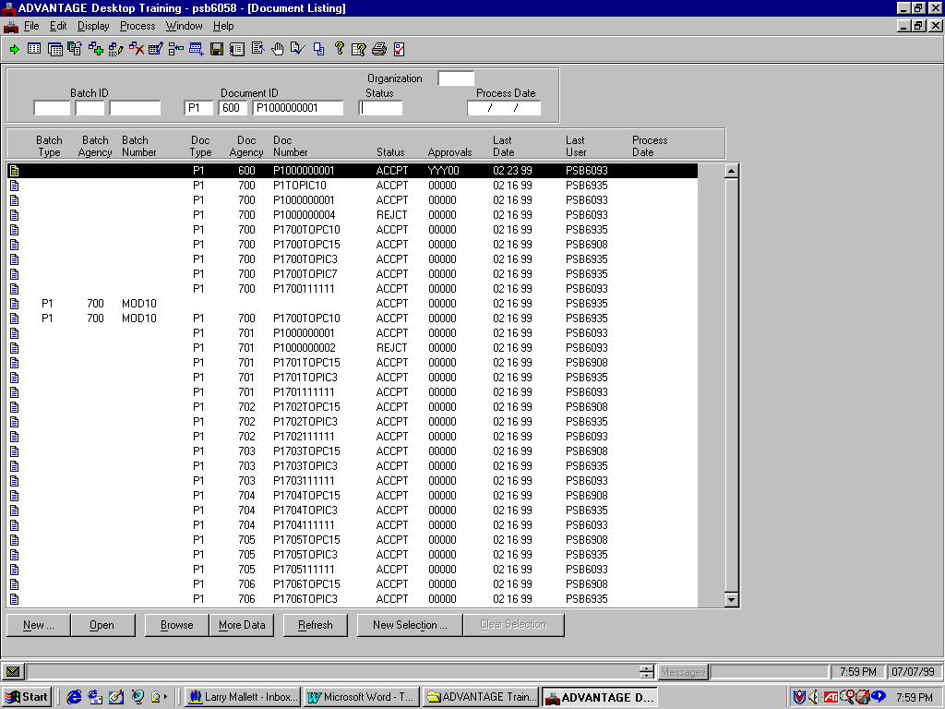

Finding the P1 Document

Let’s find your original document.

Step 1 In the DOCUMENT ID field for DOC TYPE, type “P1”.

Step 2 In the DOCUMENT ID field for DOC AGENCY, type “☺☺☺”.

Step 3 In the DOCUMENT ID NUMBER field for DOC Number, type your document number.

Type “P1☺☺☺☺☺☺☺☺☺”.

We recorded this number when we copied our original P1 document.

Step 4 Select the <BROWSE> button.

Your document will display on Line 1.

Step 5 Verify that the correct P1 document is highlighted on Line 1.

Now that you have the correct P1 selected on Line 1, you are ready to copy it.

Target Document for COPY dialog box
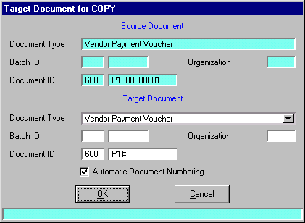

Copying the P1 Document

To copy the P1 document you would perform the following:

Step 1 On the Menu Bar, select Process: Copy Document…..

The Target Document for COPY dialog box appears.

From the dialog box you can see your original P1 Document’s type and Document ID number.

Step 2 In first field of DOCUMENT ID field, type “☺☺☺” for Agency.

Step 3 In the second field of document ID, type P1.

Step 4 Check the Automatic Document Numbering option.

Step 5 Click <OK>.

A copy of your original P1 document appears.

Vendor Payment Voucher (P1)

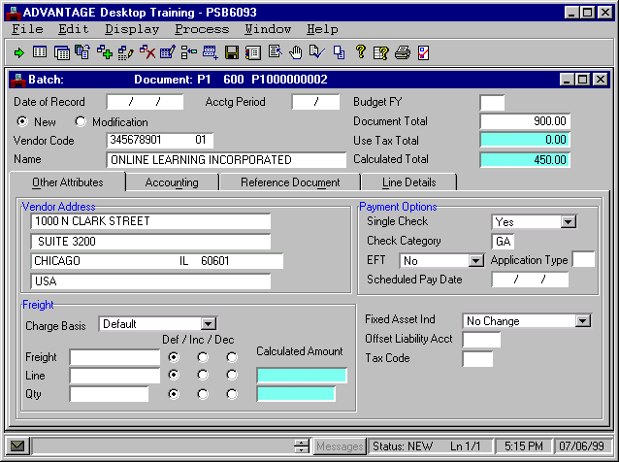
Status

Populate the P1 Document

Notice that the data entered in the fields is the same as the original document. Please note the status of our P1 document is “NEW”. This indicates to you that although a copy is made of a document, the new documents still must go through the normal document process of editing, approving, and being run. Now that we have a copy of the original P1 document let’s populate the essential fields with our new transaction information.

Populate the P1 document

Step 1 Enter the following values in the corresponding fields of the Header.

DOCUMENT TOTAL Type “900.00”.

Step 2 Select the Line Details tab. Notice all your original data is displayed. We do not need to change any of the data in Line 01. One of our travelers is going to use the same accounting distribution as our Scenario 1 traveler to pay for the cost of the registration fee.

Now you need to add an additional line to enter the funding strip paying for Traveler 2’s registration fee. You create this second line by copying Line 01.
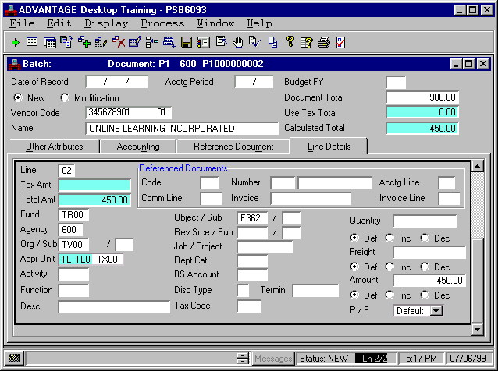

Vendor Payment Voucher (P1)
Lines Detail Tab Line 2

Create a Second Line in a Document

Let’s create a second line to enter the amount for the Traveler 2’s registration fee cost which is $450.00.

Step 1 On the Menu Bar, select Edit: Copy Line.

A copy of the line is displayed. We must now make this line our second line.

Step 2 Enter the following values in the corresponding fields for our Traveler 2 registration fee information.

LINE Type “02”.

Appropriation Unit “TX00”.

We have completed populating the fields on the P1 document. The next step in the process would be to edit the P1 for errors.

Step 1 On the Menu Bar, select Process: Edit.

Once we have edited without errors we are ready to approve and then run the document. Scenario 1 illustrated how the document life cycle is completed in the “real world”. For training purposes and in the interest of time we are going to approve and run the document from our current position in the system.

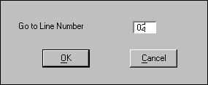

Go to Line Number dialog box

Vendor Payment Voucher (P1)

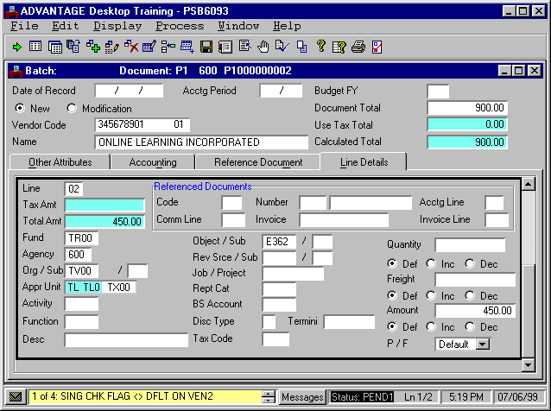

Deleting a Line in a Document
(Discussion Only)

If you ever need to delete a line on a document here are the instructions to do so.

Step 1 On the Menu Bar, select Edit: Go To Line.

The Go to Line dialog box is displayed.

Step 2 In the dialog box enter the line number you need to delete.

You can now see the second line contains the water filter and its line detail information.

Step 3 On the Menu Bar, select Edit: Remove Line.

A message box will appear asking you “Do you really want to delete the selected lines"?

Step 4 Click <YES> to delete the line number.

The line number will now be deleted from the document. You should use the Go to Line feature to try to find the document line.
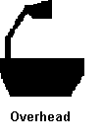
VENDOR PAYMENT VOUCHER (P1)
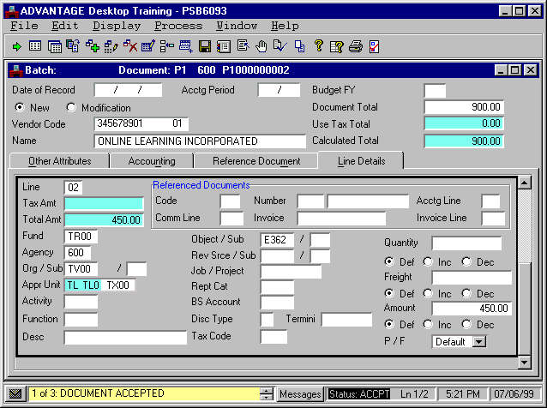

We have now created, edited, approved, and run our P1 document for Scenario 2. At this point we want to inquire upon the Payment Voucher tables we accessed earlier to see how our second document has updated MARS.

The tables impacted by processing a P1 are:

- Open Payment by Document Number Inquiry (OPVD)
- Open Payment Voucher Header Inquiry (OPVH)
- Open Payment Voucher by Line Inquiry (OPVL)

We will first access the Open Payment by Document Number Inquiry (OPVD)
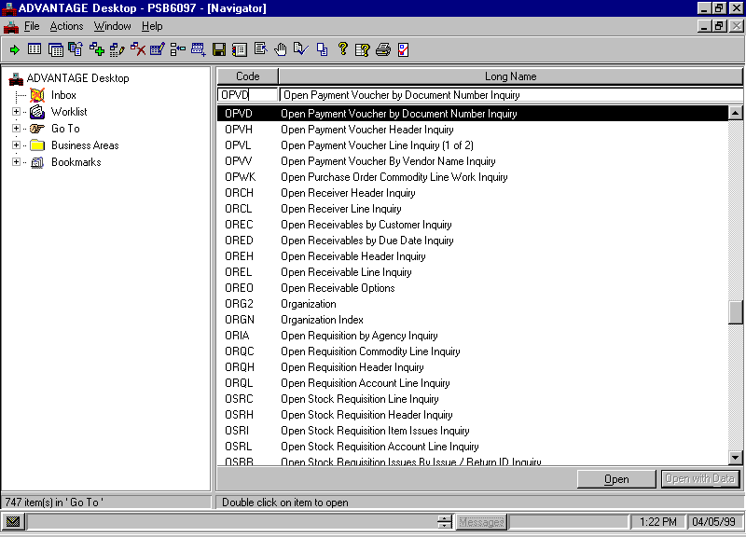
Go To Window

Access the Open Payment by Document Number Inquiry (OPVD)

Step 1 Open the Go To Window.

Step 2 Place a cursor in the CODE field and type “OPVD”.

Step 3 Click the <OPEN> button.

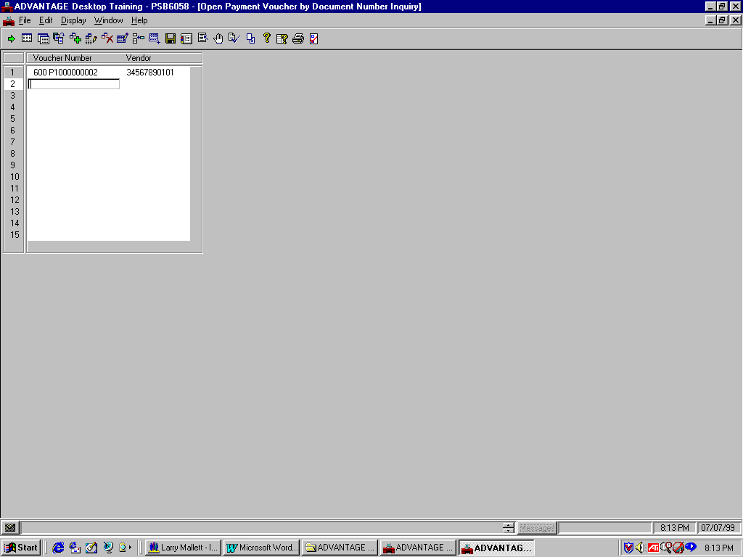
Open Payment Voucher By Document Number Inquiry (OPVD)

Let’s populate the fields to inquire on the OPVD table.

Step 1 In the VOUCHER NUMBER field, type the Document ID. Refer to the Document ID we recorded when we first opened up the P1 document.
Type “☺☺☺ P1☺☺☺☺☺☺☺☺☺”.

The transaction code, P1 does not need to be entered on the open item tables. All payment vouchers are stored as PVs. For example, your P1 document is stored in the ledgers and tables as PV ☺☺☺ P1☺☺☺☺☺☺☺☺☺.

Step 2 On the Menu Bar, select Display: Browse Data.

Notice that the VENDOR code or Traveler ID is displayed. By using OPVD, you can get to your Payment Voucher without knowing the traveler ID or vendor code.

Now, let’s look at the Open Payment Voucher Inquiry (OPVH) table.

Open Payment Voucher Header Inquiry (OPVH)

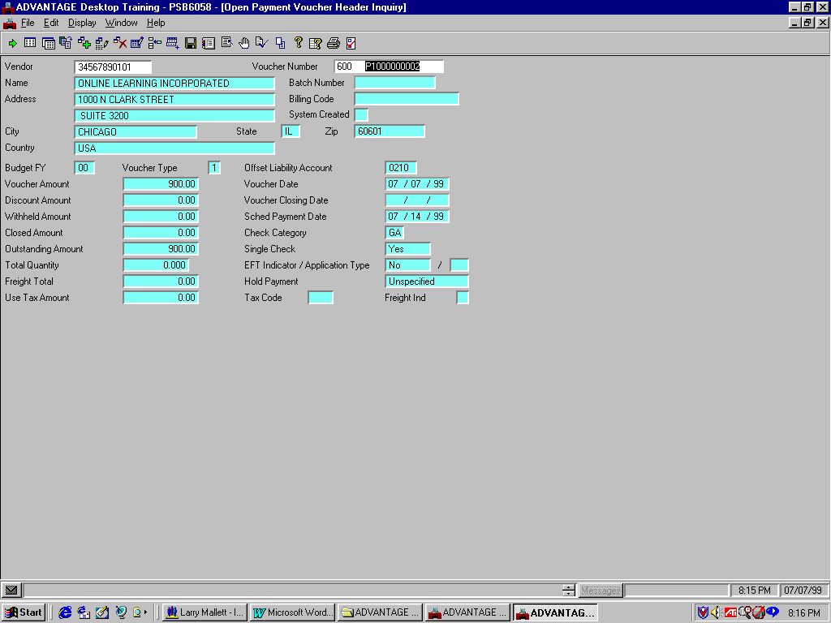

Access Open Payment Voucher Header (OPVH)

Recall that when tables have similar key fields, you can access a specified table from a related table. This is true for tables with similar key fields like Open Payment Voucher by Document Number Inquiry (OPVD) and OPVH. Let’s access the OPVH using the Related Data command.

Step 1 On the Menu Bar, select Display: Related Data.

The OPVH table contains information about open payment vouchers. Notice that the VOUCHER AMOUNT and OUTSTANDING AMOUNT now read “900.00”. Also, notice the SCHED PAYMENT DATE displays the date entered on the payment voucher and the CHECK CATEGORY displays “GA”, the default value.

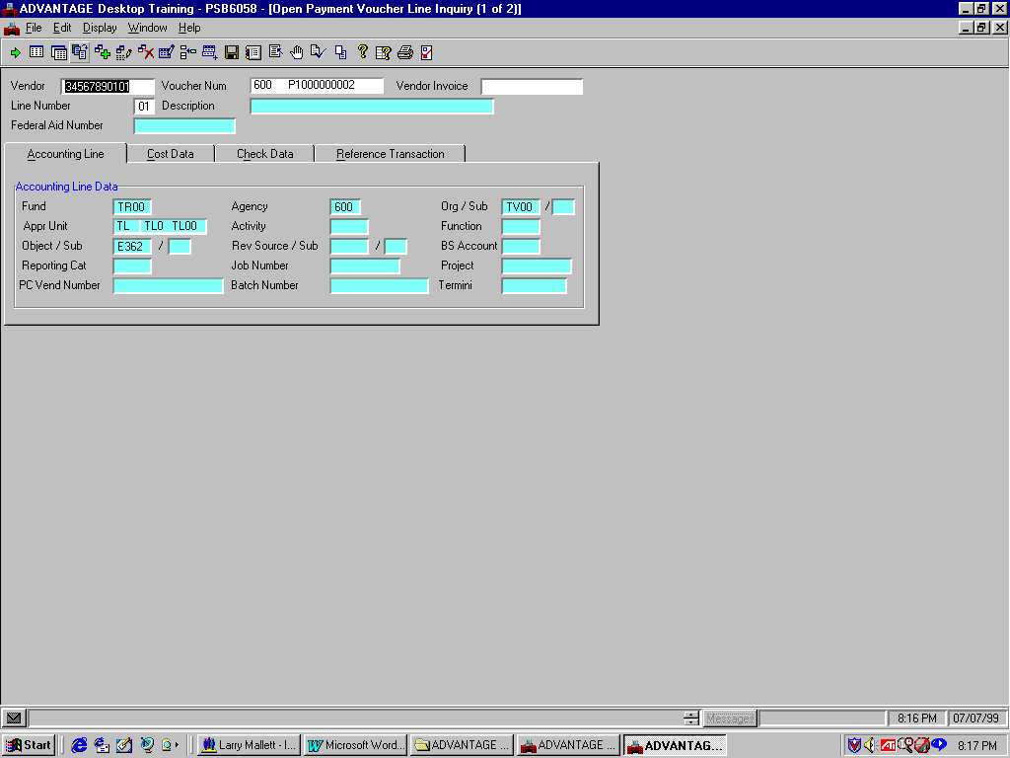
OPVL Header / Accounting Line Tab

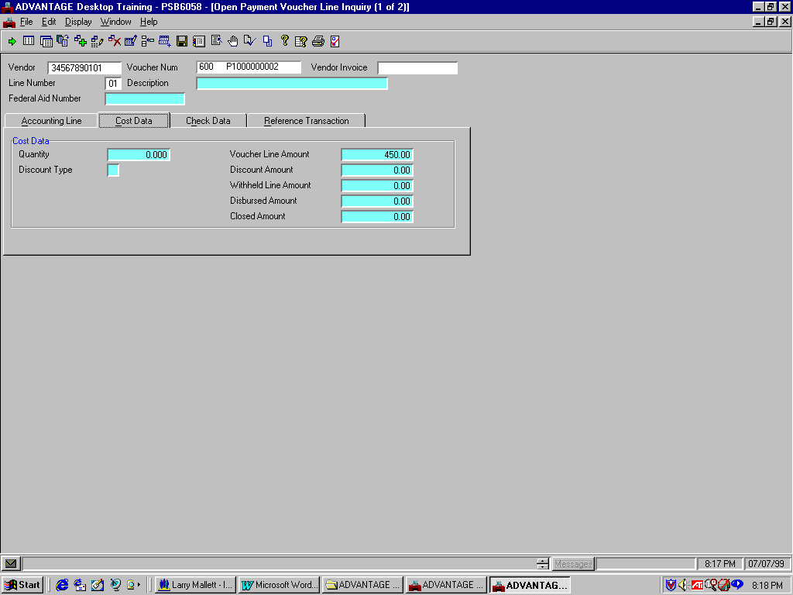
OPVL Header / Cost Data Tab

Access the Open Payment Voucher Line Inquiry (OPVL) table

Recall that when tables have similar key fields, you can access a specified table from a related table. Let’s access the OPVL using the Related Data command.

Step 1 On the Menu Bar, select Display: Related Data.

The top screen shows the Accounting Line tab. The bottom shows the Cost Data tab. We will not reference the Check Data or Reference Data tabs because they display no information at this time that is relevant to our P1 document.

The Accounting Line tab displays information specific to the accounting elements.

In the Cost Data tab note the VOUCHER LINE AMOUNT field reads “450.00”.

We can only view one line at a time on the OPVL table. In order to access the other line we will look at the next record on the table.

Step 2 On the Menu Bar, select Display: More Data

Step 3 On the Menu Bar, select Window: Close Open Windows.

This page intentionally left blank.


Are there any questions about creating, editing, approving, or running a P1 document or inquiring on impacted tables?

Go To Window

