

Scenario 3

Our traveler has attended the conference on online learning and workforce development. Online Learning Incorporated was the vendor organizing the conference. It was held in Chicago, IL and the registration fee was $450.00. The payment voucher to pay for the registration fee was processed in Scenario 1. The traveler now has returned from Chicago and needs to be reimbursed for his/her expenses. The required approvers have reviewed and signed the Travel Voucher form and we now will enter the data provided on that form into MARS. The amount specified will be issued through a straight disbursement using the Vendor Payment Voucher (P1) document.

Access the P1

Step 1 Open the Go To Window.

Step 2 In the Code field, type “P1” and press the <OPEN> button.


Batch/Document Entry Screen

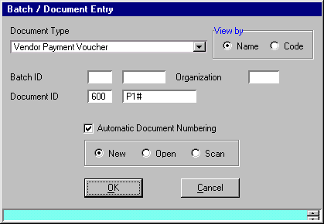

To create a new Vendor Payment Voucher (P1) document, complete the following steps on the Batch/Document Entry screen.

Step 1 Press the <TAB> key until the cursor is in the DOCUMENT ID field for Agency and type “☺☺☺”.

Step 2 Type “P1” in the DOCUMENT ID field for Document Number.

Step 3 Select the Automatic Document Numbering option.

Step 4 Verify the Document Action option is “New” and press <OK>.

Write down the document number the system assigned to your P1. You will use it later to inquire on tables.

P1 _ _ _ P1 _ _ _ _ _ _ _ _ _

Vendor Payment Voucher (P1)
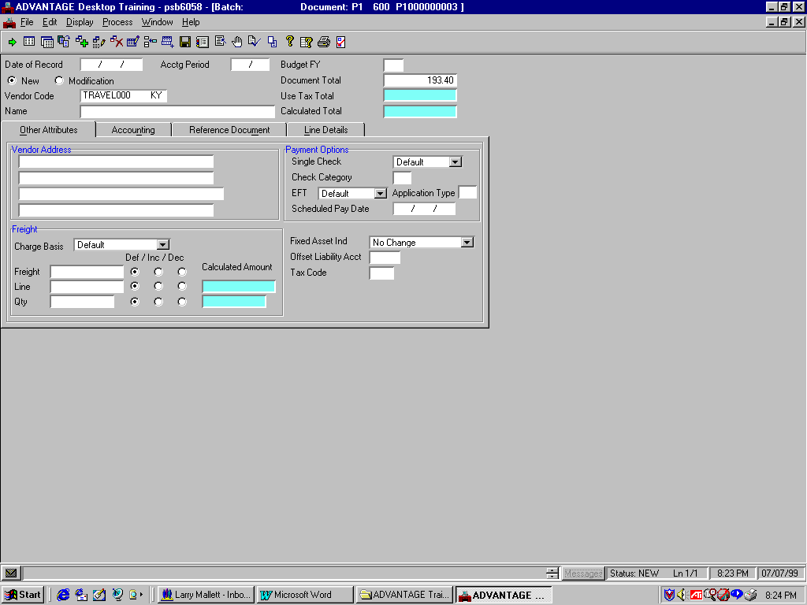
Header / Other Attributes Tab

Let’s complete the required information to process the P1 document.

Populate the P1 Document

Step 1 Enter the following values in the corresponding fields of the Header.

DATE OF RECORD Optional. The date for this document. If left blank, this field will be inferred from the system. Leave Blank.

ACCTG PERIOD Optional. The accounting period using fiscal month and fiscal year, for this document. Dual-year processing users will enter accounting period 13 and the applicable accounting fiscal year to indicate closing period and to pay from prior year funds. Leave Blank.

BUDGET FY. Optional. The budget fiscal year for this document. If left blank, this field will be inferred from the system. Leave Blank.

NEW. Default is New. Indicates that this is a new entry. Leave as New.

MODIFICATION. Select when modifying a previously entered document. Leave Blank.

DOCUMENT TOTAL Required. The net amount of all increase and decrease line amounts. Amount due Traveler for reimbursement. Type “193.40”.

VENDOR CODE Required. This code indicates the traveler who must be reimbursed for travel expenses. Type “TRAVEL0☺☺ KY.”

Vendor Payment Voucher (P1)
Header / Other Attributes Tab

USE TAX TOTAL Protected. This field shows the total amount of tax calculated for this document if the tax codes used on the document are use tax. Leave Blank.

NAME This field is inferred from the Vendor Code entered on the document Leave Blank.

CALCULATED TOTAL Protected. This field contains the system-computed total of the line amounts. Leave Blank.

VENDOR ADDRESS. This field is inferred from the Vendor Code. Leave Blank.

SINGLE CHECK Optional. Used only when traveler or vendor elects to receive payment in a different manner than normally specified. When “Yes” for single check is selected a separate check for this payment will be issued. When “No’ or “Default” is selected for single check, this payment is consolidated with other vouchers to the same Traveler or Vendor Code for the same disbursement date. Default is “No” for consolidated checks. Leave as Default.


Screen View

Vendor Payment Voucher (P1)
Header / Other Attributes Tab


Walkthrough
CHECK CATEGORY Optional. This field specifies the check category that this payment voucher is printed under. Payment documents are summarized by the traveler or vendor and check category. If left blank, defaults to General Treasury (GT-check is sealed and mailed by Treasury). The single check flag may be selected requesting that a single check be issued for the payment. If the single check flag is not selected, the payment may be consolidated with all other payments to the traveler or vendor. If agency mailed (GA) is entered (check is returned to you without being sealed) and SINGLE CHECK must be selected. If Treasury held (GH) is entered (check is held by treasury without being sealed) and single check must be selected. Leave as Default.

EFT Optional. Required if you want the current payment voucher paid by Electronic Funds Transfer (EFT) and the vendor’s default payment method is through check. This traveler or vendor must have EFT information in vendor table. Leave as Default.

APPLICATION TYPE Conditional. Required if EFT is set to Yes. Leave Blank.

SCHEDULED PAY DATE Required. Enter the date the payment is due to the traveler or vendor.
Type “☺☺/☺☺/☺☺”.

CHARGE BASIS. This field is not used by the Commonwealth of Kentucky. Leave as Default.

FREIGHT (Amount). This field is not used by the Commonwealth of Kentucky. Leave Blank.
Screen View

Vendor Payment Voucher (P1)
Header / Other Attributes Tab

Walkthrough
FREIGHT (Def/Inc/Dec). This field is not used by the Commonwealth of Kentucky. Leave as Default.

LINE (Amount). This field is not used by the Commonwealth of Kentucky. Leave Blank.

LINE (Def/Inc/Dec). This field is not used by the Commonwealth of Kentucky. Leave as Default.

LINE (Calculated Amount). This field is not used by the Commonwealth of Kentucky. Leave Blank.

QTY (Amount). This field is not used by the Commonwealth of Kentucky. Leave Blank.

QTY (Def/Inc/Dec). This field is not used by the Commonwealth of Kentucky. Leave as Default.

QTY (Calculated Amount). This field is not used by the Commonwealth of Kentucky. Leave Blank.

FIXED ASSET IND. This field is not used by the Commonwealth of Kentucky. Leave as Default.

OFFSET LIABILITY ACCT This field is not used by the Commonwealth of Kentucky. Leave as Default.

TAX CODE. This field is not used by the Commonwealth of Kentucky. Leave Blank.

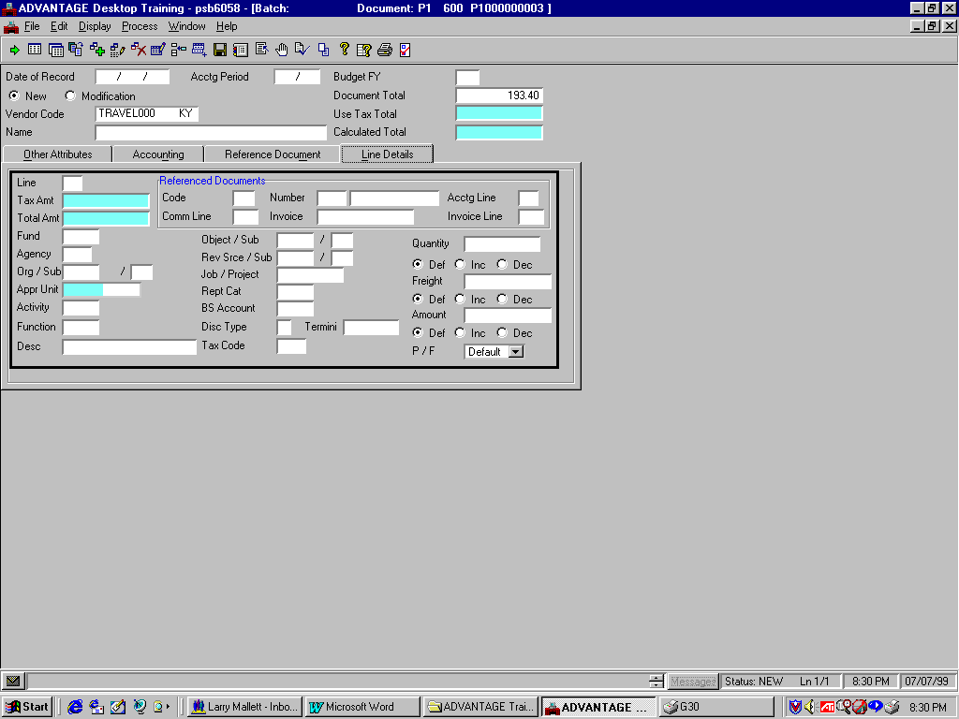
Line Details Tab

Populate the Line Details Tab

Step 2 Select the Line Details tab and enter the following values in the corresponding fields. It should be noted that the Accounting tab can be used when only limited fields are required. Since the Line Details tab contains all fields, we will use this tab for instructional purposes.

LINE Required. Enter a two-digit unique number for each line on the document. Numbers 01 to 99 are valid. Type “01”

REFERENCED DOCUMENTS CODE Conditional. All P1 documents processed for travel transactions will not reference another document. Leave Blank.

REFERENCED DOCUMENTS NUMBER
Conditional. Leave Blank.

REFERENCED DOCUMENTS ACCTG LINE Conditional. Leave Blank.

Vendor Payment Voucher (P1)

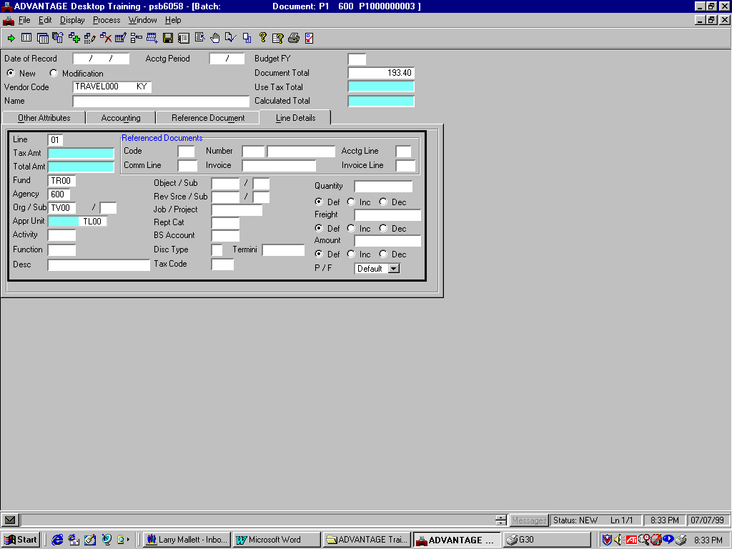
Line Details Tab

REFERENCED DOCUMENTS COMM LINE Conditional. Leave Blank.

REFERENCED DOCUMENTS INVOICE. If the Pre-Paid Registration Fee form has a vendor invoice attached enter the Vendor Invoice number in this field. If not, Leave Blank

REFERENCED DOCUMENTS INVOICE LINE The field is not used by the Commonwealth of Kentucky. Leave Blank.

TAX AMOUNT Protected. This field is not used by the Commonwealth of Kentucky. Leave Blank.

TOTAL AMT Protected. The system will calculate the total amount from the amount supplied and the calculated adjustment amount. Leave Blank.

FUND Required. The fund paying for this document line. Type “☺☺☺☺”.

AGENCY Required. The agency paying for this document line. Type “☺☺☺”.

ORG (Organization) Required. The organization paying for this document line. Type “☺☺☺☺”.

ORG/SUB (Sub-Organization) Optional. The sub-organization paying for this document line. Required when dictated by agency policy. Leave Blank.

Vendor Payment Voucher (P1)
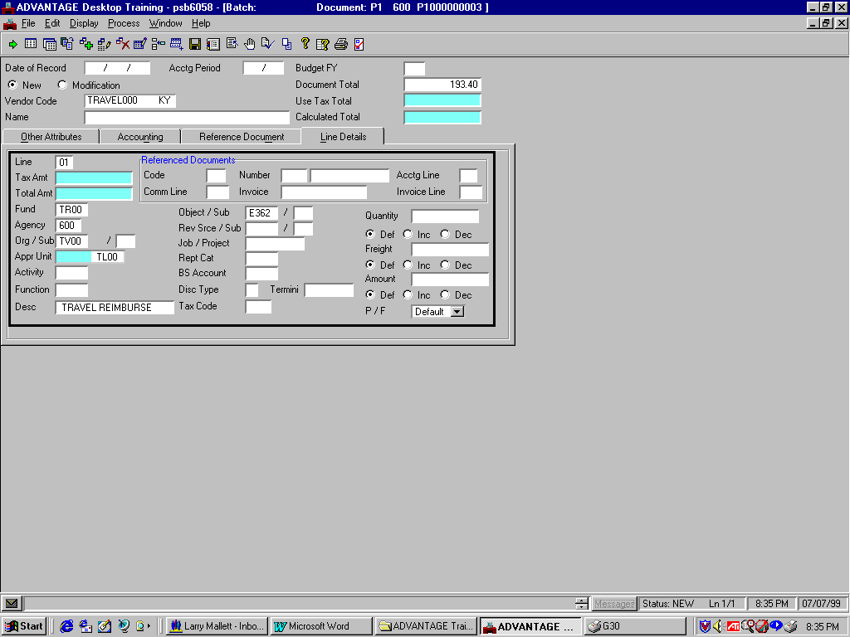
Line Details Tab

APPR UNIT Required. The Appropriation unit is a 9-character data field that consists of a 2 character Appropriation Program, a 3 character Allotment Program and a 4 digit Program Budget Unit. By typing the 4 digit Program Budget Unit, the other 5 characters will be inferred. Type “☺☺☺☺”.

ACTIVITY Optional. The activity code to be used for this document line. Required when dictated by agency policy. Leave Blank.

FUNCTION Optional. The function code to be used for this document line. Required when dictated by agency policy. Leave Blank.

DESC Optional. The general descriptive information you want recorded with this document line. If entered, the information will print on the check stub and will assist the vendor in determining the reason for payment. Type “Travel Reimburse”.

Object/Sub Required.. The object code to be charged for the traveler’s expenses for this document line. Required on all travel registration fee and reimbursement travel P1 documents. Type “E362” for Out-of-State Travel..

Vendor Payment Voucher (P1)
Line Details Tab

REV SRCE / SUB (Revenue Source) Conditional. For balance sheet or expenditure object transaction lines, leave this field blank. Required for revenue source transaction lines. All travel transactions will record an expenditure with an object code. Leave Blank

REV SRCE / SUB (Sub Revenue Source) Optional. The sub-revenue source code for this document line. Required when dictated by agency policy. Leave Blank.

JOB / PROJECT Conditional. This job number or project number code to be used for this document line. Required for Federal (1200) and Capital Project (0200) funds and also required when dictated by agency policy. Leave Blank.

REPT CAT Optional. The reporting category number to be used for this document line. Required when dictated by agency policy. Leave Blank.

BS ACCOUNT. Conditional. For expenditure object or revenue source transaction lines, leave this field blank. Required for balance sheet account transaction lines. All travel transactions will record an expenditure with an object code. Leave Blank.

DISC TYPE This field is not used by the Commonwealth of Kentucky. Leave Blank.

TERMINI Optional. The termini code associated with the document line. Required when dictated by agency policy. Leave Blank.

Vendor Payment Voucher (P1)
Line Details Tab

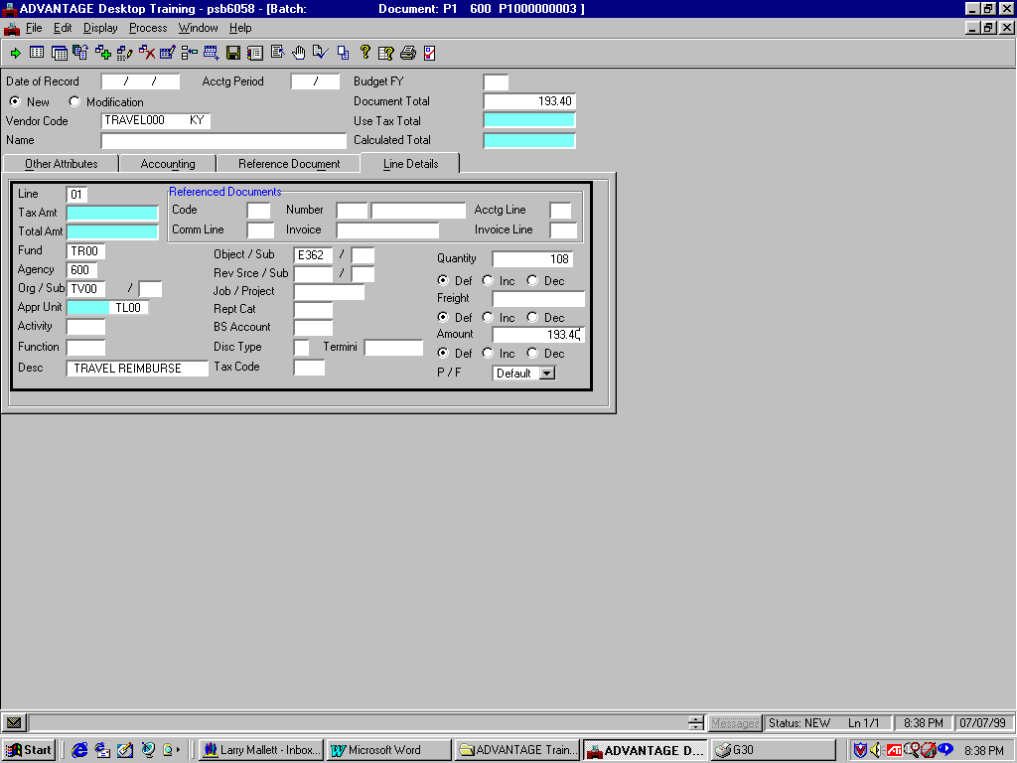

QUANTITY Enter in the mileage the traveler recorded on their approved Travel Voucher form. Enter “108”.

DEF/INC/DEC (Quantity). This field is not used by the Commonwealth of Kentucky. Leave as Default.

FREIGHT. This field is not used by the Commonwealth of Kentucky. Leave Blank.

DEF/INC/DEC (Freight). This field is not used by the Commonwealth of Kentucky. Leave as Default.

AMOUNT Required. The amount for this document line. The amount due Vendor for Pre-Paid Registration Fee. Type “193.40”.

DEF/INC/DEC (Amount) Default or increase represents an increase to the amount paid. Decrease represents a decrease to the amount paid. Leave as Default.

TAX CODE. This field is not used by the Commonwealth of Kentucky. Leave Blank.

P / F (Partial / Final). Defaults to Default (i.e., partial) [Blank]. Leave as Default.

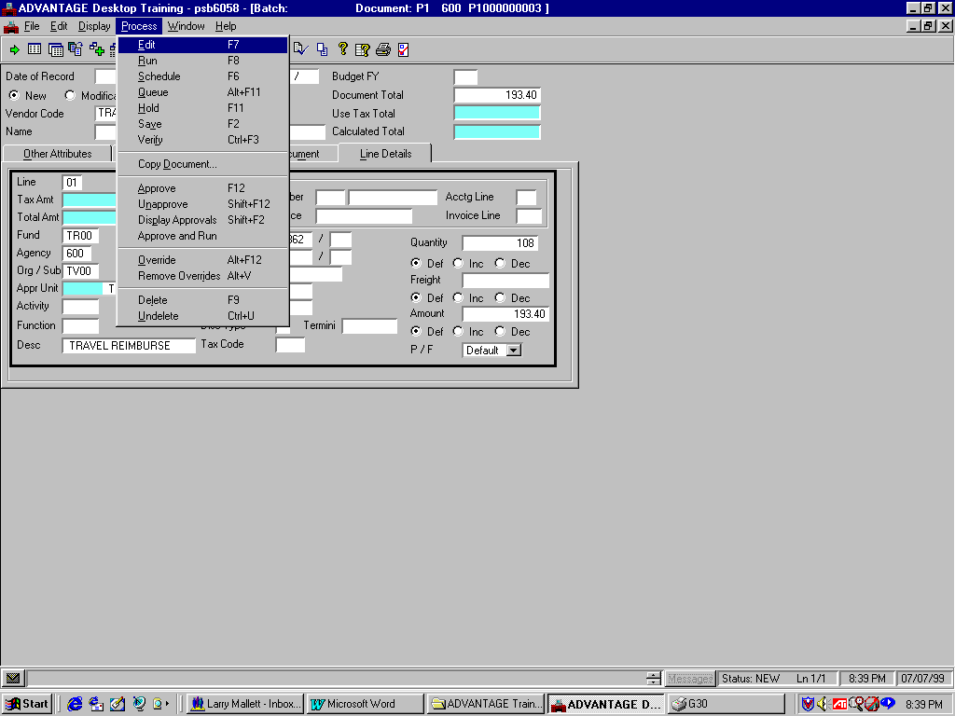
Vendor Payment Voucher (P1)

Edit the P1 document

Step 1 On the Menu Bar, select Process: Edit.

Once you have edited your document, you will get a message in the yellow field on the Status bar. This message will let you know whether or not your document has been rejected due to errors.

If your document has edited error free we can proceed to approve and run the document. Remember that the approver in the real world would follow the steps illustrated in Scenario 1.
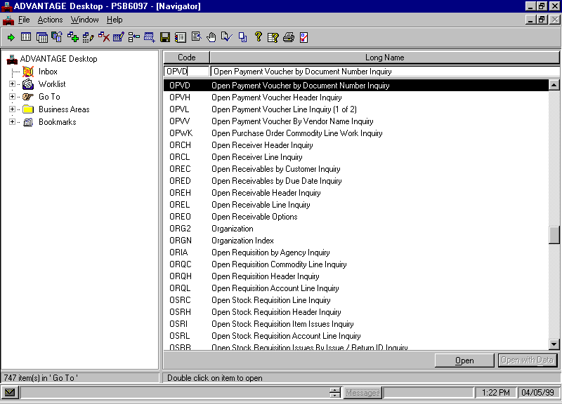
Go To Window

Access the Open Payment by Document Number Inquiry (OPVD)

Step 1 Open the Go To Window.

Step 2 Place a cursor in the CODE field and type “OPVD”.

Step 3 Click the <OPEN> button.

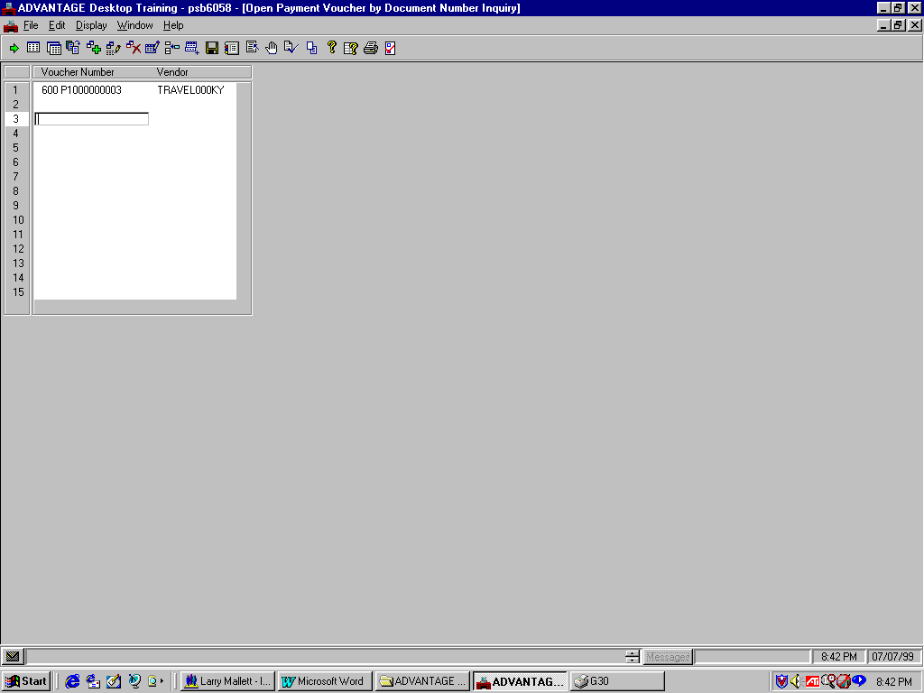
Open Payment Voucher By Document Number Inquiry (OPVD)

Let’s populate the fields to inquire on the OPVD table.

Step 1 In the VOUCHER NUMBER field, type the Document ID.

Type “☺☺☺ P1☺☺☺☺☺☺☺☺☺”.

The transaction code, P1 does not need to be entered on the open item tables. All payment vouchers are stored as PVs. For example, your P1 document is stored in the ledgers and tables as PV ☺☺☺ P1☺☺☺☺☺☺☺☺☺.

Step 2 On the Menu Bar, select Display: Browse Data.

Notice that the VENDOR code or Traveler ID is displayed. By using OPVD, you can get to your Payment Voucher without knowing the traveler ID or vendor code.

Now, let’s look at the Open Payment Voucher Inquiry (OPVH) table.

Open Payment Voucher Header Inquiry (OPVH)

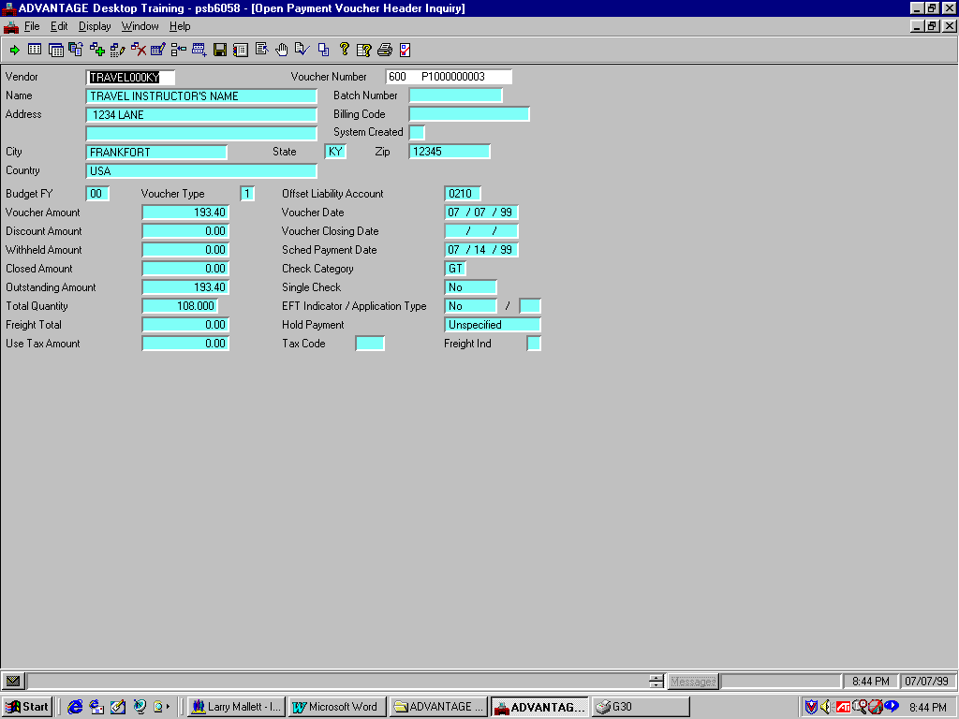

Access Open Payment Voucher Header (OPVH)

Recall that when tables have similar key fields, you can access a specified table from a related table. This is true for tables with similar key fields like Open Payment Voucher by Document Number Inquiry (OPVD) and OPVH. Let’s access the OPVH using the Related Data command.

Step 1 On the Menu Bar, select Display: Related Data.

The OPVH table contains information about open payment vouchers. Notice that the VOUCHER AMOUNT and OUTSTANDING AMOUNT now read “193.40”.

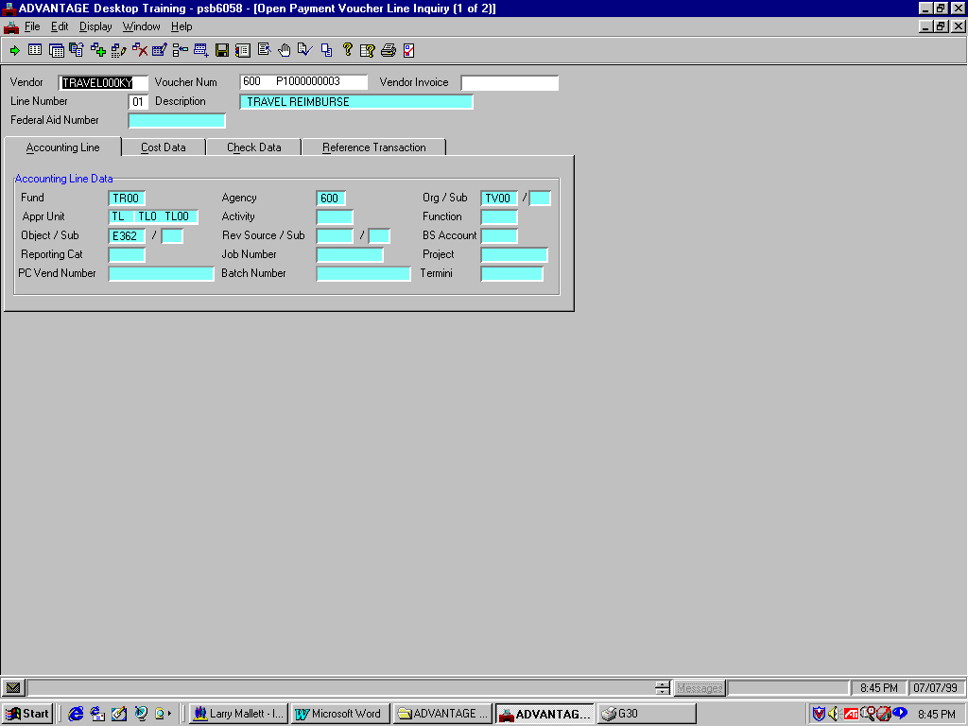
OPVL Header / Accounting Line Tab

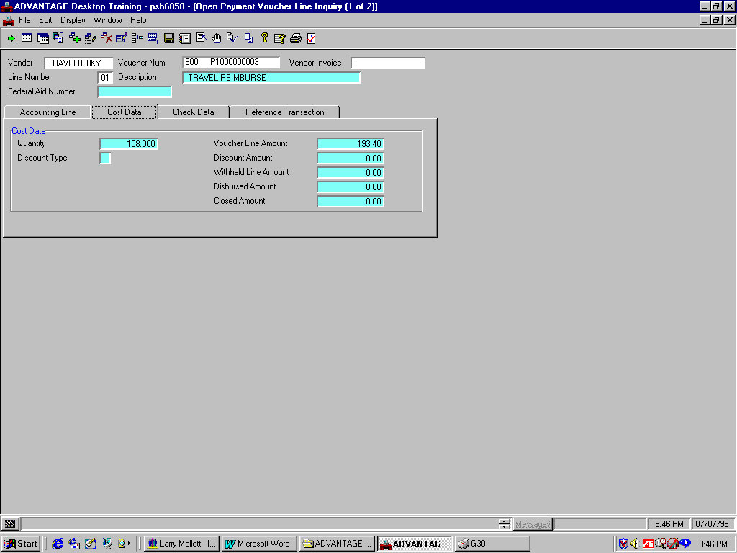
OPVL Header / Cost Data Tab

Access the Open Payment Voucher Line Inquiry (OPVL) table

Recall that when tables have similar key fields, you can access a specified table from a related table. Let’s access the OPVL using the Related Data command.

Step 1 On the Menu Bar, select Display: Related Data.

The top screen shows the Accounting Line tab. The bottom shows the Cost Data tab. We will not reference the Check Data or Reference Data tabs because they display no information at this time that is relevant to our P1 document.

The Accounting Line tab displays information specific to the accounting elements.

In the Cost Data tab note the VOUCHER LINE AMOUNT field reads “193.40”.

Step 2 On the Menu Bar, select Window: Close Open Windows.

This page intentionally left blank.


Are there any questions about creating, editing, approving, or running a P1 document or inquiring on impacted tables?

This page intentionally left blank.

Question

Do you have any questions about:

- Creating, editing, approving, and running a document,

- Accessing affected tables,

- Copying a document, or

- Copying and deleting a document line.

Good, now is the opportunity for you to test your knowledge.

This page intentionally left blank.


Questions?

1. A P1 document can only be processed to reimburse a traveler for incurred expenses?

- True
B. False

- The Traveler ID code must be set up in the Travel Table (TRAV)?

- True
B. False

- Only Travelers can be paid on a P1 document?

- True
- False

4 You can only have one accounting distribution on a Vendor Payment Voucher (P1) document?

- True
- False
This page intentionally left blank.



1. A P1 document can only be processed to reimburse a traveler for incurred expenses?

Answer: False. A P1 document is also processed to pay a vendor for registration fees.

2. The Traveler ID code must be set up in the Travel Table (TRAV)?

Answer: False. A P1 document is processed with a Traveler ID or Vendor code that is set up on the Vendor table (VEN2).

3. Only Travelers can be paid on a P1 document?

Answer: False. Vendors are also issued payments on a P1 document for Pre-Paid Registration Fees.

4. You can only have one accounting distribution on a Vendor Payment Voucher (P1) document?

Answer: False. We entered different accounting distribution to pay for two separate registration fees in Scenario 2.
This page intentionally left blank.



In this topic you learned about:

- The purpose of P1 documents pertaining to travel;

- The basic steps in document processing;

- The process of creating, editing, approving, and running a document; and

- How to inquire upon the tables a P1 document updates.

- Copying a document line and an entire document.

